Lebesgue Integration
Part 2: Lebesgue Measure

So far we have defined an outer measure $m^{*}$ that has the following properties:
- It is a non-negative set function defined for all subsets of $R$
- $m^{*}\left(∅\right)=0$
- It is monotone increasing, i.e. if $A⊂B$ then $m^{*}(A)≤m^{*}(B)$
- It is countably subadditive, i.e. $m^{*}(\bigcup_{j=1}^{∞}{A_{j})}≤\sum_{j=1}^{∞}{m^{*}(A_{j})}$
- For any subset $A$ of $R$ we defined $m^{*}\left(A\right)=inf⁡\left\{\sum_{j=1}^{∞}{l\left(A_{j}\right): A_{j}^{'}s \text{open intervals that cover }A}\right\}$ and $l\left(A_{j}\right)$ is length of the open interval $A_{j}$
Actually, any function that satisfies (1) through (4) of the above properties is called an outer measure. If the function satisfies (5) as well, it is called Lebesgue outer measure. It turns out that the Lebesgue outer measure has the property that $m^{*}\left(\left[a,b\right]\right)=m^{*}\left(\left(a,b\right)\right)=b-a$, i.e. the outer measure of any interval is its length.

Definition (Measure)
A measure is an (extended) set function with properties (1), (2), and the additional property that it is countably additive, i.e. $m^{*}(\bigcup_{j=1}^{∞}{A_{j})}=\sum_{j=1}^{∞}{A_{j}}$ for any pairwise disjoint sets $A_{j}$. Property (3) is implied, because (countably) additive implies monotonicity. Note that the domain does not have to be $P(R)$ any longer but it would have to be a $σ$-algebra, i.e. a collection that is closed under complements, countable unions, and countable intersections.

There are many measures and outer measures:

Example: Define $λ^{*}\left(E\right)=0$ if $E⊂R$ is finite and $λ^{*}\left(E\right)=1$ if $E⊂R$ is infinite. Is $λ^{*}$ a measure or an outer measaure?
Clearly the criteria (1) to (3) are easily checked out. As for (4): Consider $A_{j}=\left\{ j \right\}$. Then
$${1=m}^{*}( \bigcup{A_{j})}≤ \sum_{j=1}^{∞}{m^{*}\left(A_{j}\right)}=0$$
So, condition (4) is not true, so $λ^{*}$ is no outer measure (and therefore it cannot be a measure either)

Example: For any $A⊂R$, define $cm\left(A\right)=count(A)$ if $A$ is finite and cm$\left(A\right)=∞$ if $A$ is infinite. That set function is a measure called counting measure.
First, $cm$ is defined forall subsets or $R$, which is clearly a $σ$-algebra. Again, condition (1) to (3) are easily checked. As for (4): we cannot take the same collection of sets that we used in the previous problem. If we did, both sides would come out to $∞=∞$, which does not help us – unless this is a measure? Take a countable collection of subsets $A_{j}$. Either they are all finite, in which case (4) will be true, or at least one of the $A_{j}$ is infinite, in which case condition (4) works out again. Therefore $cm$ is an outer measure (so far). Note that since the $A_{j} ’ s$ do not have to be disjoint, what would happen for $A_{j}=\{ 1 \}$ for all $j$ ? In that case $cm(\bigcup_{j=1}^{∞}{A_{j})}=cm\left(\left\{1\right\}\right)=1≤\sum_{j=1}^{∞}{{cm(A}_{j})}=∞$.
Take a countable disjoint collection $∪A_{j}$ next. If all of the $A_{j}$ are non-empty, finite and disjoint, then we clearly have
$$∞=cm(\bigcup_{j=1}^{∞}{A_{j})}=\sum_{j=1}^{∞}{{cm(A}_{j})}=∞$$
Even if one of the $A_{j}$’s contained infinitely elements, we still would get the above equality. Finally, if we take only finitely many disjoint members in the collection, the equality above would hold again. Thus: cm is a (counting) measure.

Definition: (Probability Measure)
A space X with a $σ$-algebra $Σ$ of subsets and a measure $μ$ defined on $Σ$ with the additional property that $μ\left(X\right)=1$ is called a probability space.
Probability measures are studied, naturally, in probability theory, but they can be studied as examples of measures in analysis as well. But we will not concern ourselves with probability measures.

Example: Let $diam\left(E\right)=sup⁡(\left|x-y\right|:x,y∈E\}$ be the diameter of a set $E⊂R^{n}$. For any $δ>0$ we define
$$H_{δ}^{d}(S)=inf\left\{\sum_{j=1}^{∞}{(diam{\left(U_{j}\right)}^{d}:S⊂\bigcup_{j=1}^{∞}{U_{j} \text{and }diam\left(U_{j}\right)<δ}}\right\}$$
and let
$$H^{d}\left(S\right)=\sup_{δ>0}{H_{δ}^{d}\left(S\right)=\lim_{δ→0}{H_{δ}^{d}(S)}}$$
Then $H^{d}$ is an outer measure, called the d-dimensional Hausdorff outer measure.

The d-dimensional Hausdorff outer measure is actually very interesting. It is used, for example, to measure the dimensionality of fractals. However, it would take us too far off-track to follow this tangent; instead, let’s return to our Lebesgue outer measure.
The goal is to restrict the (Lebesgue) outer measure only to those sets for which it becomes countably additive. This definition is due to Caratheodory. It is relatively straight-forward, but it is not clear as to where his idea comes from.

Definition (Measurable Set)
A set E is called measurable if for every set A we have that
$$m^{*}\left(A\right)=m^{*}\left(A∩E\right)+m^{*}(A∩E^{c})$$
where $m^{*}$ is an outer measure. For a measurable set we define the measure of $E$ as $m\left(E\right)=m^{*}(E)$.
If the outer measure is the Lebesgue outer measure, then we call the set $E$ Lebesgue measurable, or L-measurable, and the Lebesgue outer measure restricted to the Lebesgue measurable sets Lebesgue measure.

Note: Since $A=\left(A∩E\right)∪(A∩E^{c})$ we have by subadditivity $m^{*}\left(A\right)≤m^{*}\left(A∩E\right)+m^{*}(A∩E^{c})$. Therefore a set E is measurable if $m^{*}\left(A\right)≥m^{*}\left(A∩E\right)+m^{*}(A∩E^{c})$, since the other inequality comes for free. As it will turn out, the measurable sets are those sets for which the outer measure becomes additive.

Note: Another way to define measurable set would be to define an inner measure $m_{*}$ Where the outer measure of a set E involves the inf over all open coverings of E, the inner measure of a set E would be the sup over all compact subsets of E. Then we would call those sets measurable for which $m^{*}(E)=m_{*}(E)$. That idea is rather symmetric and fairly obvious, but Caratheodory’s approach, while less intuitive, is less abstract and easier to work with.

Theorem: Properties of Measure
- The empty set $∅$ and the set $R$ are measurable
- The complement of a measurable set is measurable
- Every set with outer measure zero is measurable.
- The intersection of two measurable sets is measurable
- The union of two measurable sets is measurable
- Countable unions and intersections of measurable sets are measurable

Proofs:
(1) The empty set $∅$ and the set $R$ are measurable
Proof: To show that the empty set $∅$ is measurable, we need to show that
$$m^{*}\left(A\right)≥m^{*}\left(A∩∅\right)+m^{*}\left(A∩∅^{c}\right)=m^{*}\left(∅\right)+m^{*}\left(A∩R\right)=0+m^{*}\left(A\right)$$
Similarly, you show that $R$ is measurable
(2) The complement of a measurable set is measurable
Proof: Follows directly because ${\left(E^{c}\right)}^{c}=E$
- Every set with outer measure zero is measurable.
Proof: $A∩E^{c}⊂A$ and $A∩E⊂E$. Thus, if $m^{*}\left(E\right)=0$ then $m^{*}\left(A∩E\right)=0$. Thus:
$${m^{*}\left(A\right)≥ m}^{*}\left(A∩E^{c}\right)=m^{*}\left(A∩E\right)+m^{*}(A∩{ E}^{c})$$
- The intersection of two measurable sets is measurable
Proof: If $E$ and $F$ are measurable, then their complements are measurable as well. By (6) we have that $E^{c}∪F^{c}$ is measurable and hence ${\left(E^{C}∪F^{c}\right)}^{c}=E∩F$ is measurable
- The union of two measurable sets is measurable
Proof: Of course we can’t use (5) to prove this because that would be circular reasoning. So, assume that $E$ and $F$ are two measurable sets. We know that $E$ and $F$ are measurable so that for every set $A$ we have:
$$\left(*\right) m^{*}\left(A\right)=m^{*}\left(A∩E\right)+m^{*}\left(A∩E^{c}\right) \\ \text{(**)} m^{*}\left(A\right)=m^{*}\left(A∩F\right)+m^{*}(A∩F^{c})$$
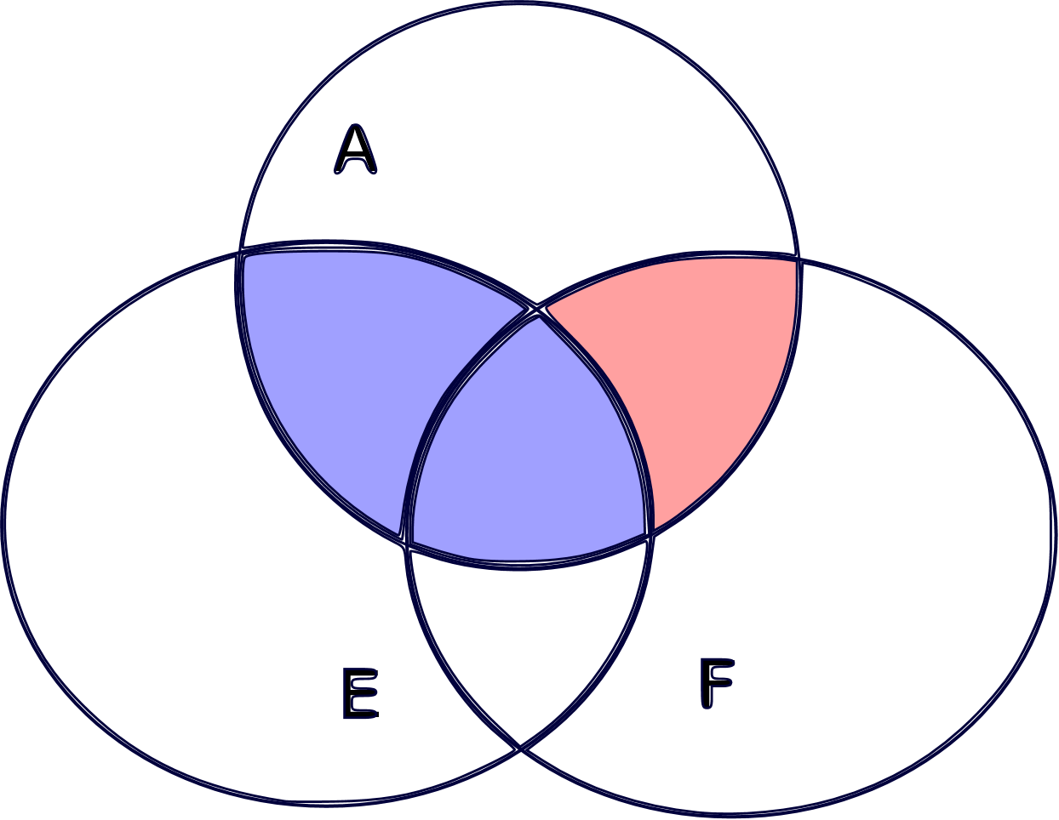
From set theory we know (draw a Venn diagram to verify) that:
$$A∩\left(E∪F\right)=(A∩E)∪(A∩E^{c}∩F)$$
which implies by subadditivity of m* that
$${\left(***\right) m}^{*}\left(A∩\left(E∪F\right)\right)≤m^{*}\left(A∩E\right)+m^{*}(A∩E^{c}∩F)$$
Using $A∩E^{c}$ in place of $A$ in (**) gives:
$$m^{*}\left(A∩E^{c}\right)=m^{*}\left(A∩E^{c}∩F\right)+m^{*}\left(A∩E^{c}∩F^{c}\right)=m^{*}\left(A∩E^{c}∩F\right)+m^{*}\left(A∩{\left(E∪F\right)}^{c}\right)$$

which we can in turn substitute in (*) to get:
$$m^{*}\left(A\right)=m^{*}\left(A∩E\right)+m^{*}\left(A∩E^{c}∩F\right)+m^{*}\left(A∩{\left(E∪F\right)}^{c}\right)≥ \\ ≥ m^{*}\left(A∩\left(E∪F\right)\right)+m^{*}\left(A∩{\left(E∪F\right)}^{c}\right)$$
Of course we used (***) to obtain the inequality. But that's what we needed; not very enlightening, but done.
- All countable unions and intersections of measurable sets are measurable
Proof: We have just shown that the union and intersection of two (and therefore of finitely many) measurable sets is again measurable, so the measurable sets from an algebra of sets (see below). Thus, to prove the statement for countable unions and intersections we may assume that the sets are disjoint because of the Algebra of Sets lemma below. So, let $\{E_{n}\}$ be a countable collection of disjoint measurable sets and $E=∪E_{n}$ be their union. Define their “partial union $F_{n} = E_{1}∪E_{2}∪…∪E_{n}$ . Applying the distributive lemma (see below) gets us:
$$m^{*}\left(A∩F_{n}\right)=m^{*}\left(A∩E_{1}\right)+m^{*}\left(A∩E_{2}\right)+…+m^{*}(A∩E_{n})$$

Because $E^{c}⊂F_{n}^{c}$ we know that $m^{*}\left(E^{c}\right)≤m^{*}(F_{n}^{c})$. Thus, for any set A we have:

$$m\left(A∩E_{1}\right)+m\left(A∩E_{2}\right)+…+m\left(A∩E_{n}\right)+m^{*}\left(A∩E^{c}\right)=$$
$$=m^{*}\left(A∩F_{n}\right)+m^{*}\left(A∩E^{c}\right)≤$$
$$≤m^{*}\left(A∩F_{n}\right)+m^{*}\left(A∩F_{n}^{c}\right)=m^{*}(A)$$

because the set $F_{n}$ is measurable. But this is true for any integer $n$ so that

$$m^{*}\left(A\right)≥m^{*}\left(A∩E_{1}\right)+…+m^{*}(A∩E_{n})+m^{*}\left(A∩E^{c}\right)≥m^{*}\left(A∩E\right)+m^{*}(A∩E^{c})$$

because of subadditivity. But that proves that the countable union $E$ of measurable sets $E_{n}$ is measurable.

That countable intersections of measurable sets are measurable follows from de Morgan laws and because complements of measurable sets are measurable.

Lemma: (Distributive Lemma) If $E_{1} , E_{2}, ..., E_{n}$ are finitely many disjoint measurable sets, then
$$m^{*}\left(A∩\left(E_{1}∪E_{2}∪…. ∪ E_{n}\right)\right)=m^{*}\left(A∩E_{1}\right)+m^{*}\left(A∩E_{2}\right)+…+m^{8}(A∩E_{n})$$
Proof: Let's show the lemma for two disjoint measurable sets E and F. Since F is measurable, we have:
$$m^{*}\left(A∩\left(E∪F\right)\right)=m^{*}\left(A∩\left(E∪F\right)∩F\right)+m^{*}\left(A∩\left(E∪F\right)∩F^{c}\right)$$
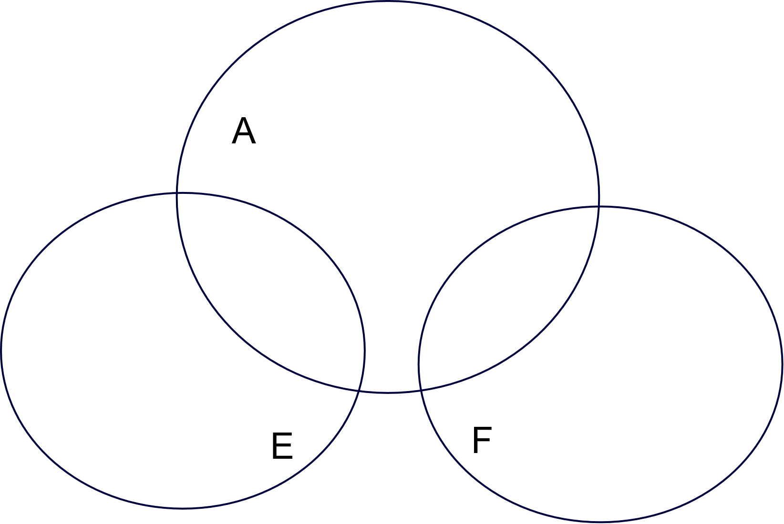
But E and F are disjoint so that $A∩\left(E∪F\right)∩F=A∩F$ and $A∩\left(E∪F\right)∩F^{c}=A∩E$. But then:
$$m^{*}\left(A∩\left(E∪F\right)\right)=m^{*}\left(A∩F\right)+m^{*}\left(A∩E\right)$$
You can now use induction to finish the proof.

Lemma: (Algebra of Sets) Suppose $O$ is a collection of sets such that the union of two elements and the complement of every element from $O$ is again part of $O$. Such a collection is called an Algebra of Sets. If $\{E_{n}\}$ is any countable collection of elements from $O$ then there is another countable collection $\{F_{n}\}$ of disjoint elements from $O$ such that $\bigcup{E_{j}}=\bigcup{F_{j}}$
Proof: Because $A∩B={\left(A^{c}∪B^{c}\right)}^{c}$ we know that intersections of two sets from $O$ must also be part of $O$. The same is true (by induction) for finite unions, intersections, or complements of sets in $O$. Now let $\{E_{n}\}$ be a countable collection of sets in $O$ and recursively define sets $F_{n}$ as follows:
$$F_{1}=E_{1} \text{and} F_{n}=E_{n}-\left(E_{1}∪E_{2}∪…∪E_{n-1}\right) \text{for} n>1$$
It is left as an exercise to show that (i) the $F_{n}$ are disjoint and (ii) the union of the $F_{n}$ is the same as the union of the $E_{n}$.

Note that the above statements are true for any measure, whereas the next theorem applies to Lebesgue measure in particular. We finally prove that moving from Lebesgue outer measure to Lebesgue measure achieves our goal of countable additivity.

Theorem: Properties of Lebesgue Measure
- The set $(a, ∞)$ is Lebesgue measurable
- All intervals are Lebesgue measurable and their measure is their length.
- All open and closed sets are Lebesgue measurable
- If $A_{j}$ are Lebesgue measurable, then $m(\bigcup_{j=1}^{∞}{A_{j})≤\sum_{j=1}^{∞}{m(A_{j})}}$
- If $A_{j}$ are Lebesgue measurable and pairwise disjoint, then $m(\bigcup_{j=1}^{∞}{A_{j})=\sum_{j=1}^{∞}{m(A_{j})}}$

Proof: This proof will take a little time, sorry. Here we go:
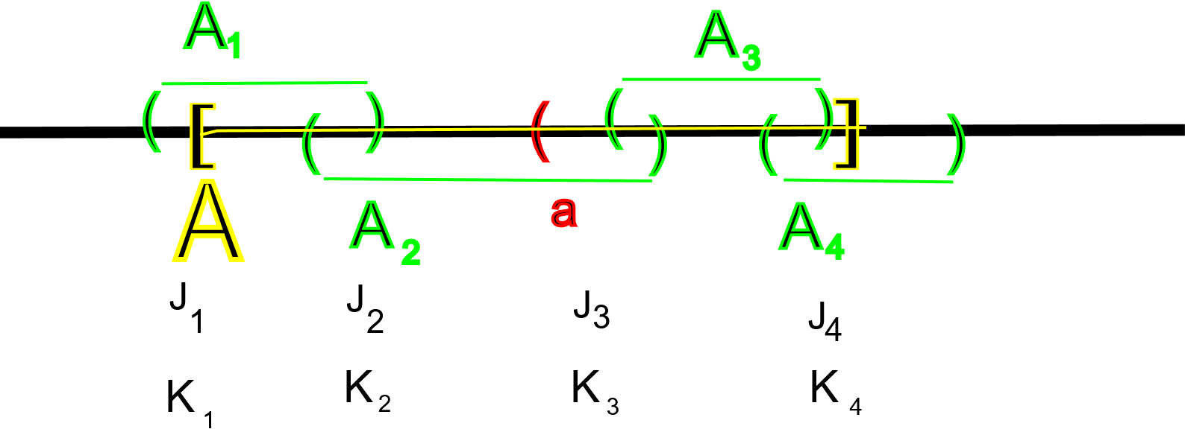
(1) We need to show that for any set $A$ we have $m^{*}\left(A\right)≥m^{*}\left(A∩\left(a,∞\right)\right)+m^{*}\left(A∩\left(-∞,a\right] \right)$ where $m^{*}$ is the Lebesgue outer measure. Without loss of generality we may assume that $m^{*}\left(A\right)<∞$. Thus, by the definition of outer measure there exists a collection of open intervals $A_{n}=\left(a_{n}, b_{n}\right)$ such that their union covers $A$ and $m^{*}\left(A\right)+ϵ≥\sum_{n=1}^{∞}{l(A_{n})}$. Now define $J_{n}={(a}_{n},b_{n})∩(a, ∞)$ and $K_{n}={(a}_{n},b_{n})∩(-∞,a]$. Then:
$J_{1}=∅$
$J_{2}=(a, b_{2})$
$J_{3}=(a_{3}, b_{3})$
$J_{4}=(a_{4}, b_{4})$
$K_{1}=(a_{1},b_{1})$
$K_{2}=(a_{2}, a]$
$K_{3}=∅$
$K_{4}=∅$

$J_{n}$ and $K_{n}$ are intervals or empty, so that $m^{*}\left(J_{n}\right)=l(J_{n})$ and $m^{*}\left(K_{n}\right)=l\left(K_{n}\right)$ and $l\left(J_{n}\right)+l\left(K_{n}\right)=l(A_{n})$
$J_{n}⊂\left(a_{n},b_{n}\right)$ and $K_{n}⊂(a_{n},b_{n})$ so that $\sum{l\left(J_{n}\right)≤\sum{{l(A}_{n})}}$ and $\sum{l\left(K_{n}\right)≤\sum{l(A_{n})}}$
All sums are convergent because the measure of $A$ is finite.
$A∩\left(a,∞\right)⊂\bigcup{J_{n}}$ and $A∩\left(-∞,a\right]⊂\bigcup{K_{n}}$so that $m^{*}\left(A∩\left(a,∞\right)\right)≤m^{*}\left(∪J_{n}\right)≤\sum{l(J_{n})}$ and $m^{*}\left(A∩\left(-∞,a\right]\right)≤m^{*}\left(∪K_{n}\right)≤\sum{l(K_{n})}$because of subadditivity and the above estimates. But then we have:
$$m^{*}\left(A∩\left(a,∞\right)\right)+m^{*}\left(A∩\left(-∞,a\right]\right)≤\sum{l\left(J_{n}\right)}+\sum{l\left(K_{n}\right)}=\sum{l\left(A_{n}\right)≤m^{*}\left(A\right)+ϵ}$$
Since $ϵ>0$ is arbitrary, we have shown that $m^{*}\left(A\right)≥m^{*}\left(A∩\left(a,∞\right)\right)+m^{*}\left(A∩\left(-∞,a\right]\right)$
(2) We just proved that $(a, ∞)$ is L-measurable, and we already know that complements and unions of measurable sets are measurable. Thus, $(-∞,b]={\left(b,∞\right)}^{c}$ and $\left(-∞,b\right)=\bigcup_{n=1}^{∞}{(-∞,b-\frac{1}{n}]}$ are also measurable. But then $\left(a,b\right)=\left(a,∞\right)∩(-∞,b)$ is measurable. Similarly, $[a, b]$[ is measurable. Since the outer measure of an interval is its length, and intervals are now measurable, their Lebesgue measure must be their length.
(3) We have shown in our excursion into Topology that any open set U R can be written as a countable union of open intervals. By (2) intervals are L-measurable and from before we know that countable unions of measurable sets are measurable. Therefore open sets are measurable. But closed sets are the complements of open sets, and complements of measurable sets are measurable. Therefore closed sets are measurable.
(4) There is – for once – nothing to prove. The statement follows directly from the subadditivity of outer measure.
(5) If we set $A=R$ in the distributive lemma we proved in the previous theorem, then we get finite additivity: if $E_{1}, E_{2}, …, E_{n}$ are finitely many disjoint measurable sets, then the distributive lemma with $A=R$ states:
$$m\left(E_{1}∪E_{2}∪…∪E_{n}\right)=m\left(E_{1}\right)+m\left(E_{2}\right)+…+m(E_{n})$$
Now let $\left\{E_{j}\right\}$ be a countable collection of disjoint measurable sets. Then
$$\bigcup_{j=1}^{n}{E_{j}}⊂\bigcup_{j=1}^{∞}{E_{j}}\text{ so that m}\left(\bigcup_{j=1}^{n}{E_{j}}\right)≤m\left(\bigcup_{j=1}^{∞}{E_{j}}\right)$$
But for finitely many sets we know that
$$m\left(\bigcup_{j=1}^{n}{E_{j}}\right)=\sum_{j=1}^{n}{m(E_{j})}\text{ so that }\sum_{j=1}^{n}{m(E_{j})}≤m\left(\bigcup_{j=1}^{∞}{E_{j}}\right)$$
Because that statement holds for all n we conclude that
$$\sum_{j=1}^{∞}{m(E_{j})}≤m\left(\bigcup_{j=1}^{∞}{E_{j}}\right)$$
The reverse inequality follows immediately from subadditivity (statement 4), so that we have proved equality, and hence statement 5.
The last of the above properties is what we were after: we wanted the L-measure to be additive and we were willing to pay the price that a measure may not be defined for all subsets. In fact, our measure is defined only for the measurable sets.
Theorem: Not every subset of $R$ is Lebesgue measurable
Proof: This proof is a ‘report’ by one of you – who volunteers?
Theorem: There are sets for which the Lebesgue outer measure is not additive.
Proof: This proof is a ‘report’ by one of you – who volunteers?
Sometimes we refer to the collection of all open sets, closed sets, and sets that can be derived from them by taking union, intersections, and complements are part of the Borel sets. But not every Borel set is a union or intersection of open/closed sets, and unions/intersections of those, etc., so that the Borel sets are really something new. In fact:
Definition: Borel sets
The Borel sets are the smallest sigma-algebra that contains the open sets. It includes complements, unions, and intersections of open sets, and complements, intersections, and unions of those sets, and so on.

Note: There are unaccountably many Borel sets, but there are not *that* many. In other words, card(Borel sets) = c. Compare this with the cardinality of all Lebesgue measurable sets, which is $2^{c}$ (why – see exercises). All Borel sets are (Lebesgue) measurable, but not all Lebesgue measurable sets are Borel sets.
So, there are a lot of Lebesgue measurable sets and comparatively few Borel sets.
Before we are done, we need one more result:
Proposition: Measure of Monotone Sequence of Sets
If $\{A_{n}\}$ is a sequence of measurable sets that is increasing, i.e. $A_{j+1}⊂A_{j}$for all j, then
$$\lim_{j→∞}{m\left(A_{j}\right)}=m(\bigcup_{j=1}^{∞}{A_{j}}$$
If $\{ A_{n}\}$ is a sequence of measurable sets that is decreasing, i.e. $A_{j}⊂A_{j+1}$ for all $j$, and $m(A_{1})$ is finite, then
$$\lim_{j→∞}{m\left(A_{j}\right)}=m(\bigcap_{j=1}^{∞}{A_{j}})$$
Proof: TBD
As our final result we show that Lebesgue measurable sets are “almost” open or “almost” closed:
Theorem:
If a set $A$ is L-measurable then for any $ϵ>0$ there exists an open set $O$ such that $A⊂O$ and $m\left(O-A\right)<ϵ$ as well as a closed set $F$ such that $F⊂A$ and $m\left(A-F\right)<ϵ$
Proof: See exercises
To summarize, we introduced a new concept called measure in two stages, each of which had a typical "good news, bad news" property.
- In the first stage we defined outer measure.
  - good news: outer measure is defined for all sets.
  - bad news: outer measure is not additive, i.e. it is not quite comparable to a length.
- In the second stage we defined measure by restricting outer measure to the measurable sets.
  - good news: measure is additive, i.e. it is a good generalization of length.
  - bad news: measure is not defined for all sets

Exercises:
- What is the cardinality of all Lebesgue measurable subsets of $R$. Hint: Find an uncountable set with measure zero. Then try to go from there
- Show that the set of rational numbers in [0,1] are measurable and find its measure ? What about the irrationals in that same interval?
- If $X=\{a, b, c, d\}$, is $Σ = \{ ∅, \{a, b\}, \{c, d\}, \{a, b, c, d\} \}$ a σ-algebra on $X$? Define a probability measure on $Σ$
- Show that (countable) additivity implies monotonicity
- Show that in the definition of a measure we could also assume that there exists at least one set E with $m\left(E\right)<∞$ instead of that $m\left(∅\right)=0$.
- Define a function $f$ on the set $X=\{a, b, c\}$ by setting$f\left(O\right)=0$, $f\left(X\right)=2$, and $f(A)=1$ for any other subset $A$ of $X$. Could this function be called an outer measure? Is it additive?
- Show that the Cantor middle-third set $C_{3}$ is measurable and find its measure. Note that we already did this by finding the ‘length’ of the Cantor set, but strictly speaking the concept of length only applies to intervals, not to the Cantor set. But the concept of measure does apply, so … what is $m(C_{3})$
- What is $m(C_{5})$, i.e. the measure of Cantor’s middle fifth set?
- Show that very compact set is L-measurable with finite measure.
- Let $\{E_{n}\}$ be a countable collection of sets and recursively define sets $F_{n}$ as follows: $F_{1}=E_{1}$ and $F_{n}=E_{n}-\left(E_{1}∪E_{2}∪…∪E_{n-1}\right)$ for $n > 1$. Show that the $F_{n}$ are disjoint and the union of the $F_{n}$ is the same as the union of the $E_{n}$.
- Prove that a measure is an outer measure, i.e. subadditivity follows from additivity.
- For any two sets A, B ⊂ R, prove: $m\left(A\right)+m(B)≤2m(A△B)+ 2m(A∩B)$, where
$A△B=\left(A∪B\right)-\left(A∩B\right)=\left(A-B\right)∪(B-A)$ is the symmetric difference between A and B.
- Suppose A ⊆ E ⊆ B, where A and B are measurable sets of finite measure. Prove that if m(A) = m(B), then E is measurable.
- Prove that if A is L-measurable then for any $ϵ>0$ there exists an open set $O$ such that $A⊂O$ and $m\left(O-A\right)<ϵ$
- Prove that if A is L-measurable then for any $ϵ>0$ there exists a closed set $F$ such that $F⊂A$ and $m\left(A-F\right)<ϵ$
- Prove that given $ϵ>0$ and A L-measurable, there exists an open set O and closed set F so that $F⊂A⊂O$ and $m\left(A-F\right)<ϵ$ and $m\left(O-F\right)<ϵ$
- Suppose m is Lebesgue measure. Define x + A = {x + y : y ∈ A} and cA = {cy : y ∈ A} for x, c ∈ R. Show that, if A is a Lebesgue measurable set, then m(x + A) = m(A) and m(cA) = |c|m(A).
- In the proposition on monotone sequences of decreasing sets we had to assume that $m\left(A_{1}\right)$ was finite. Show that without this assumption the statement in that proposition is false.
- Prove that the Lebesgue outer measure is not additive. Hint: If for every disjoint sets A and B the Lebesgue measure was additive, then every set would be L-measurable.

- PROJECT: Find a subset of $R$ that is not Lebesgue measurable

