**Sounds and Fourier Transform**

*Quiz 3 Summary*

**Explain:**

* Sound wave
* Superposition of waves
* Fourier Transform
* FFT
* Spectrum of a wave function
* Bit and Byte
* ASCII table
* BMP format
* WAV format
* MP3 format

**Exercises:**

1. Suppose we have two sounds as shown. Which one will be higher? Estimate the frequency of each sound.  
   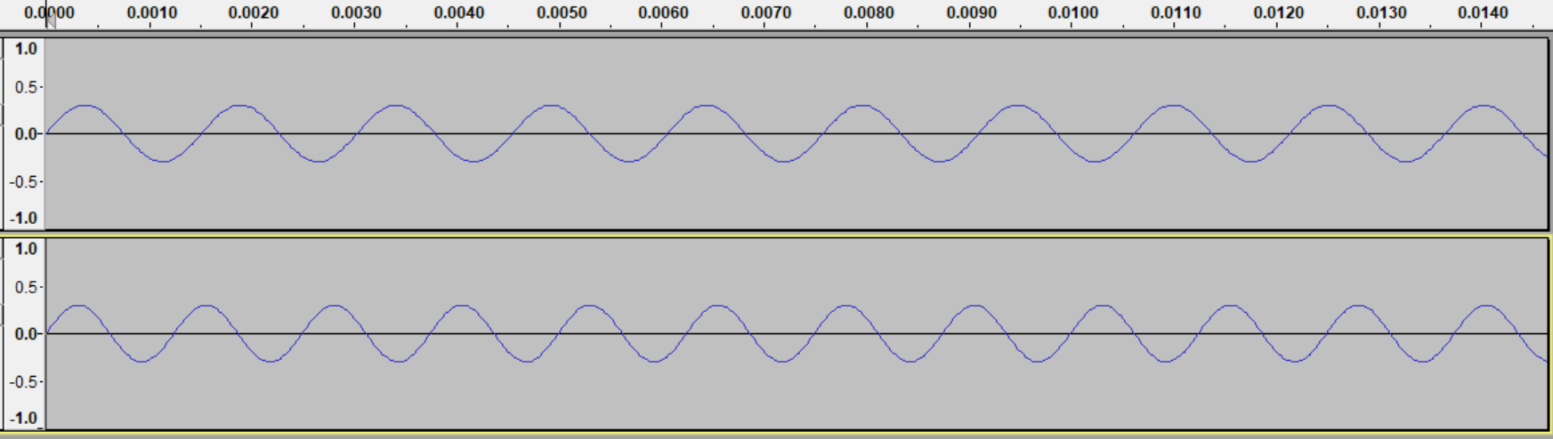
2. Suppose we have two sounds as shown. Which one will be louder?   
   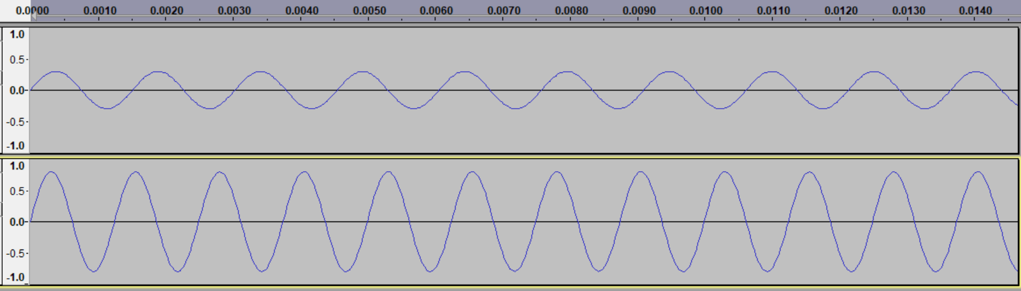
3. Describe how the following wave would sound like:



1. Describe how the following wave would sound like:  
   
2. Use the table of frequencies to mthematically create a wave representing a C–E–G chord. How can you transpose the chord into a A-C#-E chord?
3. We have seen how to merge multiple tracks into a new track by adding the wave functions. Do you think it is possible to decompose a complicated wave into its Fourier components? For example, say I give you the wave form for a 3 note-chord, could you determine which three notes the sound consists of? How would you do it?

**Exercises:**

1. Use Euler’s theorem to show that $\cos\left(t\right)=\frac{1}{2}\left(e^{it}+e^{-it}\right)$ and $\sin\left(t\right)=\frac{1}{2i}\left(e^{it}-e^{-it}\right)$
2. Find the Fourier Transform of
   1. $f\left(t\right)=\left\{\begin{aligned} 1, & -1≤t≤1 \\ 0, & \text{otherwise}\end{aligned}\right.$ b. $f\left(t\right)=\left\{\begin{aligned} |t|, & -1≤t≤1 \\ 0, & \text{otherwise}\end{aligned}\right.$ c) $f\left(t\right)=\left\{\begin{aligned} e^{-t}, & t≥0 \\ 0, & \text{otherwise}\end{aligned}\right.$
3. What does it mean to analyze the spectrum of a wave or sound?
4. What’s the difference in the spectrum of a short clapping sound versus a sound of a violin playing a slow melody?

**Exercises:**

1. How many sample points do I need to provide as input to the FFT to recover the function $f\left(x\right)=\cos\left(x\right)+2\sin\left(3x\right)-4\cos\left(4x\right)+6\sin\left(6x\right)-3sin(7x)$. What happens if you take fewer samples? More samples?
2. Use the Mathematica Fourier procedure (which computes the FFT of a list) to compute the approximate Fourier series for the step function $f\left(x\right)=\left\{\begin{aligned} -2, 0≤&x<0.8 \\ -1, 0.8≤x<1.6 \\ 1, 1.6≤x<2.4 \\ 2, 2.4≤x<3.2\end{aligned}\right.$ Note that when you define the function **f[x_] = Piecewise[{{1,0<=x<2},{2,2<=x<4},{3,4<=x<6.28}}];** you need to also use the command **SetAttributes[f,Listable]** to make sure that the function $f$ can be applied over a list.

**Exercises:**

1. Prove that $1+2+4+8+…+2^{n-1}=2^{n}-1$
2. What is the largest integer (positive or negative) you can store using 4 bytes?
3. Suppose a programming language used 2 bytes to store any integer. What would be the problem with adding the integers x and y and storing it in another integer variable z, if x = 32,767and y = 32,766. What do you think the answer stored in the integer z would be? How could you fix this problem?
4. What does the last digit of a binary number indicate? How can you tell whether a binary number equals a power of two? How do you multiply a binary number by 2? How about dividing by 2?
5. Convert 1397 to a binary number, and 101011001100111000111 to a decimal number
6. What does the following sentence say (it uses the standard ASCII table and 1 byte integers): 0110001101100001011100100111000001110000011001010010000001100100011010010110010101101101
7. What does the following picture show (file name: mystery.bgw): 0000011000000101000000101000000011101000100000
8. We figured out that 1 hour of full uncompressed HD movies requires about 540 GB of space. How much space does a standard DVD resolution of 720 x 480 pixels require? How about a 4K movie, which runs at a resolution of 3840 x 2160? If you had a compression ratio of 1 to 10, how fast would your Internet connection have to be to stream movies in full 4K resolution?
9. Suppose you to save a song in MP3 format. Describe the steps.
10. An MP3 format applies some compression schemes. Suppose we computed the spectrum of a song from $t=0$ to $t=2π$ as $a_{4}=12$.5, $a_{20}=2.7$, $b_{1}=20.3,$ $b_{2}=0.1$, $b_{3}=-15$, and $b_{4}=-1.1$. Use Mathematica to reconstruct the complete song. To save the song as MP3, what would you save to (a) save the sound without data compression, and (b) with compression. Confirm that both songs look pretty close to each other. What is the compression ratio?