Complex Analysis
Visualization
- Consider $z=2+i$ and $w=-1+2i$. Draw the vectors $z, w, z+w,$and $z-w$
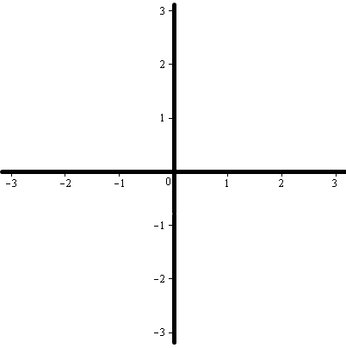

- Consider $z=1+i$ and $w=-1+i$. Draw the vectors $z, w, z∙w,\frac{z}{w},\frac{1}{z}$, and $\overline{z}$
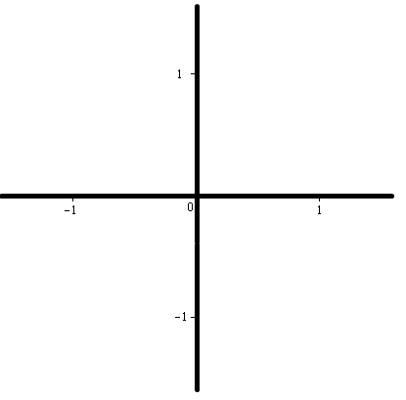
- Draw the following vectors: $z_{1}=e^{\frac{i π}{2}}$, $z_{2}={0.5e}^{iπ}$, $z_{3}={\sqrt{2}e}^{\frac{-i π}{4}}$, and $z_{4}=e^{\frac{i5 π}{4}}$
- Describe in simple geometric terms what happens to a vector $z$ when:
  - it is multiplied by $2$

  - it is multiplied by $-1$

  - it is multiplied by $i$

  - it is squared

- Consider the vector shown and draw the new vector(s) as indicated (the gray circle represents the unit circle)
Find all four 4th roots (approx.) Find $z^{4}$

Find all third roots of unity Find one sixth root

