Installing Additional LaTeX Packages
After installing the basic LaTeX package you can install additional package to extend the functionality of your LaTeX package. First we outline the general steps to install a new package, then we recommend a few packages with sample LaTeX code for you to install.

To install a new package
Start the MikTeX package manager by clicking on

Start | All Programs | MikTeX | MikTeX Package Manager

It will take a few moments to load all available packages. If you are asked to configure a "Package Repository", select "Internet" and choose a package repository in the US (the last one in the list usually works well).

You can enter a package name into the the Name field of the Package manager and click on "Filter". To search for the "exam" package, for example, enter "exam" and click on "Filter":

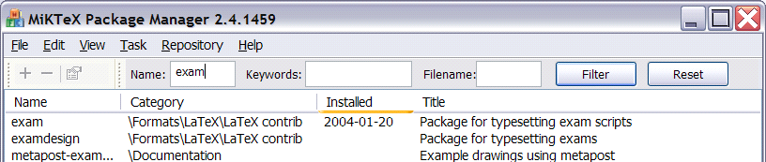

Click on the package you are interested in. If the package is already installed, the "minus sign" will be active. If the package is not yet installed, the "plus sign" will be active. Click on the "plus sign" to install the selected package and follow the instructions.

Refresh the Package Database
After you are done it is best to refresh the database of installed packages. To do that, click on:
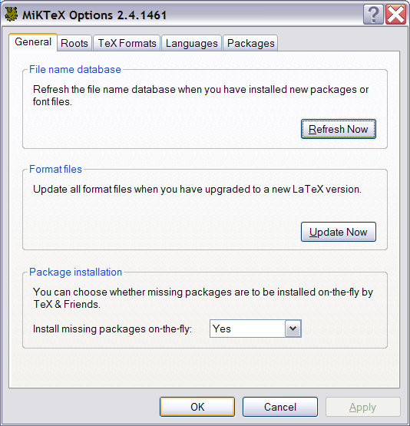
Start | All Programs | MikTeX | MikTeX Options

- Under "File name database", click the "Refresh Now" button.
- Under "Format files", click the "Update Now" button.
- Where it says "Package installation" make sure the drop-down menu to "Install missing packages on the fly" is set to "Yes".
- Click OK to close the options program.

If you have problems installing new packages, try the following:

- Restart your computer
- Open the "MikTeX Options" and refresh the file name database and the Format files, as described above.
- Click on "OK" to close the MikTeX Options program
- Then open the "MikTeX Package Manager" and install the desired packages, as described above. Close the package manager when done
- Open the "MiTeX Options" program again and refresh the name database and the format files again, as described above
- Restart your computer again

Recommended Package "exam"
The "exam" package lets you create exams and quizzes easily, complete with automatically adding the number of points, correct numbering of questions, and so on.

Start the package manager, search for "exam" and install the "exam" package as described above

To use the package, here is some sample LaTeX code (including a few comments) using the "exam" package.

\documentclass{exam}

% First we setup the header and footer
\pagestyle{headandfoot}
\header{MATH XXXX}{First Exam/Quiz}{Jan 20, 2004}
\footer{}{\thepage \, of \numpages}{}

% We want the points for each question displayed on the left
\pointsinmargin

% Automatically total the points - make sure to compile TWICE
\addpoints

\begin{document}

% Space for student to put their name
\hspace{3in}Name: \enspace \hrulefill
\vspace{0.3in}

% Some general text together with number of questions and total points possible
There are \numquestions\, questions for a total of \numpoints\, points.

\begin{questions}

% First question, worth 3 points
\question[3]
Why is the sky blue?

% Putting a vfill after each question will evenly space them accross
% a page. If you want set amounts of space, use e.g. \vspace{0.5in} instead
\vfill

% Another question without a point value
\question
Why is the water
% This question has sub-parts (2 points each)
\begin{parts}
\part[2]
sometimes green

\vspace{0.5in}

\part[2]
sometimes blue
\end{parts}

\vfill
% Now starting a new page
\newpage

% Another question, worth 5 points
\question[5]
Why is this question on a new page by itself?

\vfill

% We are done
\end{questions}
\end{document}

Recommended Package "prosper"
The "prosper" package lets you create very nice looking slides in a style similar to PowerPoint. You could use, for example, the Adobe Acrobat Reader to present a slide show written in LaTeX with this package.

Start the package manager, search for "exam" and install the "exam" package as described above

Here is some sample code that will produce nice looking slide.

Note: You must switch to the "LaTeX => PS => PDF" mode to compile and view this, and you must have the Adobe Acrobat Reader installed correctly.

\documentclass[pdf,azure,slideColor,colorBG]{prosper}

\begin{document}

\begin{slide}{Elementary mathematics}

Observations:

\begin{displaymath}
\int_{-\infty}^\infty e^{-x^2} \, dx = \sqrt{\pi}
\end{displaymath}
where
\begin{displaymath}
e^{i\pi} = -1
\end{displaymath}

which implies the following

\begin{itemize}
\item It looks difficult
\item I wonder how to get that
\item Math is not easy it seems
\end{itemize}

\end{slide}

\begin{slide}{Another slide with a Matrix}

Please note the following matrix:

\begin{displaymath}
A =
\left(
\begin{array}{cccc}
a_{11} & a_{12} & \dots & a_{1n} \\
a_{21} & a_{22} & \dots & a_{2n} \\
\vdots & & \ddots & \vdots \\
a_{n1} & a_{n2} & \dots & a_{nn} \\
\end{array}
\right)
\end{displaymath}

\end{slide}

\end{document}

