Math 3626: Assignment 1

- Use Mathematica to solve the following system of equations: List the inverse of the coefficient matrix.

x + 2y + 3z + 4w = 10
x – z = 5
y +3w = 12
y + z + w = 20

- Solve the following system of equation. If there is no unique solution, state if the system has no solution or infinitely many solution. If you used Mathematica to find your answer, explain what you did.

x + y = 1
x + z = -1
y + w = 1
2x + y + z = 2

- In class we computed the rotational matrix Rx(x) to rotate around the x-axis by x degrees, Ry(y) to rotate around the y axis by y degrees, and Rz(z) around the z-axis by z degrees. We came up with R(x,y,z) = Rx(x) Ry(y) Rz(z) to be
List the vector you get if you rotate the vector <1, 1, 1> by a) Pi/4 around x, Pi/2 around y, and Pi/3 around the z-axis. How about if you rotate <1, -2, 3> by degrees Pi, Pi, Pi around the x, y, and z-axes.

- Show that the determinant of the rotational matrix R shown above is 1. Note that it is not enough to use Mathematica to compute the determinant, you should do this without Mathematica’s help.

- The matrices Rx, Ry, and Rz were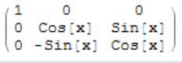, 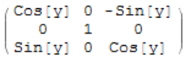, and 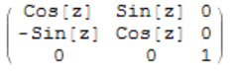, respectively. Read the paper posted on “Rotational Matrix” and explain why the matrix Ry is different from the pattern shown by Rx an Rz.

