Special Sequences and Series
Power Sequence: The convergence properties of the power sequence depends on the size of the base a:
- |a| < 1: the sequence converges to 0.
- a = 1: the sequence converges to 1 (being constant)
- a > 1: the series diverges to plus infinity
- a -1: the series diverges
Exponent Sequence: The convergence depends on the size of the exponent a:
- a > 0: the sequence diverges to positive infinity
- a = 0: the sequence is constant
- a < 0: the sequence converges to 0
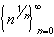 Root of n Sequence: This sequence converges to 1
Proof: If n > 1, then > 1. Therefore, we can find numbers a_{n} > 0 such that = 1 + a_{n} for each n > 1 Hence, we can raise both sides to the n-th power and use the Binomial theorem:
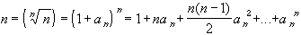
In particular, since all terms are positive, we obtain
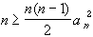
Solving this for a_{n} we obtain
0 a_{n} 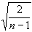
But that implies that a_{n} converges to zero as n approaches to infinity, which means, by the definition of a_{n} that converges to 1 as n goes to infinity.
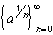 n-th Root Sequence: This sequence converges to 1 for any a > 0.
Proof: If a > 1, then for n large enough we have 1 < a < n. Taking roots on both sides we obtain
1 < <
Then use the Squeezing theorem.
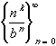 Binomial Sequence: If b > 1 then the sequence converges to zero for any positive integer k.

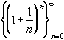 Euler's Sequence: Converges to e ~ 2.718281828459045235360287471...(Euler's number). This sequence serves to define e.
Series

So far we have learned about sequences of numbers. Now we will investigate what may happen when we add all terms of a sequence together to form what will be called an infinite series.

Example 4.1.1: Zeno's Paradox (Achilles and the Tortoise)
Achilles, a fast runner, was asked to race against a tortoise. Achilles can run 10 meters per second, the tortoise only 5 meter per second. The track is 100 meters long. Achilles, being a fair sportsman, gives the tortoise 10 meter advantage. Who will win ?
- Both start running, with the tortoise being 10 meters ahead.
- After one second, Achilles has reached the spot where the tortoise started. The tortoise, in turn, has run 5 meters.
- Achilles runs again and reaches the spot the tortoise has just been. The tortoise, in turn, has run 2.5 meters.
- Achilles runs again to the spot where the tortoise has just been. The tortoise, in turn, has run another 1.25 meters ahead.
This continues for a while, but whenever Achilles manages to reach the spot where the tortoise has just been a split-second ago, the tortoise has again covered a little bit of distance, and is still ahead of Achilles. Hence, as hard as he tries, Achilles only manages to cut the remaining distance in half each time, implying, of course, that Achilles can actually never reach the tortoise. So, the tortoise wins the race, which does not make Achilles very happy at all.
That turned out to be a bad idea of the tortoise, since Achilles, who was also a fierce warrier, killed the turtle on the spot, threw it in a pot of boiling water, and thus invented “turtle soup” – just kidding!
The problem with Zeno's paradox is that Zeno was uncomfortable with adding infinitely many numbers. In fact, his basic argument was: if you add infinitely many numbers, then - no matter what those numbers are - you must get infinity. If that was true, it would take Achilles infinitely long to reach the tortoise, and he would lose the race.

Definition 4.1.2: Series, Partial Sums, and Convergence
Let {a _{n}} be an infinite sequence.
- The formal expression 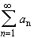 is called an (infinite) series.
- For N = 1, 2, 3, ... the expression S _{N} = 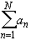 is called the N-th partial sum of the series.
- If lim S _{N} exists and is finite, the series is said to converge.
- If lim S _{N} does not exist or is infinite, the series is said to diverge.

The following three series are the most famous ones: the geometric series, the harmonic series, and the alternating harmonic series. Together they illustrate the various outcomes of dealing with infinite series very nicely.

The infinite series 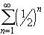 = 1/2 + 1/4 + 1/8 + 1/16 + ... converges to 1 (special case of the geometric series).
The n-th partial sum for this series is defined as

S _{n} = 1/2 + 1/2 ² + 1/2 ³ + ... + 1/2 ^{n}

We need to find a closed form for this expression to be able to take the limit of the sequence of partial sums.
If we divide the above expression by 2 and then subtract it from the original one we get:
S _{n} - 1/2 S _{n} = 1/2 - 1/2 ^{n+1}
Hence, solving this for S _{n} we obtain

S _{n} = 2 (1/2 - 1/2 ^{n+1})
This is now a sequence, and we can take the limit as n goes to infinity. By our result on the power sequence, the term 1/2 ^{n+1} goes to zero, so that, as we needed to show:

lim S _{n} = 1

The series 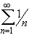 = 1 + 1/2 + 1/3 + 1/4 + 1/5 + ... is called harmonic series. It diverges to infinity.
We need to estimate the n-th term in the sequence of partial sums. The n-th partial sum for this series is:
S _{N} = 1 + 1/2 + 1/3 + 1/4 + ... + 1/n
Now consider the following subsequence extracted from the sequence of partial sums:
S ₁ = 1
S ₂ = 1 + 1/2
S ₄ = 1 + 1/2 + (1/3 + 1/4)
1 + 1/2 + (1/4 + 1/4) = 1 + 1/2 + 1/2 = 1 + 2/2
S ₈ = 1 + 1/2 + (1/3 + 1/4) + (1/5 + 1/6 + 1/7 + 1/8)
1 + 1/2 + (1/4 + 1/4) + (1/8 + 1/8 + 1/8 + 1/8) = 1 + 1/2 + 1/2 + 1/2 = 1 + 3/2
In general, one can use induction (do it as an exercise) to show that
S ₂ ^{k} 1 + k / 2
for all k. Hence, the subsequence { S ₂ ^{k} } extracted from the sequence of partial sums { S _{N} } is unbounded. But then the sequence { S _{N} } cannot converge either and must diverge to infinity.

For an interesting application of the harmonic series, check out the “story about the Leaning Tower of Lire” (http://www.mathcs.org/analysis/reals/numser/answers/lire_tower.html) .

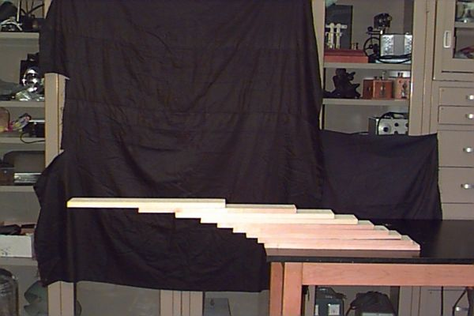

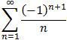 The Alternating Harmonic series converges but not absolutely, i.e. it converges conditionally.

Proof: There are many proofs of this fact. For example. the series of absolute values is a p-series with p = 1, and diverges by the p-series test. The original series converges, because it is an alternating series, and the alternating series test applies easily. However, here is a more elementary proof of the convergence of the alternating harmonic series.
We already know that the series of absolute values does not converge by a previous example. Hence, the series does not converge absolutely. As for regular convergence, consider the following two partial sums:
and
We have that
S _{2n+2} - S _{2n} = 1 / (2n+1) - 1 / (2n+2) > 0
and
S _{2n+3} - S _{2n+1} = - 1 / (2n+2) + 1/ (2n+3) < 0
which means for the two subsequences
{ S _{2n} } is monotone increasing and { S _{2n+1} } is monotone decreasing
For each sequence we can combine pairs to see that
S _{2n} 1 and S _{2n+1} 0
for all n. Hence, both subsequences are monotone and bounded and must therefore be convergent. Define their limits as
lim S _{2n} = L and lim S _{2n+1} = M
Then
| M - L | = | lim (S _{2n+1} - S _{2n}) | = 1 / (2n+1)
which converges to zero. Therefore, M = L, i.e. both subsequences converge to the same limit. But this common limit is the same as the limit of the full sequence, because: given any > 0 we have
- there exists an integer N such that | L - S _{2n} | < if n > N
- there exists an integer M such that | L - S _{2n+1} | < if n > M
Now set K = max(N, M). Then, for the above > 0 we have

| L - S _{n} | <
for n > K because n is either even or odd. Hence, the alternating harmonic series converges conditionally.

