### Math 2511: Calc III - Practice Exam 3

1. State the meaning or definitions of the following terms:
2. vector field, conservative vector field, potential function of a vector field, volume, length of a curve, work, surface area
3. curl and divergence of a vector field F, gradient of a function
4.  or  or $\iiint_{Q}{f\left(x,y,z\right)dV}$
5.  or  or or 
6. 
7. $\iint_{S}{dS}$ or
8. 
9. What does it mean when a “line integral is independent of the path”?
10. State the Fundamental Theorem of Line Integrals. Make sure to know when it applies, and when it helps.
11. State Green’s Theorem. Make sure to know when it applies, and in what situation it helps.
12. Below are four algebraic vector fields and four sketches of vector fields. Match them.

[A]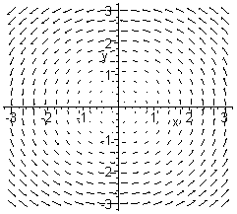[B]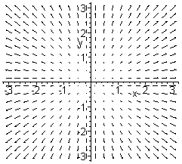[C]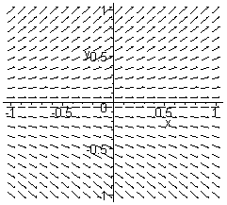[D]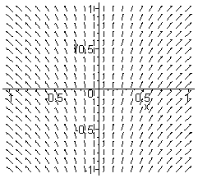

(1)  (2)  (3)  (4) 

b) Below are two vector fields. Which one is clearly not conservative, and why?

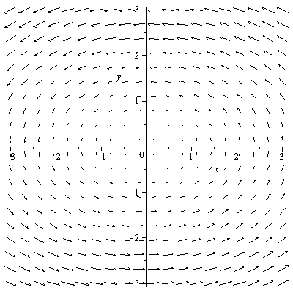 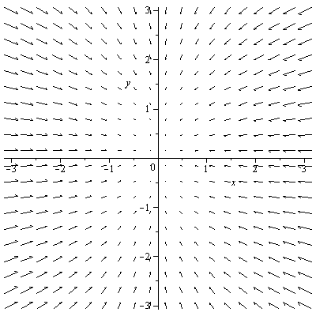

c) Say in the left vector field above you integrate over a straight line from (0,-1) to (1,0). Is the integral positive, negative, or zero? How about if you integrate from (-2,1) to (2,1)? How about from (-2,-1) to (2,-1)?

1. Are the following statements true or false:
2. If the divergence of a vector is zero, the vector field is conservative.
3. If  is a conservative vector field then 
4. If a line integral is independent of the path, then  for every path C
5. If a vector field is conservative then  for every *closed* path C
6.  denotes the surface area of the region R
7.  denotes the volume of the region under the surface *f(x,y)* and over R, if *f* is positive.
8. Can you apply the Fundamental Theorem of line integrals to the function ?
9. Can you apply the Fundamental Theorem of line integrals to the vector field ?
10. Can you apply Green’s theorem for a curve C, which is a straight line from (0,0) to (1,2)?
11. Can you apply Green’s theorem for a closed curve C given by $r\left(t\right)=<x\left(t\right),y\left(t\right),z\left(t\right)>$
12. Suppose that  is some vector field.
13. Find *div(F)*
14. Find *curl(F)*
15. Find *curl(curl(F))*
16. Find *div(curl(F))*
17. *grad*., *div*., and *curl* of the vector field if appropriate for 
18. *grad*., *div*., and *curl* of the vector field if appropriate for 
19. *grad*., *div*., and *curl* of the vector field if appropriate for 
20. Decide which of the following vector fields are conservative. If a vector is conservative, find its potential function
21. 
22. 
23. 
24. 
25. 
26. 
27. 
28. 
29. Evaluate the following integrals:
30.  where R is the triangular region bounded by y = 0, y = x, and x = 1
31. 
32. , where C is the curve given by ,  (you might want to use Maple at some point)
33. , where C is the curve given by , 
34.  where C is the half circle , 
35.  where C is a line segment given by , 
36.  where  and C is the curve given by , 
37.  where  and C is the curve given by , 
38.  where C is a parabolic arc given by , 
39. Find the surface integral ****, where S is the surface  such that x is between 0 and 2 and y is between 0 and 4.
40.  where S is the first-octant portion of the cylinder  between x = 0 and x = 4
41. What is the surface area of the plane $6x+4y+2z=8$, where $0≤x≤2$ and $0≤y≤1$
42. For some of the following line integrals there may be short-cut you can use to simplify your computations (but justify your shortcut by quoting the appropriate theorem)
43.  where  and C is the curve , 
44.  where C is some smooth curve from (0,0,0) to (1,4,3)
45.  where  and C is the upper half of the unit circle, from (1,0) to (-1,0)
46.  where  and C is the line segment from (-1,0) to (2,3).
47.  where C is the path from (0,0) to (1,1) along the graph of  and from (1,1) back to (0,0) along the graph of .

# Green’s Theorem

1. Use Green’s theorem to find  where  and C is the circle with radius 3, oriented counter-clockwise (You may need the double-angle formula for cos somewhere during your computations, or use Mathematica)

# Evaluate the following integrals. You can use any theorem that’s appropriate:

1.  where C is a smooth curve from (0,0,0) to (1,4,3)
2.  where C is the boundary of the square with vertices (0,0), (0,2), (2,0), and (2,2)
3. , where C is given by , t between 0 and 2 Pi.
4.  where C is the boundary of the region between the graphs of  and .
5. Prove that if  is any vector field where  are twice continuously differentiable then 

Suppose a region R is enclosed by a simple, closed curve C. Use Green’s theorem to show that $area\left(R\right)=\int_{C}{\frac{x}{2}dy-\frac{y}{2}dx}$. Use this result to find the area of the ellipse $\frac{x^{2}}{a^{2}}+\frac{y^{2}}{b^{2}}≤1$. *Hint: the boundary of that ellipse is given by $r\left(t\right)=<a\cos\left(t\right), b\sin\left(t\right)>$, where $0≤t≤2π$*