Math 2511 – Calc III Practice Exam 2

*This is a practice exam. The actual exam consists of questions of the type found in this practice exam, but will be shorter. If you have questions do not hesitate to send me email. Answers will be posted if possible – no guarantee.*

1. **Definitions**: Please state in your own words the following **definitions**:

1. Limit of a function 
2. Continuity of a function 
3. partial derivative of a function f(x,y)
4. gradient and its properties
5. directional derivative of a function f(x, y) in the direction of a unit vector u
6. The (definition and geometric meaning of) the double integral of *f* over the region *R* 

2. **Theorems:** Describe, in your own words, the following:

1. a result that classifies critical points into relative max., min., or saddle points
2. the procedure to find *relative* extrema of a function f(x, y)
3. the procedure to find *absolute* extrema of a function f(x, y)
4. a theorem that allows you to evaluate a double integral easily
5. how to “change of variables” from rectangular to polar coordinates

3. **True/False** questions:

1. If  then   
   true
2. If then   
   false
3. $\lim_{h→0}{\frac{f\left(x+ah,y+bh\right)-f(x,y)}{h}}=\frac{∂}{∂x}f(x,y)$ false (but true if b = 0)
4. If *f* is continuous at *(0,0)*, and *f(0,0) = 10*, then   
   true
5. If *f(x, y)* is a function such that all second order partials exist and are continuous then fxx = fyyfalse
6. The volume under *f(x,y)*, where and  is   
   false (but true if f(x,y) was never negative, or if we called it the “net” volume)
7. If *f(x,y)* is continuous then   
   true (Fubini’s theorem)
8. If *f(x,y)* is continuous then   
   surprisingly, this is true
9. If *f* is continuous over a region *D* then $\iint_{D}{f\left(x,y\right)dxdy=\iint_{D}{f(r,θ)θdθdr}}$  
   false (but r dr d theta was right)

5. **Limits and Continuity**: Determine the following limits as *(x,y) -> (0,0)*, if they exist.

is 1/1 = 1 by simple substitution

 is 1/0, which is undefined

 finally, 0/0, so more work required. If x -> 0, limit was zero but if x = y, then limit is ½. So, limit does not exist

 no matter what region we are trying, the limit will be zero, which proves nothing! But it is a hint that maybe this limit exists (and would have to be zero, then). So we need to prove it:

Take any $ϵ>0$. We are to find a number $δ>0$ such as whenever $\left|\left|\left(x,y\right)-\left(0,0\right)\right|\right|=\sqrt{x^{2}+y^{2}}<δ$ implies that $\left|f\left(x,y\right)– 0\right|<ϵ$. But we know, as a side calculation, that $x^{2}<x^{2}+y^{2}$ so that $\frac{x^{2}}{x^{2}+y^{2}}<1$, which in turn implies that $\left|y\right|>\frac{x^{2}|y|}{x^{2}+y^{2}}$ With this little scrap computation we can now start the actual proof: take any $ϵ>0$, I pick $δ<0$. Then:

if $\left|\left|\left(x,y\right)-\left(0,0\right)\right|\right|<δ$, then

$$\left|f\left(x,y\right)-0\right|=\left|\frac{x^{2}y}{x^{2}+y^{2}}\right|<\left|y\right|<\sqrt{x^{2}+y^{2}}=\left|\left|x,y\right|\right|<δ=ϵ$$

But that is exactly what we needed to prove, so we are done and have proved that the limit is zero.



If we let x = 0, y -> 0, the limit would be -1. If on the other hand y = 0 and x -> 0,the limit was 1. Thus two limits are different so that the original limit does not exist.

6. **Picture**: Match the following contour plots (level plots) to their corresponding surfaces.

[1]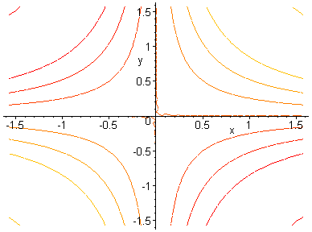[2]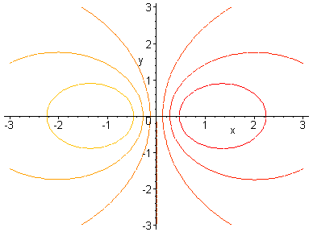[3]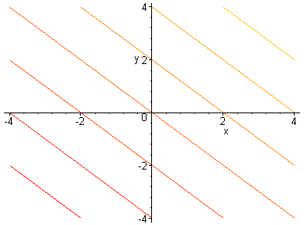[4]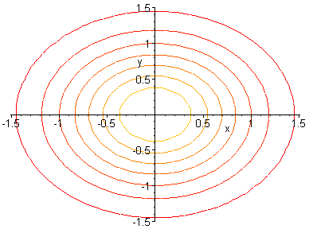



[A]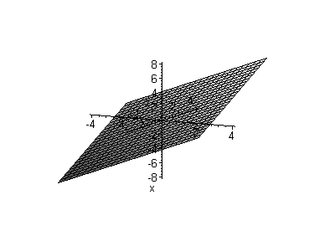[B]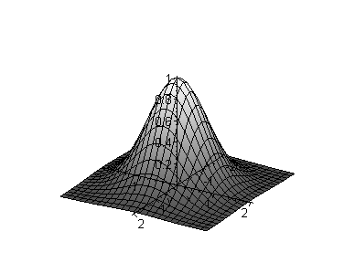[C]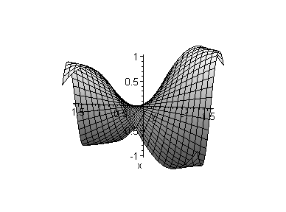[D]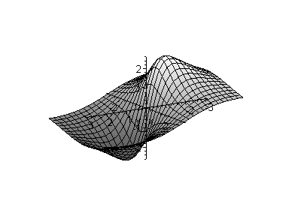



Other picture problems:

* Given a contour plot, draw the gradient vector at specific points

7. **Differentiation**: Find the indicated derivatives for the given function:

1. Suppose , find

fx

fy

fxx =

fxy =

fyy

fyx

1. Consider the function $f\left(x,y\right)=3x^{2}y-4xy^{2}+{\left(2x+3y\right)}^{2}$. Find

$f_{x}$ = $6xy-4y^{2}+4(2x+3y)$

$\frac{∂^{2}f}{∂y^{2}}$ = $18-8x$

$∇f$ = $\{6xy-4y^{2}+4(2x+3y),3x^{2}-8xy+6(2x+3y)\}$

1. Let $g\left(x,y,z\right)=xy\tan\left(x^{2}y^{3}z^{4}\right)$. Compute $∇g$ = $\{y(2x^{2}y^{3}z^{4}{Sec[x^{2}y^{3}z^{4}]}^{2}+Tan[x^{2}y^{3}z^{4}]),x(3x^{2}y^{3}z^{4}{Sec[x^{2}y^{3}z^{4}]}^{2}+Tan[x^{2}y^{3}z^{4}]),4x^{3}y^{4}z^{3}{Sec[x^{2}y^{3}z^{4}]}^{2}\}$
2. Consider $h\left(x,y,z,w\right)=2xy-3yz+4zw-5xw$. Compute $h_{xyzw}$ 
   = 0
3. Let $f\left(x,y\right)=\frac{xy sin\left(xy\right)}{cos⁡(xy)}$. Find $f_{x}$ 
    = $xy^{2}{Sec[xy]}^{2}+yTan[xy]$ and $f_{y}$  
    = $x^{2}y{Sec[xy]}^{2}+xTan[xy]$
4. Consider $f\left(x,y\right)=\frac{x}{y}$. Find $f_{xx}$  
    = 0 $f_{yy}$ 
    = $\frac{2x}{y^{3}}$ $f_{xy}$ 
    = $-\frac{1}{y^{2}}$ $f_{yx}$ 
    = $-\frac{1}{y^{2}}$  
   Indeed: $f_{xy}=f_{yx}$
5. Let . Find   
   fxyy = fyxy = fyyx =
6. If $f\left(x,y\right)=2x^{2}y^{3}-xcos(xy^{2})$, find the **equation of the tangent plane** at $\left(1,\sqrt{π}\right):$

fx = $4xy^{3}-Cos\left[xy^{2}\right]+xy^{2}Sin\left[xy^{2}\right]$ so that at P $(1,\sqrt{π})$: f_x = $1+4π^{3/2}$  
fy = $6x^{2}y^{2}+2x^{2}ySin\left[xy^{2}\right]$ so that = at P $(1,\sqrt{π})\}$: f_y = $6π$

Thus, tangent plane is: y = (x – 1) + (y - ) +

8. **Directional Derivatives**:

1. Find the directional derivative of *f(x, y) = xy exy* at (-2, 0) in the direction of a vector u, where the street makes an angle of Pi/4 with the x-axis.

Grad(f) = < $ⅇ^{xy}y+ⅇ^{xy}xy^{2},ⅇ^{xy}x+ⅇ^{xy}x^{2}y>$, so that Grad(f) at (-2,0) is <0, -2>. Thus, directional derivative of f at (-2,0) is <0,-2> . <Cos(Pi/4), sin(Pi/4)> = -2/sqrt(2) = - sqrt(2)

1. Find $D_{u}(f)$ where $f\left(x,y\right)=\frac{x}{y}-\frac{y}{x}$ and $\vec{u}=<-\frac{4}{5},\frac{3}{5}>$  
   Grad(f) . u = $\frac{3}{5}(-\frac{1}{x}-\frac{x}{y^{2}})-\frac{4}{5}(\frac{1}{y}+\frac{y}{x^{2}})$
2. Suppose . Find the maximum value of the directional derivative at (-2, 0) and compute a unit vector in that direction.  
   Max value of dir derivative is ||Grad(f)|| at (-2,0), so ||<-4,4>|| = sqrt(32), in the direction of 1/sqrt(32) <-4,4>

10. **Max/Min Problems:** Compute the extrema as indicated

* 1. . Find *relative* extreme and saddle point(s), if any.  
     Critical points: (2,6), which is a minimum
  2. . Find *relative* extrema and saddle point(s), if any

Critical points: (-1, -1), which is a local max, (0,0), which is a saddle, and (1,1), which is another local max

* 1. Let . Find **absolute** maximum and minimum inside the triangular region spanned by the points (0,0), (3, 0), and (0, 5).  
     Work out later

1. Let . Find the **absolute** extrema over [0, 1] x [0, 2]  
   Work out later

11. Evaluate the following integrals:

1. = 2/3 and $\int_{1}^{2}{\int_{ln⁡(2)}^{ln⁡(3)}{xe^{y} dy dx}}$ = 3/2
2. = 2 and $\int_{e}^{e^{2}}{\int_{0}^{1}{ \frac{x}{y} dx dy}}$ = 1/2
3. = -92/15
4. = 9 Pi (switch to polar coordinates)
5. $\int_{0}^{1}{\int_{0}^{1}{x\sin\left(xy\right) dx dy}}$ and $\int_{0}^{1}{\int_{0}^{1}{x\sin\left(xy\right) dy dx}}$. Which way, if any, is easier?  
   Second integral is way easier, no integration by parts. Either way, answer is 1 – sin(1)
6. $\int_{0}^{1}{\int_{x}^{1}{cos⁡(y^{2})}}dydx=\int_{0}^{1}{\int_{0}^{y}{cos⁡(y^{2})}}dxdy=\frac{\sin\left(1\right)}{2}$ Note that I had to change the y-bounds in the first integral to go from x to 1, not from y to 1, which would not make sense since the integration is for y already.
7. , where R is the part of the circle in the 1st quadrant.

Need to give this circle a radius, say R. Then switch to polar gives integrate r^2 as r goes from 0 to R and the angle goes from 0 to Pi/2. Answer is Pi/2 * 1/3 R^3

1. $\iiint_{R}{xy^{2}z^{3}}dV$ where $R=\{\left(x,y,z\right): -1≤x≤1, 0≤y≤2, 1≤z≤3\}$  
   Straight forward – answer is 0

12. The pictures below show two different ways that a region R in the plane can be covered. Which picture corresponds to the integral   
dx dy means for a y fixed between two numbers, x goes horizontally. Thus, this integral corresponds to the second picture. The first picture would correspond to a dy dx integration order

c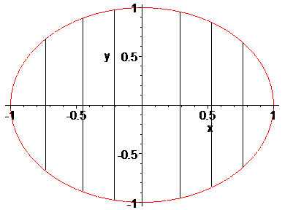 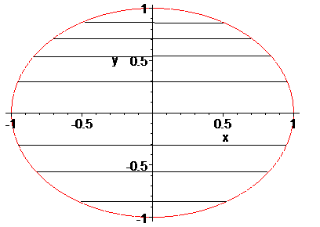

13. Suppose you want to evaluate  where R is the region in the xy plane in the first quadrant bounded by , , and . According to Fubini’s theorem you could use either the iterated integral  or  to evaluate the double integral. Which version do you prefer? Explain. You do not need to actually work out the integrals.



Integrating in dx dy order would require two integrals, whereas dy dx only requires one

Integral. Thus, we prefer dy dx for this problem.



14. Use a multiple integral and a convenient coordinate system to find the volume of the solid:



1. bounded by , , ,, and 



$\int_{0}^{4}{\int_{0}^{x^{2}+4}{x^{2}-y+4}}dy dx$ = $\frac{3296}{15}$



1. bounded by  and the planes , , and 



$\int_{0}^{1}{\int_{0}^{x}{e^{-x^{2}}}}dy dx$ = $\frac{e-1}{2ⅇ}$



1. bounded above by  and bounded below by the circle 



In the xy plane the domain D is a disk, centered at (0,0) with radius 2. To cover that with polar coordinates, the angle goes from 0 to 2 Pi while the radius, for each fixed angle, would run from 0 to 2. The integrant, when converted to polar coordinates x = r cos(t) and y = r sin(t), is $\sqrt{16-r^{2}(\cos^{2}\left(x\right)+\sin^{2}\left(x\right)}=\sqrt{16-r^{2}}$. Thus, the desired volume is:



$$\int_{0}^{2π}{\int_{0}^{2}{\sqrt{16{-r}^{2}}}}r dr dθ=2(\frac{64}{3}-8\sqrt{3})π$$

where we of course used Mathematica to evaluate the integral.

1. evaluate  where R is a triangle bounded by , , 



As usual, one order of integration works better than the other. In this  
case if we used dx dy, we’d have to do two integrals, whereas only/  
one for dy dx. Thus, we pick that order:



$\int_{0}^{1}{\int_{x}^{2x}{\frac{y}{x^{2}+y^{2}}}}dy dx=\frac{1}{2}ln⁡(\frac{5}{2})$

1. bounded by the paraboloid  and the xy plane
2. $\iiint_{V}{x\left(y-z\right)dV}$, where V is bounded by x = 0, y = 0, z = 0, x + y + z = 2

This is a triple integral, so to determine the integration bounds, we need to draw the domain in xyz space, or 3D. Fortunately we know that x + y + z = 2 is a plane, and they can be drawn easily:



Thus, x is between 0 and 2. For such an x, the y goes from



y = 0 to the line y = 2 – x. If we now fix such a y, the z goes



from 0 to the plane z = 2 – x – y. Thus, our integral goes as



follows:



15. Answer the following applications of integration:

a) If D is a thin lamina bounded by $x=1-y^{2}$ and the coordinate axis in the first quadrant with density function $ρ(x,y)=y$, find the center of its mass (Hint: to speed things up, use Mathematica for the various integrations)

m = $\int_{0}^{1}{\int_{0}^{1-y^{2}}{y}} dx dy=1/4$

Mx = $\int_{0}^{1}{\int_{0}^{1-y^{2}}{y^{2}}} dx dy=2/15$

My = $\int_{0}^{1}{\int_{0}^{1-y^{2}}{x y}} dx dy=1/12$

Thus, center of mass is (m/My, m/Mx) = ((1/4)/(1/12), (1/4)/(2/15)) = (3, 15/8)

b) If D is a thin lamina bounded by $y=\sqrt{4-x^{2}}$ and y = 0 with density function $ρ\left(x,y\right)=\frac{1}{x^{2}+y^{2}+1}$, find the center of its mass.  
  
 m = $\int_{-2}^{2}{\int_{0}^{\sqrt{4-x^{2}}}{\frac{1}{x^{2}+y^{2}+1}}}dy dx= \int_{0}^{π}{\int_{0}^{2}{\frac{1}{r^{2}+1}}}r dr dθ=\frac{π}{2}ln⁡(5)$

Mx = $\int_{-2}^{2}{\int_{0}^{\sqrt{4-x^{2}}}{\frac{y}{x^{2}+y^{2}+1}}}dy dx= \int_{0}^{π}{\int_{0}^{2}{\frac{r\sin\left(θ\right)}{r^{2}+1}}} dr dθ=4-2\arctan\left(2\right)=$

My = m = $\int_{-2}^{2}{\int_{0}^{\sqrt{4-x^{2}}}{\frac{1}{x^{2}+y^{2}+1}}}dy dx= \int_{0}^{π}{\int_{0}^{2}{\frac{r^{2}Cos[θ]}{r^{2}+1}}}r dr dθ=0$

Thus, center of mass is (0, $\frac{\frac{π}{2}\ln\left(5\right)}{4-2\arctan\left(2\right)}$)

c) If a thin lamina has the shape of circle with radius 3 and density function $ρ\left(x,y\right)=2x^{2}+2y^{2}$, find the center of mass. First guess the answer if possible, then verify your guess by computing the answer.

The enter of this object should be (0,0). To verify, compute

Mx= $\int_{0}^{2π}{\int_{0}^{3}{\left(r\sin\left(θ\right)\right)2r^{3}dr dθ=0}}$ and My = $\int_{0}^{2π}{\int_{0}^{3}{\left(r cos⁡(θ)\right)2r^{3}dr dθ=0}}$

d) Find the center of mass of a thin lamina bounded by $x=y^{2}$ and $y=x^{2}$ with density function $ρ\left(x,y\right)=\sqrt{x}$. What about if $ρ\left(x,y\right)=\sqrt{y}$? Also find the moments of inertia and



16. **Prove** the following facts:

1. Use the **definition** to find $f_{x}$ for 
2. Use the **definition** to find $f_{x}$ for 
3. A function *f* is said to satisfy the Laplace equation if . Show that the function satisfies the Laplace equation.
4. Two function u(x, y) and v(x, y) are said to satisfy the Cauchy-Riemann equations if  and . Show that the functions and satisfy the Cauchy-Riemann equations.
5. Prove that the volume of a sphere with radius R is 4/3 * Pi * r3

