**Flux Integral and Gauss Theorem**

Recall our definition of a surface integral: if $z=f(x,y)$ defines a surface $S$ over a domain $R$, then

$$\iint_{S}{g(x,y,z)}dS=\iint_{R}{g\left(x,y,f\left(x,y\right)\right)\sqrt{1+f_{x}^{2}+f_{y}^{2}}}dA$$

We will use this type of integration to define the flux of a vector field through a surface S:

**Definition:** If $z=f(x,y)$ defines a surface S over a domain R with an outward normal vector $\vec{n}$, and $\vec{F}$ is a 3D vector field, then the integral

$$\iint_{S}{\vec{F}∙\vec{n}}dS$$

denotes the **flux of the vector field through the surface $S$**

**Note:** Since $\vec{n}$ and $\vec{F}$ are vectors, the dot product $\vec{n}∙\vec{F}$ is indeed a function, so that this is indeed a regular surface integral.

**Note**: The outward normal to a surface $z = f(x,y)$ is $n=\frac{1}{\sqrt{f_{x}^{2}+f_{y}^{2}+1}}<-f_{x},-f_{y},1>$. This is because the normal vector $\vec{n}$ is the vector nrmal to the tangent plane to the surface $S$, and since the tangent plane to $z = f(x,y)$ is ${z=f}_{x}\left(x-x_{0}\right)+f_{y}\left(y-y_{0}\right)+z_{0}$, the normal vector has the direction of $<-f_{x}, -f_y,1>$. Normalizing it to have length 1 gives the above vector.

**Example:** Below are two 3D vector fields, each with a closed sphere S in the middle. For the first one, imagine the center being a black whole, sucking everything in. For the second, imagine the center as the big bang that explodes and generates the entire universe out of a single point. In both pictures I’ve added a closed surface S in form of a sphere. Decide on the sign of $\iint_{S}{\vec{F}∙\vec{n}}dS$ in each case.

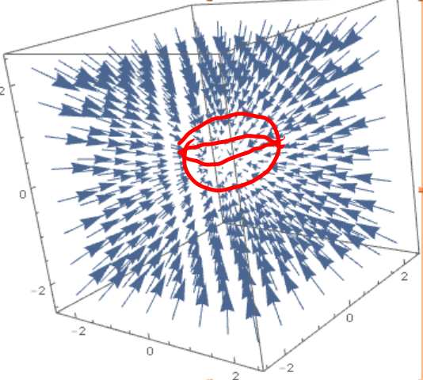 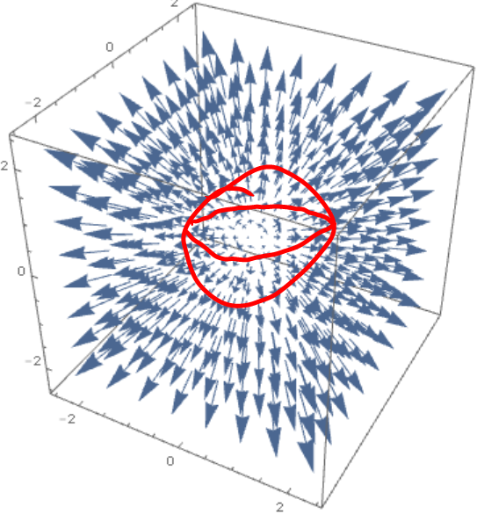

In the left, the flux through the surface is negative, everything is sucked in through the surface S into the black hole, or a *sink*, and destroyed. In the second, the flux is positive, since new material is born out of a *source* and pushed outwards through the surface S.

**Example**: Let $S$ be given by $z=9-x^{2}-y^{2}$, $z≥0$, and $\vec{F}=<3x,3y,z>$. Find the flux of $\vec{F}$ through $S$

Let’s find the outward normal first: since $f(x,y)=9-x^{2}-y^{2}$ we have: $\vec{n}=<2x,2y,1>\frac{1}{\sqrt{4x^{2}+4y^{2}+1}}$. At the same time we have that $dS=\sqrt{1+4x^{2}+4y^{2}} dA$. Combining everything we get:

$$\iint_{S}{F∙n dS}=\iint_{S}{<3x,3y,z>∙<2x,2y,1> }\frac{1}{\sqrt{4x^{2}+4y^{2}+1}}\sqrt{1+4x^{2}+4y^{2}} dA=$$

$$=\iint_{R}{6x^{2}+6y^{2}+z}dA=\iint_{R}{6x^{2}+6y^{2}+9-x^{2}-y^{2}}dA=$$

$$=\iint_{disk, radius 3}{9+5(x^{2}+y^{2})}dA=\int_{0}^{2π}{\int_{0}^{3}{\left(9+5r^{2}\right)}r}drdt=\frac{567}{2}π$$

where we switched to polar coordinates to work out the integration. Note that since the surface S is given by $z=9-x^{2}-y^{2}$, the projection onto the xy plane gives $z=9-x^{2}-y^{2}=0$, or equivalently $x^{2}+y^{2}=9$, which is a circle of radius 3.

We see in the example that the pesky square root cancels out. That is no coincidence (thank heavens):

**Theorem:** If $z=f(x,y)$ defines a surface S over a domain R with an outward normal vector $\vec{n}$, and $\vec{F}$ is a 3D vector field, then the flux integral

$$\iint_{S}{\vec{F}∙\vec{n}}dS=\iint_{R}{<M,N,P>∙}\frac{1}{\sqrt{f_{x}^{2}+f_{y}^{2}+1}}<-f_{x},-f_{y},1>\sqrt{f_{x}^{2}+f_{y}^{2}+1}dA=$$

$$=\iint_{R}{<M,N,P>∙}<-f_{x},-f_{y},1>dA=\iint_{R}{-f_{x}M-f_{y}N+PdA}$$

**Example**: Let $S$ be the surface $x+y+z=1$ bounded by the coordinate planes and $\vec{F}=<x,xy,xyz>$. Find the flux of $\vec{F}$ through $S$.



Since $f\left(x,y\right)=z=1-x-y$ we have that

$$\iint_{S}{\vec{F}∙\vec{n}}dS=\iint_{R}{-f_{x}M-f_{y}N+PdA}=\iint{-\left(-1\right)x-\left(-1\right)xy+xyz}dA=\iint{x+xy+xy(1-x-y)}dA=\int_{0}^{1}{\int_{0}^{1-x}{x+xy+xy(1-x-y)}}dydx=\frac{13}{60}$$

This integration is usually a fair amount of work, especially if the surface S is closed, like a cube, since to find the flux through a cube we would have to work out the flux integral through each of the six sides of the cube separately and then combining the six answers for the total flux.

Imagine in the above example we had asked to find the flux over the closed surface consisting of the plane segment $1=x+y+z$ and the appropriate portions of the coordinate planes: we’d have to compute the integral as above plus 3 additional flux integrals. That’d be a lot of work!

Fortunately, there is a (big deal) theorem that applies in case of a closed surface:

**Gauss Theorem (or Divergence Theorem):** Suppose $S$ is a closed 3D surface enclosing a volume $Q$. Then the flux of a vector field F through this closed surface S is:



$$∯_{S}{\vec{F}∙\vec{n}}dS=\iiint_{Q}{div(\vec{F})}dV$$

Just like Greeen’s theorem, this theorem “compares apples with oranges” and it is a big deal that both sides indeed amount to the same value. Also similarly, Green’s theorem requires a closed curve $C$ enclosing some area $R$, while Gauss’ theorem applies to closed surfaces $S$ enclosing some volume $Q$.

**Example**: Let $S$ be the closed surface $x+y+z=1$*including* the appropriate portions of the coordinate planes, and consider $\vec{F}=<x,xy,xyz>$. Find the flux of $\vec{F}$ through this closed surface $S$.



To tackle this problem directly, we’d have to compute the above flux integral plus 3 additional flux integrals – a lot of work. Instead, since the surface is closed, we can apply Gauss’ theorem:

$$∯_{S}{\vec{F}∙\vec{n}}dS=\iiint_{Q}{div(<x,xy,xyz>)}dV=\iiint_{Q}{1+x+xy}dV=\int_{0}^{1}{\int_{0}^{1-x}{\int_{0}^{1-x-y}{1+x+xy}}}dzdydx=\frac{13}{60}$$

**Example**: Let $Q$ be the region bounded by $z=4-x^{2}$, $y+z=5$, xy and xz planes. Consider the vector field $F=<x^{3}+\sin\left(z\right),x^{2}y+\cos\left(z\right), e^{x^{2}+y^{2}}>$ and find $∯_{S}{F∙n}dS$, where $S$ is the surface bounding the region $Q$.

First, let's visualize the surface S:



- there is the parabola in the xz plane



- there is a line in the yz plane



- the parabola extends as a sheet in the y-dir



- the line becomes a plane, extending in x-dir



- the parabola sheet is cut off by the plane



- we add the xy and xz planes to close S

Now we can apply Gauss’ theorem:



$$∯_{S}{\vec{F}∙\vec{n} dS}=\iiint_{Q}{div(\vec{F})}=\iiint_{Q}{3x^{2}+x^{2}+0}dV=\int_{-2}^{2}{\int_{0}^{4-x^{2}}{\int_{0}^{5-z}{4x^{2}}dydzdx}}=\frac{4608}{35}$$

Note that we choose $dy dz dx$ as the order of integration. Had we selected the usual $dz dy dx$ order, we’d have to break up the integral into two parts, hence double the workload.