Line Integration
Last time:
- a 3D vector field is conservative if: ________________________
- a 2D vector field is conservative if: ________________________

Line Integration
We now introduce a new type of integration that will come in handy when we integrate vector fields. For now, we define:
Definition: If $r\left(t\right)=<x\left(t\right),y\left(t\right),z\left(t\right)>$, for $a≤t≤b$ is a curve $C$, and $f(x,y,z)$ a function defined in a neighborhood of the curve $C$, then we define the (line) integral of the function f over the curve C as:
$$\int_{C}{f(x,y)}ds=\int_{a}^{b}{f(x\left(t\right),y\left(t\right))}\sqrt{{\left(x^{'}\left(t\right)\right)}^{2}+{\left(y^{'}\left(t\right)\right)}^{2}}dt$$

Note: If $f\left(t\right)=1$ then $\int_{C}{1}ds=\int_{a}^{b}{\sqrt{{\left(x^{'}\left(t\right)\right)}^{2}+{\left(y^{'}\left(t\right)\right)}^{2}}}dt$ is the: __________________

Example: Find $\int_{C}{xy^{2}}ds$, where C is the straight line from (-1,-1) to (1,3).

To compute line integrals we need to be familiar with “paths”. The following paths occur frequently:

line segment from P to Q circle around 0, radius R graph of $y=f(x)$ graph of $x=g(y)$

Example: Find $\int_{C}{2x}ds$, where C is a portion of a standard parabola from (0,0) to (1,1) followed by a line segment from (1,1) to (2,3). Also, find $\int_{C}{ds}$, where C is the line segment from (-1,2) to (2,-1)

Other line integrals
$\int_{C}{f(x,y)}ds=\int_{a}^{b}{f(x\left(t\right),y\left(t\right))}\sqrt{{\left(x^{'}\left(t\right)\right)}^{2}+{\left(y^{'}\left(t\right)\right)}^{2}}dt$
$\int_{C}{f(x,y)}dx=\int_{a}^{b}{f(x\left(t\right),y\left(t\right))}x^{'}\left(t\right)dt$ (with respect to x)
$\int_{C}{f(x,y)}dy=\int_{a}^{b}{f(x\left(t\right),y\left(t\right))}y^{'}\left(t\right)dt$ (with respect to y)
$\int_{C}{f(x,y)}dx+g\left(x,y\right)dy=\int_{a}^{b}{f(x\left(t\right),y\left(t\right))}x^{'}\left(t\right)+g\left(x\left(t\right),y\left(t\right)\right)y'(t)dt$
$\int_{a}^{b}{f(x)}dx$
$\int{\int_{R}{f(x,y)}}dA$

Example: If the curve C is a straight line from (0,1) to (2,5), find the following line integrals:
$\int_{C}{xy^{2}}ds$

$\int_{C}{xy^{2}}dx$

$\int_{C}{xy^{2}}dy$

$\int_{C}{xy^{2}}dx+2xdy$

Definition: The line integral of vector field $F=<M,N,P>$ over a curve C given by $r\left(t\right)=<x\left(t\right),y\left(t\right),z(t)>$ is:
$$\int_{C}{\vec{F}∙d\vec{r}}=\int_{C}{<M,N,P>∙<dx,dy,dz>}=\int_{C}{Mdx+Ndy+Pdz}$$
That integral gives the work necessary to move a particle through the field along the path C

Note: $\int_{C}{Mdx+Ndy+Pdz}=\int_{C}{M(x\left(t\right),y\left(t\right),z\left(t\right) x'(t)+N(x\left(t\right),y\left(t\right),z\left(t\right) y'(t)+P(x\left(t\right),y\left(t\right),z\left(t\right) z'(t)}dt$

Example:
- Find the work necessary to move a particle in a straight line from (0,1) to (3,4) through the field $F\left(x,y\right)=<x^{2}+y^{2},2xy>$
- Find $\int_{C}{<y^{2},x> ∙d\vec{r}}$, where (i) $C_{1}$ is a line from (-5,-3) to (0,2) and for (ii) $C_{2}$ is given by $x={4-y}^{2}$ from (-5,-3) to (0,2)
- Find the work necessary to move a particle along the line from (2,0,0) to (3,4,5) through $F=<y,z,x>$

Next we will tie everything together by looking at the work done through conservative vector fields

Fundamental Theorem of Line Integration
If F is a conservative vector field with potential function f, and C is a curve from P to Q, then:
$$\int_{C}{\vec{F}∙d\vec{r}=f\left(Q\right)-f(P)}$$

Thus, if a vector field is conservative, we have two ways to find the work integral $\int_{C}{\vec{F}∙d\vec{r}}$: (i) you can use the definition of the line integral (as long as the path is explicitly given), or (ii) you could find the potential function and then compute the difference $f(end) – f(start)$. Sometimes one is easier, sometimes the other:

Name: ________________________
Quiz 11

- Mat0063h the following vector fields:
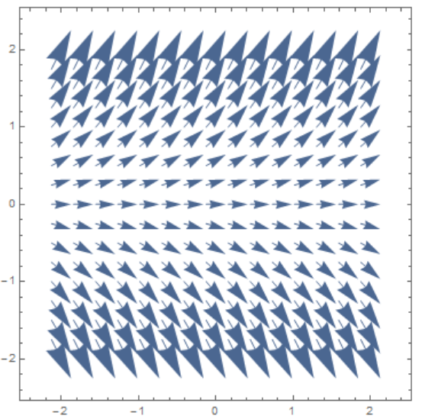 | 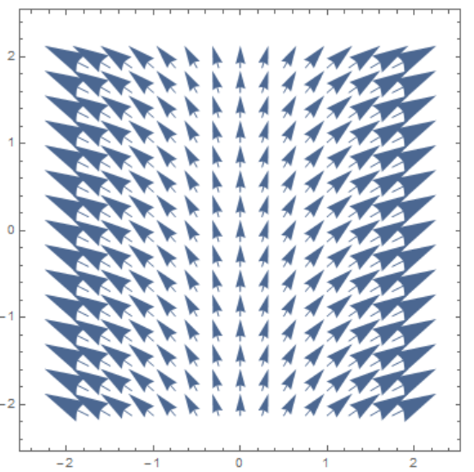 | 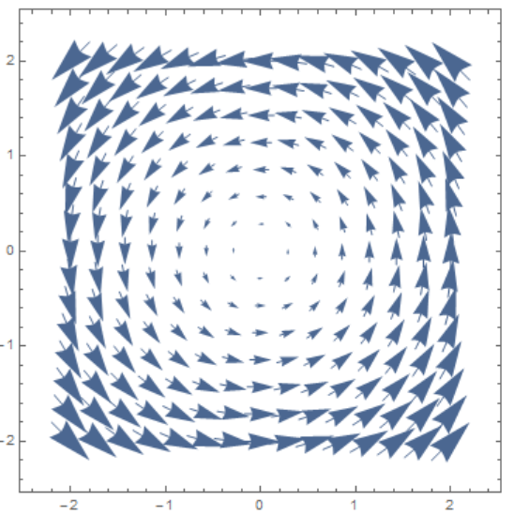

- For the vector field $\vec{F}\left(x,y,z\right)=<x^{2},2xy,z^{2}-xy>$, find
  - $div(\vec{F})$

  - $curl(\vec{ F})$

- Which of the following vector fields are conservative? Find their potential function(s) if they are.
  - $F=<x^{3}-{2x}^{2}y^{3},y^{2}-{2x}^{3}y^{2}>$

  - $G=<xz,z+y,yz>$

