**Integration Worksheet**

1. 

Then convert to an integral $\iint{xy^{2}}dy dx$ and evaluate



$\int_{0}^{1}{\int_{x^{2}}^{x}{x^{2}+2y}}dy dx$

Then convert to an integral $\iint{x^{2}+2y}dx dy$ and evaluate

1. 

In how many different ways could you evaluate this integral? Choose one of them and do it

1. Find the volume of the solid bounded by , , ,, and 
2. Find the volume of the solid bounded by  and the planes , , and 
3. **(HW)**  where R is a triangle bounded by , , 
4. 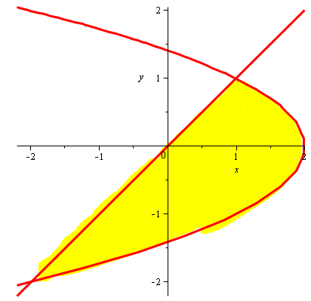Suppose you want to evaluate $\iint_{R}{f\left(x,y\right)dA}$ where *R* is the region shown in the picture below. According to Fubini’s theorem you could use either the iterated integral $\iint_{R}{f\left(x,y\right)dxdy}$ or $\iint_{R}{f\left(x,y\right)dydx}$ to evaluate the double integral. Which version do you prefer and why?



1. **(HW)** Suppose you want to evaluate  where R is the region in the xy plane bounded by , , and . According to Fubini’s theorem you could use either the iterated integral  or  to evaluate the double integral. Which version do you prefer? Explain.
2. The pictures below show to different ways that a region R in the plane can be covered. Which picture corresponds to the integral 

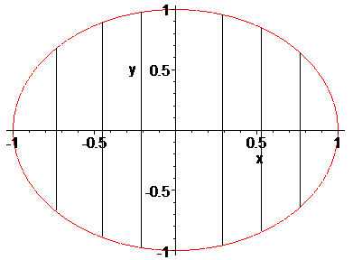 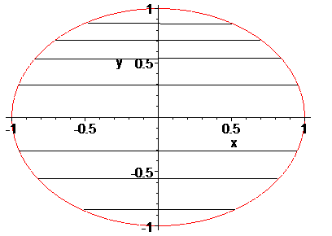

1. Consider $\int_{0}^{1}{\int_{0}^{1}{x\sin\left(xy\right) dx dy}}$ and $\int_{0}^{1}{\int_{0}^{1}{x\sin\left(xy\right) dy dx}}$. Which way, if any, is easier?
2. **(HW)** Find $\int_{0}^{1}{\int_{y}^{1}{cos⁡(x^{2})}}dx dy$