**Integration Worksheet worked out**

1. $=\int_{0}^{1}{\left({\left.\frac{1}{2}x^{2} y^{2}\right\rfloor }_{x=0}^{x=2}\right)}dy=\int_{0}^{1}{\left(2y^{2}-0\right)}dy=\frac{2}{3}$

Then convert to an integral $\iint{xy^{2}}dy dx$ and evaluate

*By Fubini’s theorem we can switch dx dy as long as we switch the bounds as well. That, however,* ***ONLY*** *works if* ***all*** *bounds are simple numbers!!!! If they don’t, you need to draw the domain to figure out how the bounds switch. Anyway, this one is easy:*

= $\int_{0}^{2}{\int_{0}^{1}{xy^{2}}dy dx}=\int_{0}^{2}{\left({\left.\frac{1}{3}x y^{3}\right\rfloor }_{y=0}^{y=1}\right)}dx=\int_{0}^{2}{\frac{1}{3}x}dx={\left.\frac{1}{6}x^{2}\right\rfloor }_{0}^{2}=\frac{4}{6}=\frac{2}{3}$  
  
Both integrations are best done with Mathematica, however:

$$Integrate\left[Integrate\left[xy^{2},\left\{x,0,2\right\}\right],\left\{y,0,1\right\}\right]=2/3$$

and



$$Integrate\left[Integrate\left[xy^{2},\left\{y,0,1\right\}\right],\left\{x,0,2\right\}\right]=2/3$$

$=\int_{0}^{1}{\left({\left.x^{2}y+y^{2}\right\rfloor }_{y=x^{2}}^{y=x}\right)} dx=\int_{0}^{1}{\left({(x}^{2}x+x^{2})-(x^{2}x^{2}+x^{4})\right)} dx=\int_{0}^{1}{\left(x^{3}+x^{2}-2x^{4}\right)} dx=\frac{1}{4}+\frac{1}{3}-\frac{2}{5}=\frac{11}{60}$

1. 



With Mathematica: $Integrate\left[Integrate\left[x^{2}+2y,\left\{y,x^{2},x\right\}\right],\left\{x,0,1\right\}\right]=11/60$

Then convert to an integral $\iint{x^{2}+2y}dx dy$ and evaluate

You cannot simply switch the bounds with the variables in this case, since not all of them are numbers. Instead you have to draw the graph of the xy bounds only (you can ignore the integrant for this):

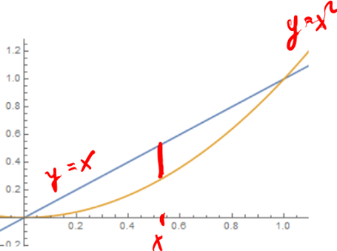

In the original order, we first fix an x between 0 and 1, then we fix a y along that vertical line between y=x^2 and y=x, as in the picture on the *left.*

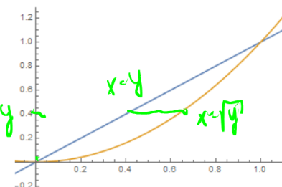

If we want to switch the order of integration, we then fix a y first, between 0 and 1 on the y-axis, then we fix an x along that horizontal line between y=x^2 and y=x. To finish up, we need to solve both of these for x, which is easy for x = y, and the first equation is x = sqrt(y). Thus, y goes from 0 to 1 and x goes from x=y to x=sqrt(y), as in the picture on the *right.*

Thus, we have

$$\int_{0}^{1}{\int_{x^{2}}^{x}{x^{2}+2y}dy}dx=\int_{0}^{1}{\int_{y}^{\sqrt{y}}{x^{2}+2y}dx}dy=\int_{0}^{1}{\left({\left.\frac{1}{3}x^{3}+2y x\right|}_{x=y}^{x=\sqrt{y}}\right)}dy=\int_{0}^{1}{\frac{1}{3}y^{\frac{3}{2}}}+2y y^{\frac{1}{2}}-\frac{1}{3}y^{3}-2y^{2}dy=\frac{11}{60}$$ Hard to believe, but this does give the same answer. Of course the integration should be done with Mathematica (but the switching of x and y needs to be done manually, usually by drawing x and y curves as we did above.

$$Integrate\left[Integrate\left[x^{2}+2y,\left\{y,x^{2},x\right\}\right],\left\{x,0,1\right\}\right]=11/60$$

And the other way around:

$$Integrate\left[Integrate\left[x^{2}+2y,\left\{x,y,Sqrt\left[y\right]\right\}\right],\left\{y,0,1\right\}\right]=11/60$$

1. 

What works with two variables also works with three or more. In this case:

$\int_{0}^{a}{\int_{0}^{b}{\int_{0}^{c}{x^{2}+y^{2}+z^{2}}dx dy dz}=}\int_{0}^{a}{\int_{0}^{b}{\left({\left.\frac{1}{3}x^{3}+y^{2}x+z^{2}x\right|}_{x=0}^{c}\right)}dy dz=}\int_{0}^{a}{\int_{0}^{b}{\frac{1}{3}c^{3}+y^{2}c+z^{2}c}dy dz}$ =

$\int_{0}^{a}{\left({\left.\frac{1}{3}c^{3}y+\frac{1}{3}y^{3}c+z^{2}c y\right|}_{y=0}^{y=b}\right)dz=\int_{0}^{a}{\frac{1}{3}c^{3}b+\frac{1}{3}b^{3}c+z^{2}bc}}dz=\frac{1}{3}c^{3}ab+\frac{1}{3}b^{3}ca+\frac{1}{3}a^{3}bc=\frac{abc}{3}(a^{2}+b^{2}+c^{2})$

In how many different ways could you evaluate this integral? Choose one of them and do it.

There are six different combinations of dx, dy, and dz, so there are six different integrals to work out. However, the answer will be the same regardless of which variation I am using.

1. Find the volume of the solid bounded by , , ,, and 

This problem is typical. We have the power of Mathematica at our disposal but we first need to setup the problem (manually) before I can “hit it” with Mathematica. To determine exactly how the bounds for x and y work, we need to draw the domain in the xy plane. Clearly x goes between 0 and 4, but y goes from zero to … where? Well, z = 0 is another bound, so since z = x^2 – y + 4 = 0, we have that y = x^2 + 4 as another bound for y. Thus:

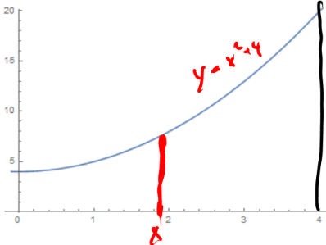x is between 0 and 4 and y is between 0 and y = x^2+4. With that established, we can use Mathematica to work out the integral:

$\int_{0}^{4}{\int_{0}^{x^{2}+4}{x^{2}-y+4}dy}dx=$

= $Integrate\left[Integrate\left[x^{2}-y+4,\left\{y,0,x^{2}+4\right\}\right],\left\{x,0,4\right\}\right]=\frac{3296}{15}$

If we tried to do this the other way around, i.e. dy dx, then we need to split up the integral into two integrals, because if y is between 0 and 4, x is between 0 and 4, while for x between 4 and 20 we have that x goes from y=x^2+4 to x=4. And of course we’d have to solve this for x, so that y goes from x=sqrt(y-4) to x=4. This would definitely not be our preferred way to integrate:

$$\int_{0}^{4}{\int_{0}^{x^{2}+4}{x^{2}-y+4}dy}dx=\int_{0}^{4}{\int_{0}^{4}{x^{2}-y+4}dx}dy+\int_{4}^{20}{\int_{\sqrt{y-4}}^{4}{x^{2}-y+4}dx}dy$$

We already worked out the left integral. The sum of the right integrals comes out, in accordance with Fubini’s theorem:

$Integrate\left[Integrate\left[x^{2}-y+4,\left\{x,0,4\right\}\right],\left\{y,0,4\right\}\right]+$

$+Integrate\left[Integrate\left[x^{2}-y+4,\left\{x,Sqrt\left[y-4\right],4\right\}\right],\left\{y,4,20\right\}\right]=3296/15$

1. Find the volume of the solid bounded by  and the planes , , and 

We could do this in two ways: $\iint_{D}{e^{{-x}^{2}}}dx dy$ or $\iint_{D}{e^{{-x}^{2}}}dy dx$. In the first case the first x-integration is complicated. In fact, this particular function does not even have an antiderivative with respect to x. Thus, we are stuck right away. But in the second case we could at least perform the first integration, since the antiderivative of $e^{{-x}^{2}}$ with respect to y is simply $y e^{{-x}^{2}}$. This gets us half way, and maybe something happens when we substitute the upper and lower bounds to make the second integration work out as well. So, we settled on doing the integration in the dy dx order. That means our bounds will look like this:

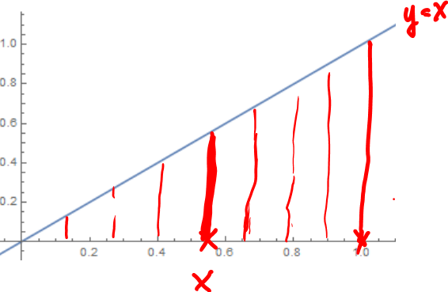

So as I fix and x between 0 and 1, the y goes from 0 to the curve y=x. Thus:

$$\iint_{D}{e^{{-x}^{2}}}dy dx= \int_{0}^{1}{\int_{0}^{x}{e^{{-x}^{2}}}}dy dx=\int_{0}^{1}{\left({\left.ye^{{-x}^{2}}\right|}_{y=0}^{y=x}\right)}dx=\int_{0}^{1}{xe^{{-x}^{2}}}dx$$

But now this integral works out, because the extra x in front of the exponential function is exactly what we need to make u-substitution work out perfectly:

$$\int_{0}^{1}{xe^{{-x}^{2}}}dx={\left.-\frac{1}{2}e^{{-x}^{2}}\right|}_{0}^{1}=-\frac{1}{2}(e^{-1}-1)$$

1.  where R is a triangle bounded by , , 

**This one is left as HW**. As in the previous problem, one of the two integration orders will work out better than the other.

1. 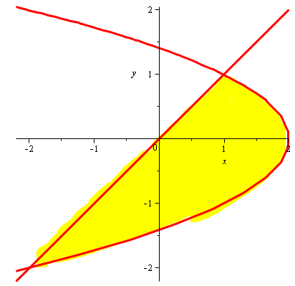Suppose you want to evaluate $\iint_{R}{f\left(x,y\right)dA}$ where *R* is the region shown in the picture below. According to Fubini’s theorem you could use either the iterated integral $\iint_{R}{f\left(x,y\right)dxdy}$ or $\iint_{R}{f\left(x,y\right)dydx}$ to evaluate the double integral. Which version do you prefer and why?



If we did this in dx dy order, we’d first pick a y between -3 and 1 on the y axis. For that y, our x would go horizontally from the main diagonal to the sideways parabola. Sounds doable.

If, on the other hand, we tried this in dy dx order, we’d first pick an x between -3 and 2 on the x-axis. Then we go vertically to see the bounds for y. But that is a problem, because if my x is on the left of x = 1, the y goes from the sideways parabola up to the main diagonal. But if x is on the right of x = 1, the y would go from the lower side of the parabola to the upper part. That means we would have to split this up into two integrations!

Clearly one integrations sounds better, so we would go for the dx dy order in this case.

1. Suppose you want to evaluate  where R is the region in the xy plane bounded by , , and . According to Fubini’s theorem you could use either the iterated integral  or  to evaluate the double integral. Which version do you prefer? Explain.

**This one is left as HW**

1. The pictures below show to different ways that a region R in the plane can be covered. Which picture corresponds to the integral 

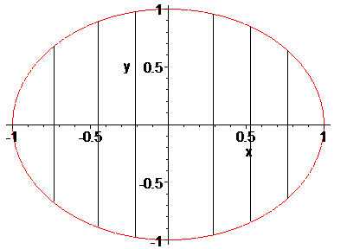 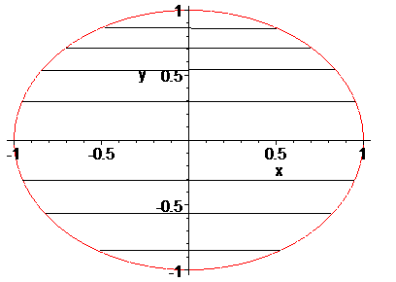

The order dx dy means to fix y between two numbers on the y-axis, then find x horizontally. The order dy dx means to fix x between two numbers on the x-axis, then find y vertically. Thus, the above integral dx dy corresponds to the second picture, while the order dy dx would correspond to the first picture.

1. Consider $\int_{0}^{1}{\int_{0}^{1}{x\sin\left(xy\right) dx dy}}$ and $\int_{0}^{1}{\int_{0}^{1}{x\sin\left(xy\right) dy dx}}$. Which way, if any, is easier?

For the dx dy order (first integral) we would have to use integration by parts to find the first antiderivative. For the dy dx order (second integral) the first integration would be easy. Thus, that’s the way we would try it:

$$\int_{0}^{1}{\int_{0}^{1}{x\sin\left(xy\right) dy dx}}=\int_{0}^{1}{\left(x∙{\left.\frac{1}{x}cos⁡(xy)\right|}_{y=0}^{y=1}\right)}dx=\int_{0}^{1}{-\cos\left(x\right)+1}dx=1-sin⁡(1)$$

That was **much** easier than integration by parts!

1. Find $\int_{0}^{1}{\int_{y}^{1}{cos⁡(x^{2})}}dx dy$

**This one is left as HW**