Math 2511 – Calc III Practice Exam 2

*This is a practice exam. The actual exam consists of questions of the type found in this practice exam, but will be shorter. If you have questions do not hesitate to send me email. Answers will be posted if possible – no guarantee.*

1. **Definitions**: Please state in your own words the following **definitions**:

1. Limit of a function 
2. Continuity of a function 
3. partial derivative of a function f(x,y)
4. gradient and its properties
5. directional derivative of a function f(x, y) in the direction of a unit vector u
6. The (definition and geometric meaning of) the double integral of *f* over the region *R* 

2. **Theorems:** Describe, in your own words, the following:

1. *a theorem relating differentiability with continuity*
2. a theorem stating criteria for a function to have relative extrema
3. a result that classifies critical points into relative max., min., or saddle points
4. the procedure to find *relative* extrema of a function f(x, y)
5. the procedure to find *absolute* extrema of a function f(x, y)
6. a theorem that allows you to evaluate a double integral easily
7. the “change of variables” theorem to change from rectangular to polar coordinates

3. **True/False** questions:

1. If  then 
2. If then 
$\lim_{h→0}{\frac{f\left(x+ah,y+bh\right)-f(x,y)}{h}}=\frac{∂}{∂x}f(x,y)$

3. If *f* is continuous at *(0,0)*, and *f(0,0) = 10*, then
4. If *f(x, y)* is a function such that all second order partials exist and are continuous then fxx = fyy
5. The volume under *f(x,y)*, where and  is 
6. If *f(x,y)* is continuous then 
7. If *f(x,y)* is continuous then 
8. If *f* is continuous over a region *D* then

5. **Limits and Continuity**: Determine the following limits as *(x,y) -> (0,0)*, if they exist.

  

 

6. **Picture**: Match the following contour plots (level plots) to their corresponding surfaces.

[1]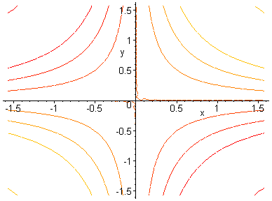[2]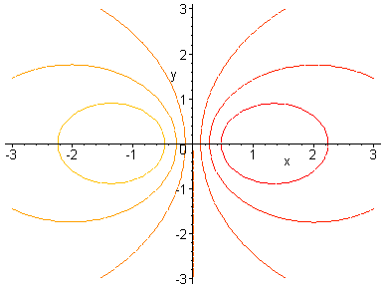[3]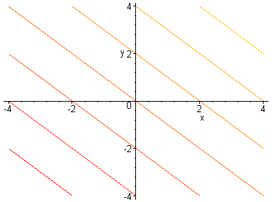[4]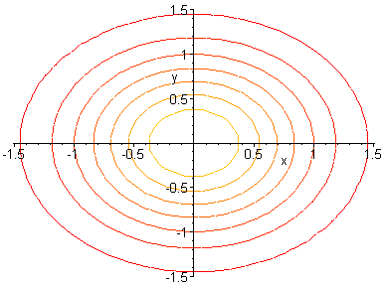

[A]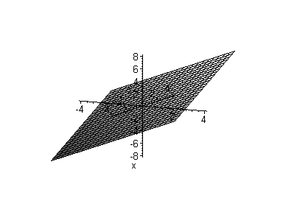[B]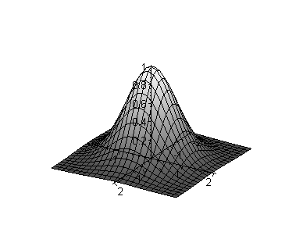[C]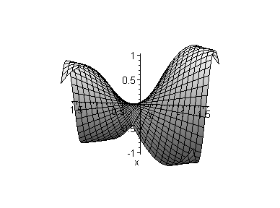[D]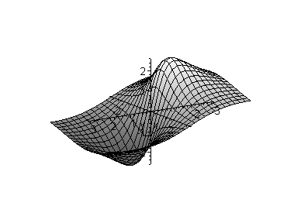

Other picture problems:

* Given a contour plot, draw the gradient vector at specific points
* classify some regions as type-1, type-2, or neither.

7. **Differentiation**: Find the indicated derivatives for the given function:

1. Suppose , find fx, fy, fxx, fxy, fyy, and fyx
2. Consider the function $f\left(x,y\right)=3x^{2}y-4xy^{2}+{\left(2x+3y\right)}^{2}$. Find $f_{x}$, $\frac{∂^{2}f}{∂y^{2}}$, and $∇f$
3. Let $g\left(x,y,z\right)=xy\tan\left(x^{2}y^{3}z^{4}\right)$. Compute $∇g$
4. Consider $h\left(x,y,z,w\right)=2xy-3yz+4zw-5xw$. Compute $h_{xyzw}$
5. Let $f\left(x,y\right)=\frac{xy sin\left(xy\right)}{cos⁡(xy)}$. Find $f_{x}$ and $f_{y}$
6. Consider $f\left(x,y\right)=\frac{x}{y}$. Find $f_{xx}$, $f_{yy}$, $f_{xy}$, and $f_{yx}$ and confirm that $f_{xy}=f_{yx}$
7. Let . Find fxyy, fyxy, and fyyx
8. If $f\left(x,y\right)=2x^{2}y^{3}-xcos(xy^{2})$, find the **equation of the tangent plane** at

8. **Directional Derivatives**:

1. Find the directional derivative of *f(x, y) = xy exy* at (-2, 0) in the direction of a vector u, where u makes an angle of Pi/4 with the x-axis.
2. Find $D_{u}(f)$ where $f\left(x,y\right)=\frac{x}{y}-\frac{y}{x}$ and $\vec{u}=<-\frac{4}{5},\frac{3}{5}>$
3. Suppose . Find the maximum value of the directional derivative at (-2, 0) and compute a unit vector in that direction.

10. **Max/Min Problems:** Compute the extrema as indicated

* 1. . Find *relative* extreme and saddle point(s), if any.
  2. . Find *relative* extrema and saddle point(s), if any
  3. Let . Find **absolute** maximum and minimum inside the triangular region spanned by the points (0,0), (3, 0), and (0, 5).

1. Let . Find the **absolute** extrema over [0, 1] x [0, 2]

11. Evaluate the following integrals:

1. and $\int_{1}^{2}{\int_{ln⁡(2)}^{ln⁡(3)}{xe^{y} dy dx}}$
2. and $\int_{e}^{e^{2}}{\int_{0}^{1}{ \frac{x}{y} dx dy}}$
3. 
4. 
5. $\int_{0}^{1}{\int_{0}^{1}{x\sin\left(xy\right) dx dy}}$ and $\int_{0}^{1}{\int_{0}^{1}{x\sin\left(xy\right) dy dx}}$. Which way, if any, is easier?
6. 
7. , where R is the part of the circle in the 1st quadrant
8. where

12. The pictures below show two different ways that a region R in the plane can be covered. Which picture corresponds to the integral 

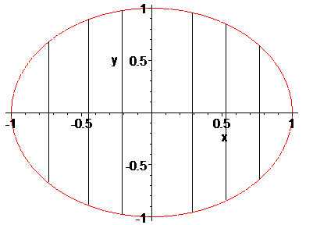 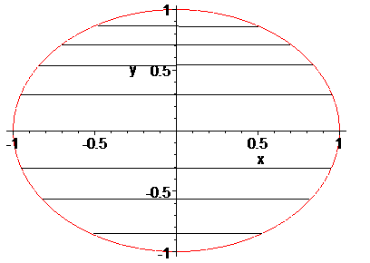

13. Suppose you want to evaluate  where R is the region in the xy plane bounded by , , and . According to Fubini’s theorem you could use either the iterated integral  or  to evaluate the double integral. Which version do you prefer? Explain. You do not need to actually work out the integrals.

14. Use a multiple integral and a convenient coordinate system to find the volume of the solid:

1. bounded by , , ,, and 
2. bounded by  and the planes , , and 
3. bounded above by  and bounded below by the circle 
4. evaluate  where R is a triangle bounded by , , 
5. bounded by the paraboloid  and the xy plane
6. $\iiint_{V}{x\left(y-z\right)dV}$, where V is bounded by x = 0, y = 0, z = 0, x + y + z = 2

15. Answer the following applications of integration:

a) ,If D is a thin lamina bounded by $y=\sqrt{2-x^{2}}$ and y = 0 with density function $ρ\left(x,y\right)=\frac{1}{x^{2}+y^{2}+1}$, find he center of its mass.

16. **Prove** the following facts:

1. Use the **definition** to find $f_{x}$ for 
2. Use the **definition** to find $f_{x}$ for 
3. A function *f* is said to satisfy the Laplace equation if . Show that the function satisfies the Laplace equation.
4. Two function u(x, y) and v(x, y) are said to satisfy the Cauchy-Riemann equations if  and . Show that the functions and satisfy the Cauchy-Riemann equations.
5. Prove that the volume of a sphere with radius R is 4/3 * Pi * r3