### Math 2511: Calc III - Practice Exam 3

1. State the meaning or definitions of the following terms:
2. vector field, conservative vector field, potential function of a vector field, volume, length of a curve, work, surface area, flux integral
3. curl and divergence of a vector field F, gradient of a function
4.  or  or $\iiint_{Q}{f\left(x,y,z\right)dV}$
5.  or  or  or or  or $\iint_{S}{g\left(x,y,z\right)dS}$
6.  or 
7. 
8. What does it mean when a “line integral is independent of the path”?
9. State the Fundamental Theorem of Line Integrals. Make sure to know when it applies, and when it helps.
10. State Green’s Theorem. Make sure to know when it applies, and in what situation it helps.
11. State Gauss’ Theorem. Make sure to know when it applies, and in what situation it helps.
12. Below are four algebraic vector fields and four sketches of vector fields. Match them.

[A]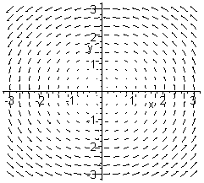[B]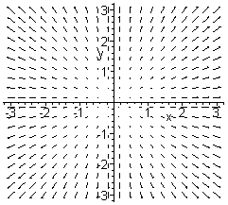[C]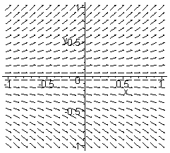[D]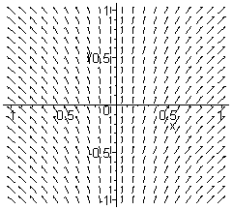

(1) , (2) , (3) , (4) 

b) Below are two vector fields. Which one is clearly not conservative, and why?

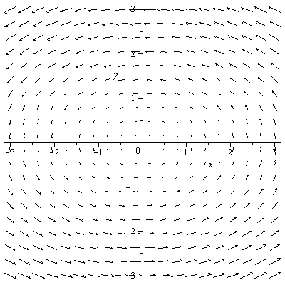 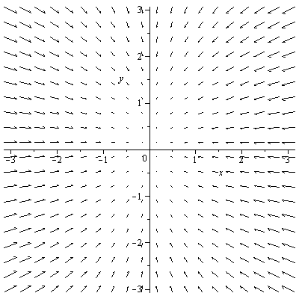

c) Say in the vector field [C] above you integrate over a straight line from (0,-1) to (-1,0). Is the integral positive, negative, or zero?

1. Are the following statements true or false:
2. If the divergence of a vector is zero, the vector field is conservative.
3. If  is a conservative vector field then 
4. If a line integral is independent of the path, then  for every path C
5. If a vector field is conservative then  for every closed path C
6.  denotes the surface area of the region R
7.  denotes the volume of the region R
8. Can you apply the Fundamental Theorem of line integrals for the function ?
9. Can you apply the Fundamental Theorem of line integrals for the vector field ?
10. Can you apply Green’s theorem for a curve C, which is a straight line from (0,0,0) to (1,2,3)?
11. Can you apply the Divergence theorem to the plane *x+y+z=1* over [-1, 1] x [-1, 1]?
12. Suppose that  is some vector field.
13. Find div(F)
14. Find curl(F)
15. Find curl(curl(F))
16. Find div(curl(F))
17. grad., div., and curl of the vector field if appropriate for 
18. grad., div., and curl of the vector field if appropriate for 
19. grad., div., and curl of the vector field if appropriate for 
20. Decide which of the following vector fields are conservative. If a vector is conservative, find its potential function
21. 
22. 
23. 
24. 
25. 
26. 
27. 
28. 
29. Evaluate the following integrals:
30.  where R is the triangular region bounded by y = 0, y = x, and x = 1
31. , where S is the portion of the hemisphere  that lies above the circle 
32.  where C is a line segment given by , 
33.  where  and C is the curve given by , 
34.  where C is a parabolic arc given by , 
35.  where S is the first-octant portion of the cylinder  between x = 0 and x = 4
36. Find the flux of the vector field  through the surface given by potion of the paraboloid  that lies above the xy-plane. Note that this surface is *not* closed.
37. For the following line integrals there is a short-cut you can use to simplify your computations (but justify your shortcut by quoting the appropriate theorem)
38.  where  and C is the curve , 
39.  where C is some smooth curve from (0,0,0) to (1,4,3)
40.  where  and C is the upper half of the unit circle, from (1,0) to (-1,0).
41.  where  and C is the line segment from (-1,0) to (2,3).
42.  where C is the path from (0,0) to (1,1) along the graph of  and from (1,1) to (0,0) along the graph of .
43.  where  and S is 

# Green’s Theorem

1. Use Green’s theorem to find  where  and C is the circle with radius 3, oriented counter-clockwise (You may need the double-angle formula for cos somewhere during your computations)
2. Evaluate  where R is the ellipse  by using a vector field  and the boundary C of the ellipse R.

# Evaluate the following integrals. You can use any theorem that’s appropriate:

1.  where C is a smooth curve from (0,0,0) to (1,4,3)
2.  where C is the boundary of the square with vertices (0,0), (0,2), (2,0), and (2,2)
3. , where C is given by , t between 0 and 2 Pi.
4.  where C is the boundary of the region between the graphs of  and .
5. Prove the following:
6. If  is any vector field where  are twice continuously differentiable then 
7. A function (not a vector field)  is called harmonic if . Show that for any function  the function  is harmonic.