Curve Sketching
Example: Sketch the graph of $f\left(x\right)=3x^{4}+4x^{3}-12x^{2}$
- Domain: all numbers
- Asymptotes:
  - v.a. none
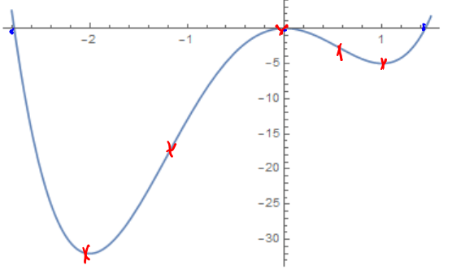
  - h.a. none
- $f^{'}\left(x\right)=12x^{3}+12x^{2}-24x=$
$=12x\left(x+2\right)\left(x-1\right)$
$f^{''}\left(x\right)=36x^{2}+24x-24=$ $=12(3x^{2}+2x-2)$
- Critical points: $12x\left(x+2\right)\left(x-1\right)=0$
so $x=0,x=1,x=-2$
Possible infl. pts: $3x^{2}+2x-2=0$
so $x=-1.215, x=0.548$
- Setting up the table
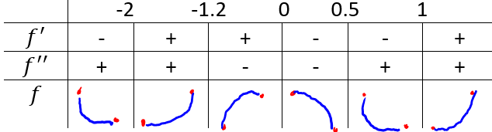
- Find zeros: $x=0.x=-2.77,x=1.44$
- Find y-intercept: $f(0)=0$
- Evaluate f: f(-2)=-32, f(-1.2)=-17.9, f(0)=0, f(0.5)=-2.3, f(1)=-5

Example: Sketch the graph of $p\left(x\right)=2x^{3}+3x^{2}-36x+1$
- Domain: all numbers
- Asymptotes:
  - v.a. : none
  - h.a. : none
- $p^{'}\left(x\right)=6x^{2}+6x-36=6(x+3)(x-2)$
$p^{''}\left(x\right)=12x+6$
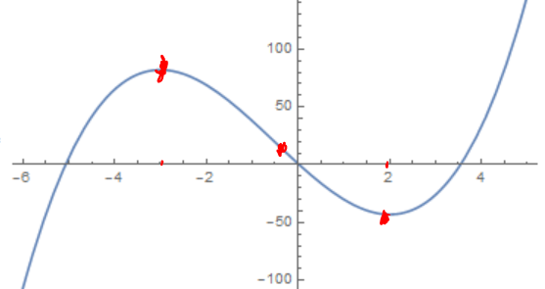
- Critical points: $6\left(x^{2}+x-6\right)=6\left(x+3\right)\left(x-2\right)=0$
so: $x=-3, x=2$
Possible infl. pts: $12x+6=0$
so: $x=-\frac{1}{2}$
- Setting up the table
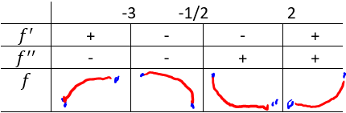
- Find zeros: $p(x)=0$, so can’t find them without computer
- Find y-intercept $p\left(0\right)=0$
- Evaluate f: $p\left(-3\right)=82, p\left(-\frac{1}{2}\right)=19.5, p\left(2\right)=-43$

Example: Sketch the graph of $g\left(x\right)=\frac{x}{x^{2}-9}$
- Domain: all numbers except $±3$
2. Asymptotes:
  - v.a. : $x=-3, x=3$
  - h.a. $y=\lim_{x→∞}{\frac{x}{x^{2}-9}}=0$
3. $f^{'}\left(x\right)=-\frac{x^{2}+9}{{{(x}^{2}-9)}^{2}}$
$f^{''}\left(x\right)=\frac{2x(27+x^{2})}{{(x^{2}-9)}^{3}}$
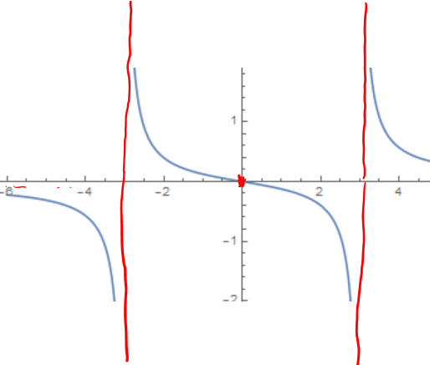
- Critical points: $-\frac{x^{2}+9}{{{(x}^{2}-9)}^{2}}=0$ or $x^{2}+9=0$
so: none
Possible infl. pts: $\frac{2x(27+x^{2})}{{(x^{2}-9)}^{3}}=0$ or $2x\left(27+x^{2}\right)=0$
so: $x=0$
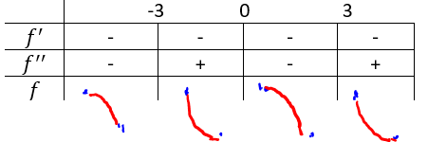
- Setting up the table
- Find zeros: $f(x)=0$, so $x=0$
- Find y-intercept $f\left(0\right)=0$
- Evaluate f: $f\left(0\right)=0$
Example: Sketch the graph of $f\left(x\right)=\frac{x^{2}}{x^{2}-4}$
- Domain: all numbers except $±2$
- Asymptotes:
  - v.a. : $x=-2, x=2$
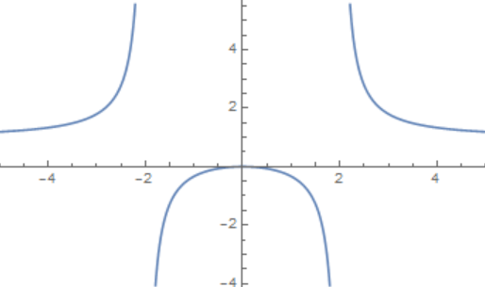
  - h.a.: $y=\lim_{x→∞}{\frac{x^{2}}{x^{2}-4}}=1$
- $f^{'}(x)=-\frac{8x}{{(x^{2}-4)}^{2}}$
$f^{''}\left(x\right)=\frac{8(4+3x^{2})}{{(x^{2}-4)}^{3}}$
- Critical points: $-\frac{8x}{{\left(x^{2}-4\right)}^{2}}=0$
so: $x=0$
Possible infl. pts: $\frac{8(4+3x^{2})}{{(x^{2}-4)}^{3}}=0$
so: none
- Setting up the table
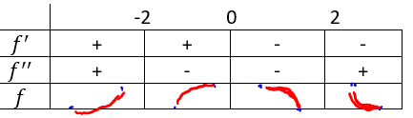
- Find zeros: $f(x)=0$, so $x=0$
- Find y-intercept $f\left(0\right)=0$
Example: Sketch the graph of $f\left(x\right)=\frac{x}{{\left(x-1\right)}^{2}}$
- Domain: all numbers except $x=1$
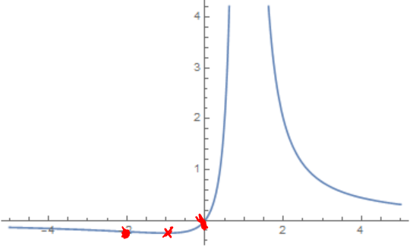
2. Asymptotes:
  - v.a.: $x=1$
  - h.a. $y=0$
3. $f^{'}\left(x\right)=-\frac{1+x}{{(x-1)}^{3}}$
$f^{''}\left(x\right)=\frac{2(2+x)}{{(x-1)}^{4}}$
- Critical points: $-\frac{1+x}{{\left(x-1\right)}^{3}}=0$ or $x=-1$
Possible infl. pts: $\frac{2(2+x)}{{(x-1)}^{4}}=0$ or $x=-2$
- Setting up the table:
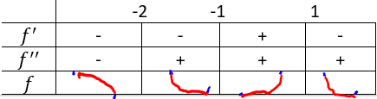
- Find zeros: $f\left(x\right)=0$, so $x=0$
- Find y-intercept: $f(0)=0$
- Evaluate f: $f\left(-2\right)=-\frac{2}{9}, f\left(-1\right)=-\frac{1}{4}$

