Curve Sketching HW
Sketch the graphs of the following functions:
- $f\left(x\right)=3x^{4}+4x^{3}-12x^{2}$
Hint: $f^{'}\left(x\right)=12x^{3}+12x^{2}-24x$ and $f^{''}\left(x\right)=36x^{2}+24x-24$
- $p\left(x\right)=2x^{3}+3x^{2}-36x+1$
Hint: $p^{'\left(x\right)}=6x^{2}+6x-36$ and $p^{''}\left(x\right)=12x+6$
c) $g\left(x\right)=\frac{x}{x^{2}-9}$
Hint: $g^{'}\left(x\right)=-\frac{x^{2}+9}{{{(x}^{2}-9)}^{2}}$ and $g''\left(x\right)=\frac{2x(27+x^{2})}{{(x^{2}-9)}^{3}}$
d) $f\left(x\right)=\frac{x^{2}}{x^{2}-4}$
Hint: $f^{'}(x)=-\frac{8x}{{(x^{2}-4)}^{2}}$ and $f^{''\left(x\right)}=\frac{8(4+3x^{2})}{{(x^{2}-4)}^{3}}$
e) $f\left(x\right)=\frac{x}{{\left(x-1\right)}^{2}}$
Hint: $f^{'}\left(x\right)=-\frac{1+x}{{(x-1)}^{3}}$ and $f^{''\left(x\right)}=\frac{2(2+x)}{{(x-1)}^{4}}$

Solution: Sketch the graph of $f\left(x\right)=3x^{4}+4x^{3}-12x^{2}$
- Domain: all numbers
- Asymptotes:
  - v.a. none
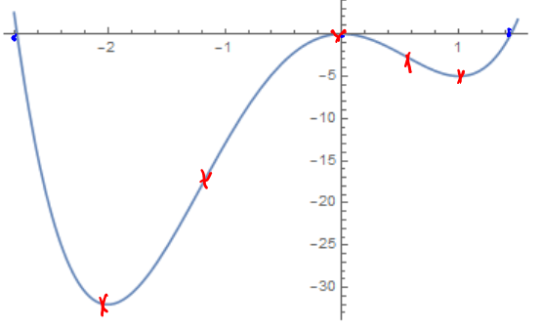
  - h.a. none
- $f^{'}\left(x\right)=12x^{3}+12x^{2}-24x$
$=12x\left(x+2\right)\left(x-1\right)$
$f^{''}\left(x\right)=36x^{2}+24x-24$ $=12(3x^{2}+2x-2)$
- Critical points: $12x\left(x+2\right)\left(x-1\right)=0$
so $x=0,x=1,x=-2$
Possible infl. pts: $3x^{2}+2x-2=0$
so $x=-1.215, x=0.548$
- Setting up the table
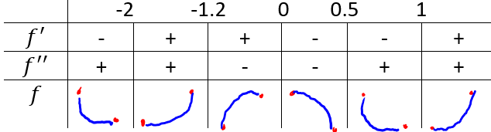
- Find zeros: $x=0.x=-2.77,x=1.44$
- Find y-intercept: $f(0)=0$
- Evaluate f: f(-2)=-32, f(-1.2)=-17.9, f(0)=0, f(0.5)=-2.3, f(1)=-5

