Summary 2: Functions
Vertical Line Test: if every vertical line intersects graph at most once, the graph represents a function  Piecewise Defined Functions: Most functions are defined in a single expression, but more complicated functions are defined in multiple cases.  Function Catalog: We know the basic shape of the following functions:  (1) linear: graph is straight line  (2) power: graph is like a parabola (even) or a third degree power (odd)  (3) polynomial: graph is wavy with finitely many mins and max  (4) rational: graph usually has horizontal and/or vertical asymptotes  (5) trig: graph is periodic, i.e. it repeats  (6) exp, logarithm: either grows or shrinks super-fast | 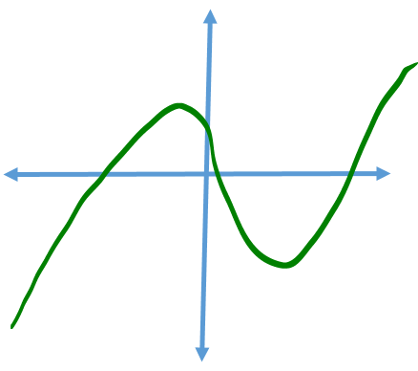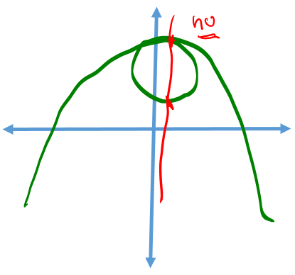  $$f\left(x\right)=\left\{\begin{matrix}x-1 if x<-1 \\ 2-x^{2} if-1≤x<2 \\ \frac{x}{x-1} if x≥2 \end{matrix}\right.$$  