**Practice Exam 3**

1. Answer the following questions. Be concise:
2. What is the definition of the indefinite integral $\int{f(x)}dx$
3. What is the *mathematical definition* of the definite integral ?
4. What is the *geometric interpretation* of the definite integral 
5. What is the MVT for Integrals (include a graphical interpretation).
6. State the first fundamental theorem of calculus. What is that theorem good for, in your own words?
7. State the second fundamental theorem of calculus. What is that theorem good for, in your own words?
8. What is the difference between  and 
9. What is the definition of *ln(x)*, *arcsin(x)*, *arcos(x)*, and *arctan(x).* What is the derivative of each of those functions?
10. What is l’Hopital’s Rule and why is it so useful?
11. What is “logarithmic differentiation” and when is it helpful?
12. What is “exponential growth” and “exponential decay”?

2. Consider the following definite integral:  (The integrand is depicted below).

a) Approximate the value of that definite integral by using 4 subdivisions and **right** rectangles in the corresponding summation.



b) Find the exact value of that definite integral by using the first fundamental theorem of calculus. Compare with the answer in (a).

3. Below are the graphs of four functions. For each graph, decide whetheris positive, negative, or zero.

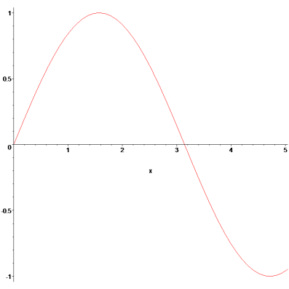 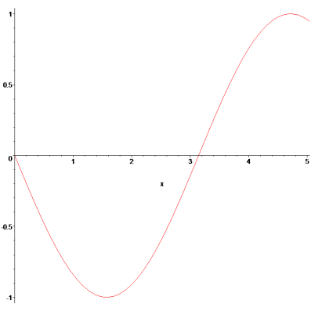

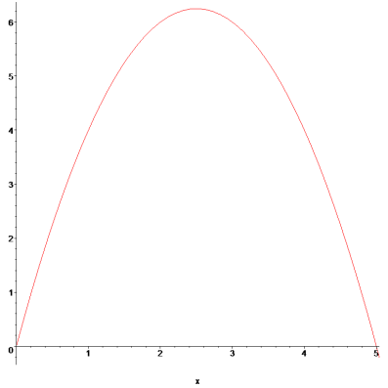 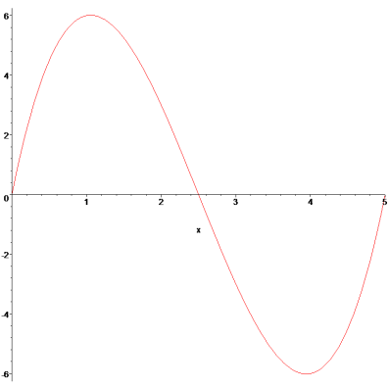

4. Evaluate each of the following integrals.

  

  

5. Evaluate each of the following definite integrals.

   (trick question)

   (trick questi

6. At SLAC (Stanford Linear Accelerator) the initial position of a particle was recorded at time ***t = 0*** to be 10m. Several detectors were used to record the speed of the particle, and it could be determined that the velocity function of the particle was given by ***v(t) = 4t2*** ***+ 3t***. What is the distance function of the particle, and where is the particle after 5 seconds?

7. Suppose that gasoline is increasing in price according to the equation  where *p* is the dollar price per gallon, and *t* is the time in years, with *t = 0* representing 1990. If an automobile is driven 15,000 miles a year, and gets M miles per gallon, the annual fuel cost is . Estimate the annual fuel cost (a) for the year 2000 and (b) for the year 2005.

8. Define a function . Then find S(0), S'(x), and S''(x). Where is the function increasing and decreasing? Also, if  then find G(1) and G’(x). Finally, define $H\left(x\right)=\int_{0}^{x}{5e^{t}-3t^{2}dt}$. Find H(x) using the 1st Fund. Theorem of Calculus, then compute the derivative of that function. Compare that with $\frac{d}{dx}H(x)$ as worked out with the 2nd Fund. Theorem of Calc.

9. Find the derivatives of the following functions. You might use logarithmic differentiation if that simplifies your task:



 

10. Simplify and

11. The half-life or radium-226 is 1590 years. A sample of radium-226 has a mass of 100 mg. Find a formula about how much of the substance remains after t years. Find the mass after 1000 years. Also, find out how long it takes until the original mass of 100mg is reduced to 80 mg.

12. Use the fact that the world population was 2560 million in 1950 and 3040 million in 1960.Assuming exponential growth, what would the population of the world be in 2020?

13. Evaluate and

14. Show that

15. Find the derivatives of and and

16. Prove that $\sin^{-1}\left(x\right)+\cos^{-1}\left(x\right)=\frac{π}{2}$ for all *x*. *Hint: Find the derivative and interpret your answer*

17. Find the following limits. You might want to use l’Hospital’s rule (but not all limits require that and for some it might not be appropriate)

$\lim_{x→ ∞}{arctan⁡(x)}$ $\lim_{x→∞}{e^{-x^{2}}}$ $\lim_{x→3}{\frac{x^{2}-9}{x+3}}$

$\lim_{x→ 1}{\frac{\ln\left(x\right)}{x-1}}$ $\lim_{x→3}{\frac{x^{2}-9}{x-3}}$ $\lim_{x→∞}{\frac{x^{2}}{e^{x}}}$

$\lim_{x→ 0}{\frac{\tan\left(x\right)-x}{x^{3}}}$ $\lim_{x→0}{\frac{\cos\left(x^{2}\right)-1}{5x^{4}}}$ $\lim_{x→π}{\frac{sin⁡(x)}{1-cos⁡(x)}}$

$\lim_{x→ 0^{+}}{x ln⁡(x)}$ $\lim_{x→{\frac{π}{2}}^{+}}{ \sec\left(x\right)-tan⁡(x)}$