**Math 1401: Practice Exam 2**

**Disclaimer:** This is a *practice exam* only. It is longer than the actual exam.

Please find the derivative for each of the following functions (do not simplify unless it is helpful).   
 

 

 

 

, find  , find 

State Rolle’s theorem. Then look at the graph below for a function defined on [-1, 1] and mark all numbers c that Rolle’s theorem mentions.

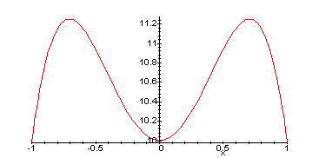

If  is a function defined on [-1, 1], verify the assumptions of Rolle’s theorem and find all numbers c that Rolle’s theorem mentions.

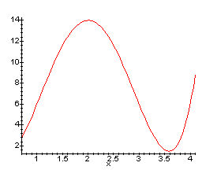

State the Mean Value Theorem. After that, look at the picture on the right which shows the graph of a function defined on the interval [0, 4]. Mark all numbers ‘c’ that are mentioned in the theorem in that picture.

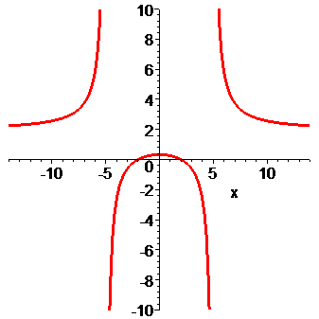

For the function displayed below, find the following limits:

a) 

b) 

c) 

d) 

Suppose a function y is implicitly defined as a function of x via the equation .

a) Find the derivative of y using implicit differentiation.

b) What is the equation of the tangent line at the point (1, 2).

Find the slope of the tangent line to the graph of  at the point (1, -2), assuming that the equation defines *y* as a function of *x* implicitly.

Find  if , assuming that *y* is an implicitly defined function of *x*.

Suppose both x and y are both functions of t, implicitly defined via . Implicitly differentiate this equation with respect to t. Note that you do not have to solve for  or  in this problem.

Find the following limits at infinity:

 

 

 

Find all asymptotes, horizontal and vertical, if any, for the functions

  

If , find the intervals on which f is increasing and decreasing, and find all relative extrema, if any.

Determine where the function  is increasing and decreasing and find all relative extrema, if any.

Find the local maxima and minima for the function 

Find the absolute extrema (i.e. absolute maximum and absolute minimum) for the function  on the interval [0, 2]

Find the absolute maximum and minimum of the function  on the interval [0, 4]. Do the same for  on [0, 3], or for  on [-2, 0].

If , determine intervals on which the graph of *f* is concave up and intervals on which the graph is concave down.

If , find all points of inflection and discuss the concavity of *f*. Do the same for ,

Find the interval where  is concave up, if any.

Graph the function . Note that  and . Make sure to find all asymptotes (horizontal and vertical) and clearly label any maximum, minimum, and inflection points. Then do the same for the function , or , or 

A 13 meter ladder is leaning against a wall If the top of the ladder slips down the wall at a rate of 2 m/sec, how fast will the foot be moving away from the wall when the top is 5 m above the ground.

Gas is escaping from a spherical balloon at a rate of 10 ft3/hr. At what rate is the radius changing when the volume is 400 ft3.

A radar station that is on the ground 5 miles from the launch pad tracks a rocket, rising vertically. How fast is this rocket rising when it is 4 miles high and its distance from the radar station is increasing at a rate of 2000 mph ?

A liquid form of penicillin manufactured by a pharmaceutical firm is sold in bulk at a price of $200 per unit. If the total production cost (in dollars) for x units is C(x) = 500,000 + 80x + 0.003x2 and if the production capacity of the firm is at most 30,000 units in a specified time, how many units of penicillin must be manufactured and sold in that time to maximize the profit ?

A farmer wants to fence in a piece of land that borders on one side on a river. She has 200m of fence available and wants to get a rectangular piece of fenced-in land. One side of the property needs no fence because of the river. Find the dimensions of the rectangle that yields maximum area. (Make sure you indicate the appropriate domain for the function you want to maximize). Please state your answer in a complete sentence.

Find the dimensions of the rectangle of maximum area that can be inscribed in a semicircle of radius 16, if one vertex lies on the diameter.

An open box with a rectangular base is to be constructed from a rectangular piece of cardboard 16 inches wide and 21 inches long by cutting out a square from each corner and then bending up the sides. Find the size of the corner square which will produce a box having the largest possible volume.

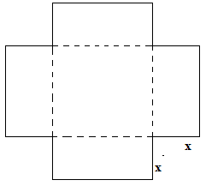

Verify the linear approximation $\sqrt[3]{1-x}≈1-\frac{1}{3}x$ near $c=0$.

Find the linear approximation of $\frac{1}{(1+2{x)}^{4}}≈1-8x$ near c = 0. Use Wolfram Alpha to graph both functions together to see if the approximation is indeed close.

Find the linearization of $f\left(x\right)=\frac{1}{\sqrt{2+x} }$ near *c = 0*. Do the same for $f\left(x\right)=x^{4}+3x^2$ near *c = -1*.

Use a linear approximation (or differentials) to estimate ${\left(2.001\right)}^{5}$. Do the same for ${\left(8.006\right)}^{\frac{2}{3}}$.

The radius of a disk is given as 24 cm with a max. error of 0.2 cm. Use differentials to find the max. error of calculating the area of the disk as well as the relative error in percent.

The edge of a cube was found to be 30 cm with a possible error of 0.1 cm. Use differentials to estimate the maximum possible error and the relative error in computing (a) the volume of the cube and (b) the surface area of the cube.

Use differentials to estimate the amount of paint needed to apply of coat of paint 0.05 cm thick to a hemispherical dome with diameter 50 m.

When blood flows along a blood vessel, the flux F (volume of blood per time) is proportional to the fourth power of the radius R of the blood vessel: $F=kR^{4}$ (Poiseuille’s Law). A partially clogged artery can be expanded by an operation called angioplasty, in which a balloon-tipped catheter is inflated inside the artery in order to widen it and restore the normal blood flow. Show that the relative change in F is about four times the relative change in R. How will a 5% increase in the radius affect the flow of blood?