Math 1303 Notes and Assignments
Last time in class we covered quadratic functions (graph, vertex, x-intercept) and looked at a number of business terms, such as revenue (R = price * quantity), cost (C = fixed cost + variable cost), and profit (P = R – C). We then discussed various applications, such as finding the equilibrium point (set supply = demand), break-even point (set revenue R = C cost), and maximizing revenue in case of a the revenue being a quadratic function (find the vertex). We also looked at some non-linear equations that are a little more tricky to solve, but we introduced Wolfram Alpha (www.wolframalpha.com) to help us with more complicated math questions.
Example: Find the equilibrium point if the demand is $p\left(q\right)=\frac{q}{40}+10$ and the supply $p\left(q\right)=\frac{8000}{q}$.
Since the equilibrium point is the demand equals supply, we would set them equal to each other and solve. We happen to get a quadratic equation, which – luckily – factors:
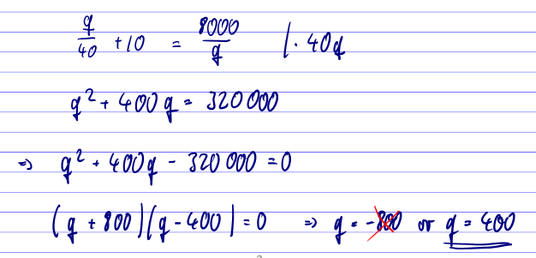
One of the numbers comes out negative, so we can neglect that because you can not have negative quantities. Thus, the answer is q = 400, which would result in a price of 8000/400 = 20, so that the equilibrium point is q = 400 and p = 20. Note that we could have used www.wolframalpha.com to solve the equation – make sure to try it NOW.
As another business application, consider the following problem:

Example: United Products Co. manufactures calculators and has plants in the cities of Exton and Whyton. At the Exton plant, fixed costs are $5,000 per month, and the cost of producing each calculator is $5.50. At the Whyton plant, fixed costs are $6,000 per month, and each calculator costs $4.50 to produce. Next month, United Products must produce 1000 calculators in total. How many must be made at each plant if the total cost at each plant is to be the same?

In this case our first problem is to introduce variables. As usual, we look at the question “How many must be made at each plant” to determine what the variables are supposed to represent. Since we are asking for the number of calculators made at each plant, we define our variables accordingly:

X = # of calculators at Exton, y = # of calculators at Whyton
As usual, once we have clearly stated what x and y are, the rest falls into place. We need the cost functions for each plants:

At Exton: C(x) = 5.50 x + 5000
At Whyton: C(y) = 4.50 y + 6000

We want that both costs are equal, and we want to produce a total of 1000 calculators. That results in two equations:

C(x) = C(y) and x + y = 1000

Or in other words:

5.50 x + 5000 = 4.50 y + 6000
x + y = 1000

It looks like the substitution method will do the trick here. We can solve the second equation for y and substitute the answer into the first one to get x = 550 and y = 450. Make sure to complete the calculations yourself.

We have now completed chapter 3, which together with chapter 2 should have been review for most everyone. We’ll conclude with a few “chapter ending” questions:

Homework Questions

Below are a number of homework questions. Please complete all questions, nice and neat, and submit your answers – stapled – during Monday’s class. It will count as a quiz.

- What is the domain of $f\left(x\right)=\frac{1}{x^{2}-6x+5}$

- If $g\left(x\right)=5-3x$ find (and simplify) the quantity $\frac{g\left(x+h\right)-g\left(x\right)}{h}$

- Solve the system of equations
$$\frac{1}{2}x-\frac{1}{3}y=2 \\ \frac{3}{4}x+\frac{1}{2}y=3$$

- Find the equation of a line that (a) passes through the points (2, 4) and (3, 6), and (b) passes through the point (4,2) and is perpendicular to the line 6x + 2y = 4.

- If $f\left(x\right)=x^{2}-x-3$, find (a) the vertex and (b) the x-intercepts. Then sketch the graph of the function, marking the points you found in (a) and (b).

- A manufacturer sells a product at $8.35 per unit, selling all units produced. The fixed cost is $2,116 and the variable cost is $7.20 per unit. At what level of production will there be a profit of $4,600? At what level of production will there be a loss of $1,150? At what level of production will the break-even point occur?

- For a particular product it is known that the demand function is p(q) = -2q + 15 while the supply function is p(q) = 3q + 10. Find the equilibrium point.

- Suppose the demand function for a product, which gives the price per unit for a given production level, is p(q) = 1000 – 4q. Find the level of production that maximizes the revenue, and determine that maximum revenue.

- Find the break-even points for company X, which sells all it produces, if the variable cost per unit is $3, fixed costs are $2, and the total revenue is given by $R\left(q\right)= 5\sqrt{q}$, where q is the number of thousands of units of output produced. Note that this will result in a non-linear equation. Solve it by hand by showing all steps, but make sure to confirm your answer using Wolfram Alpha.

