**Math 1303 Practice Exam 2**

Evaluate the following limits:

  

  

  

Let Find the limits , , , 

Let  Is f(x) is continuous at x = 0? How about at x = 2?

Let $f\left(x\right)=\left\{\begin{matrix}\frac{x^{2}-9}{x-3} if x≠3 \\ 6 if x=3\end{matrix}\right.$ Is f(x) is continuous at x = 0? How about at x = 3?

Let $f\left(x\right)=\left\{\begin{matrix}x^{2}-1 if x≤2 \\ kx if x>2\end{matrix}\right.$ Find the value of k so that f(x) is continuous at x = 2?

Using the **definition** of the derivative, find

. Then find the equation of the tangent line to f(x) at x = 3

. Then find the equation of the tangent to f(x) at x = 2

The Consumer Price Index (CPI) of an economy is described by the function , where t is time in years and t = 0 corresponds to the year 2000.

a) Find the average change in the CPI from 2001 to 2003.

b) Find the instantaneous rate of change in the CPI with respect to time in 2005. Interpret your result.

The analysis of the daily output of a factory assembly line shows that about  units are produced after t hours of work, .

a) Find the average change in production as t changes from 3 to 5 hours.

b) Find the instantaneous rate of change of production when t = 4 hours.

The picture below shows the graph of a certain function. Based on that graph, answer the following questions (if a quantity does not exist, please say so):

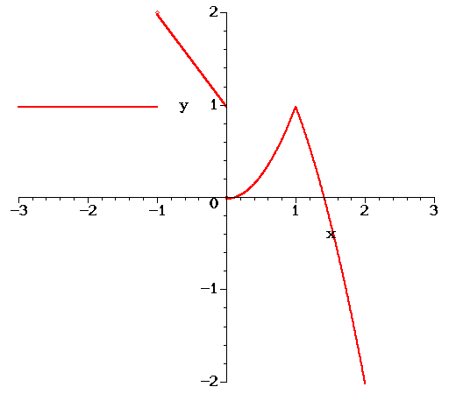a) 

b) 

c) 

d) 

e) Is f continuous at x = 0?

f) Is f continuous at x = 1?

g) Is f differentiable at x = 0?

h) Is f differentiable at x = 1?

Consider the graph shown below and answer the following questions:

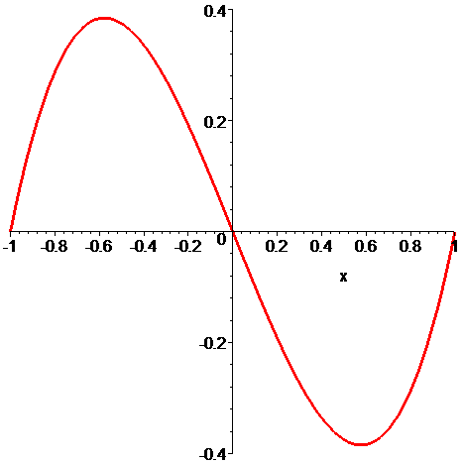

*f’(0.55) (first derivative)*

*f’’(0.55) (second derivative)*

*f’(0) (first derivative)*

*f’’(0) (second derivative)*

*f is* ***decreasing*** *on the interval(s):*

*f is* ***concave down*** *on the interval(s):*

Differentiate and simplify

 

 

 

Consider the function . Identify all critical points. State the intervals over which the graph is increasing, decreasing. Identify any absolute or relative extrema. Do the same for . Then do the same for $y=2x^{4}-4x^{3}$ as well as for $y=4x-e^{x}$

Investigate concavity, i.e. intervals where f is concave up or down and inflection points if any, of

a) 

b) 

Carefully sketch the graph of. Identify all critical points and points of inflection. State the intervals over which the graph is increasing, decreasing, concave up and concave down. Identify any absolute or relative extrema as well as any inflection points. Do the same for the graph of as well as for $y=2x^{4}-4x^{3}$.

To provide security, a manager plans to fence in a 10,800 square feet rectangular storage area adjacent to a building. The fence parallel to the building costs $3 per foot, the other two sides cost $2 per foot. Find the length and width of the dimensions that minimize the cost of fence.

A supermarket manager wants to establish an inventory policy for frozen orange juice. He finds that his inventory costs each month are  dollars, where x is the number of cases of orange juice. How many cases should he order each month to minimize his inventory costs?

The analysis of the daily output of a factory assembly line shows that about  units are produced after t hours of work. The factory currently operates 4 hours a day but management is thinking about operating it a little longer. Would the output increase or decrease?

The Consumer Price Index (CPI) of an economy is described by the function , where t is time in years and t = 0 corresponds to the year 2004. Will the CPI increase in 2010?

Suppose the cost function of making q throw rugs is . Find the marginal cost function as well as the marginal cost for q = 3. What does that mean? Find the fixed cost. What does *that* mean?

Suppose the cost for producing q items is . Find the marginal cost function as well as the marginal cost for q = 2. What does that mean? Find the fixed cost. What does *that* mean?