StatCrunch Mobile: Quick Overview
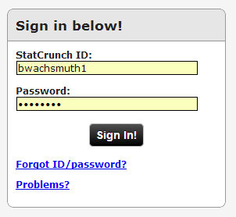
Statcrunch has an “app” that works on any phone with a web browser that supports “HTML 5”. In particular, it works on iPhone, Android, and WinPhone cell phones more or less equally well.
To load “StatCrunch Mobile”:
- Open browser app on your phone
- Enter www.statcrunch.com/mobile. You might want to create a bookmark (favorite) for that web site, or pin it to your home screen.
- Enter your usual StatCrunch login credentials (same as for the regular StatCrunch web site)
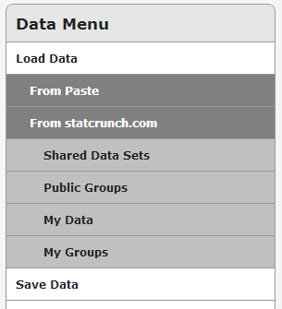
To load a data set:
StatCrunch mobile can load data sets from “My Data”, from a “shared data set” (via statcrunch.com), or via cut-and-paste. You can also enter your own data from scratch. Note, however, that you cannot load data from a web site (but you could first load such data from the regular StatCrunch web site, so that it will be available in “My Data” through the mobile app later). As an example, here is how to load shared data from a publically available data set, which your instructor can prepare for you.
- Make sure you are logged in to www.statcrunch.com/mobile
- Tap “Data”
- Tap on “Load Data”
- Tap on “From statcrunch.com”
- Tap on “Shared Data Sets”
- In the search box that opens up, type “life” and hit Go
You should see the data set “life.xls”, provided by owner “bwachsmuth1” (yours truly). You might have to scroll down to locate that set. Tap that set to load the data. It will show up in a standard, editable spreadsheet table with several buttons on the top.
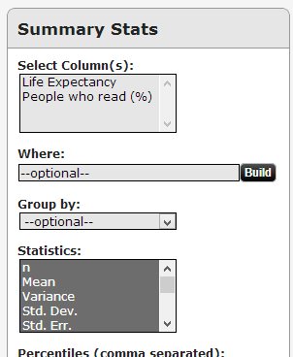
To perform some statistical analysis
The mobile version of StatCrunch offers most of the same options as the regular version. As an example, let’s find the average literacy rate and life expectancy of various countries in the world.
- Sign in and load the data set “life.xls”
- Tap the “Stat” button
- Select “Summary Stats”, then “Columns”
You should see the dialog on the right.
- Tap “Select Column(s)” and check both “Life Expectancy” and “People who read (%)” variables
- Tap “Compute” to perform the actual computation.
Note: Never tap the “return” button of your phone to return to a previous screen. That button will likely return you to the login screen and you may have to login and start from scratch. Instead, use the “Back” and other buttons on top to navigate.
Homework
- What is the mean and median life expectancy and literacy rate?
- Is the life expectancy variable normal or skewed? If skewed, is it to the right or left? Does this match up with (a)?
- Create a scatter plot of literacy rate (x) by life expectancy (y). Does it look like they are related? Confirm your answer using the correlation coefficient.
- Load the shared data set “body_temp_heartbeat”. Determine the mean temperature and heart rate grouped by sex.
- In the “temp” data set, does “Sex = 1” stand for male or female? Use the web to help with your answer.
- Is there a linear correlation between body temperature and heart beat? Justify your answer (correlation coefficient).

