Worksheet on Proportions

- Researchers are comparing the attitudes of male college students toward their fathers with their attitudes toward their mothers. 100 subjects were selected for study and they described their attitude on a scale from 1 (poor) to 10 (excellent). The data for the samples is summarized as follows:
 | Sample Size | Mean | Standard Deviation
Attitude toward Father | 100 | 8.4 | 2.2
Attitude toward mother | 100 | 7.8 | 3.1
Test whether the male students’ attitudes toward their fathers differ from their attitudes towards their mothers

2. True or false
  - If the probability of success in a proportion is .75, then the probability of failure is 0.5.
  - If the probability of success is 0.6 then the standard deviation is 0.24
  - If we compute the standard error in a proportion experiment with n = 100 and PI = 0.3, we get 0.0458, approximately.
  - If we flip a coin 144 times and find that heads shows up 100 time, while tail occurs 44 times, then a 90% confidence interval is from 0.69 to 0.71

3. We are interested in which person people would have voted for, if they had voted, in 2004. In particular, we want to know if the majority would have voted for or against Georg Bush. We use our GSS data and define a proportion variable to mean 1 if a person would have voted for Bush, and 0 if not. With the help of StatCrunch we conduct a test for propoprion Pi = 0.5 and find the following output:
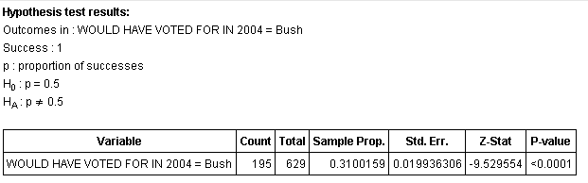
What is your conclusion?

4. For the same setup as in the previous question, we have used StatCrunch to compute the confidence interval for Pi, the probability of success. We find:

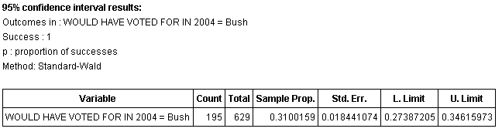

What does this mean and how does it connect to your result in the previous question.

5. We suspect a coin to be not fair. Suppose we flip that coin 200 times and we come up with 94 heads, 106 tails. Based on this evidence, do you think the coin is unfair?

6. We conduct a survey to ask people if they are for or against Hydraulic fracturing in a particular county. The survey asked 265 people, 116 came out for the practice, 149 against. Compute a 95% confidence interval for the probability of voting for hydraulic fracturing. If you were to advise a congress person to represent her district accurately, would you advise her to vote for or against the practice?

