MATH 1203 – Practice Exam 1
This is only a practice exam. The actual exam may be different from this.

1. Please state, in your own words, what the following terms mean
a) Population
b) Sample
c) Homogeneous distribution
d) Categorical variable
and any other term we discussed in class

2. Please decide if the following statements are true or false.
a) To compute the variance, you must first compute the median
b) A box plot can help you to decide whether a distribution is skewed to the right or left.
c) The mean is influenced by extremely large or extremely small values
d) The standard deviation is the square of the variance
e) The variance is the square of the standard deviation
and other similar questions

3. Below is a short segment from a (fictitious) survey questionnaire. How many variables can you identify? For each variable, state whether it is nominal, ordinal, or numeric.

Please state your height in cm:
____________

What is the color of your eyes:
[ ] green
[ ] brown
[ ] other

In which age group do you fall:
[ ] under 20 years
[ ] 20 to 50 years
[ ] over 50 years

4. Use the frequency distribution listed below to answer the following questions:
OPINION OF FAMILY INCOME | a) What percentage of the sample thinks their family income is far below average?  b) What percentage of the sample thinks their family income is less than average  c) What percentage of the sample thinks their family income is average or better
   |  | Freq. | Percent | Valid Percent | Cumulative Percent
  Valid | FAR BELOW AVERAGE | 177 | 6.1 | 6.2 | 6.2
   | BELOW AVERAGE | 700 | 24.1 | 24.4 | 30.6
   | AVERAGE | 1384 | 47.7 | 48.3 | 78.8
   | ABOVE AVERAGE | 534 | 18.4 | 18.6 | 97.5
   | FAR ABOVE AVERAGE | 73 | 2.5 | 2.5 | 100.0
   | Total | 2868 | 98.8 | 100.0
  Missing |  | 36 | 1.2
  Total |  | 2904 | 100.0

5. Suppose a random sample of size 10 taken from the GSS survey shows that the age for that sample are as follows:

28, 32, 33, 28, 29, 30, 30, 28, 32, 30

a) Find the mode, the mean, and the median for this data
b) Find the range, variance, and standard deviation for this data
b) Find Q₁, Q₃, and the IQR for this data
c) Draw an approximate box plot for this data

6. A random sample of size 25 selected from the GSS shows the following distribution for the highest degree of the respondent.
RS HIGHEST DEGREE
 | Freq | Percent | Valid Percent | Cumulative Percent
LT HIGH SCHOOL (0) | 10 | 40.0 | 40.0 | 40.0
HIGH SCHOOL (1) | 9 | 36.0 | 36.0 | 76.0
JUNIOR COLLEGE (2) | 1 | 4.0 | 4.0 | 80.0
BACHELOR (3) | 3 | 12.0 | 12.0 | 92.0
GRADUATE (4) | 2 | 8.0 | 8.0 | 100.0
Total | 25 | 100.0 | 100.0

a) Is this distribution heterogeneous or homogeneous?
b) Find the mean, mode, and median for this distribution.
c) Find Q₁, Q₃, and the IQR.

7. Please match the following statements to the distribution pictures below.

i) Skewed to the Right ii) Skewed to the Left

(a) Mean less than median (b) median less than mean

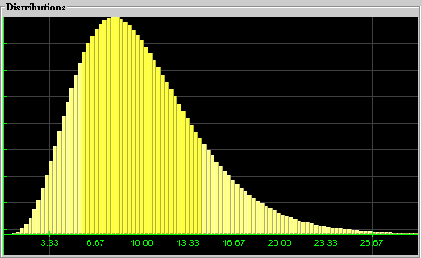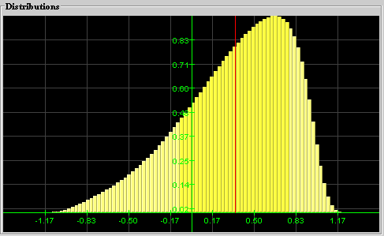
(1) (2)

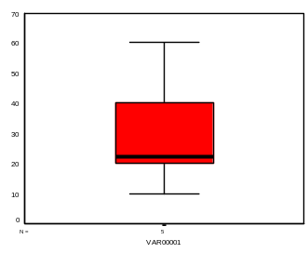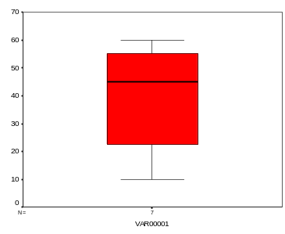
(*) (**)

Additional questions are possible. Please review our lecture notes and all quizzes. In particular, make sure you understand how the variance is related to the picture of a distribution.

