Review Questions
- Why do we use a programming language instead of programming in plain English (or German, Spanish, French, etc.)?

- What three steps are necessary to create a working computer program?

- One of the named components of the NXT Kit refers to the small black & white screen of the brick. Do you use LCD, Lcd, or either one to refer to that component? Why?

- What are the exact names for at least three components of the NXT Kit that can be addressed by name?

- For the Sound component, name at least three functions that are supported by that component.

- What does the following working program do (be as precise as possible):
public class MysteryProgram
{
public static void main(String args[])
{
LCD.drawString(“What’s up?”, 0, 0);

Sound.beep();
Sound.pause(2000);
Sound.buzz();

LCD.drawString(“Good bye”, 0, 1);
}
}

- What is the name of the above program?

- The program below contains many mistakes, as you can see from the warning sides on the left side. Explain each mistake ad state how to fix it. Note: there are 6 (six) mistakes – find 5 of them (or list them all for extra points).
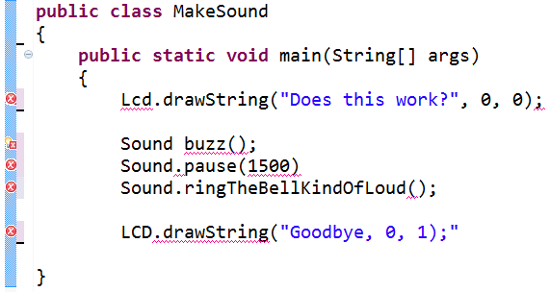
- Create a complete, working program to play a single note, display “thanks” on its screen, then quit.

- Bonus question: You should find at least 4 different sensors in your NXT Kit. Two are passive sensors, two are active sensors. Which ones are active, which ones passive?

