Creating Our First Java Program
Here is a step-by-step guide to create a Java program for your EV3 brick. Programs can consist of multiple files, so they are combined into “projects”. Thus, we first need to create a new project:
- Start “Eclipse”
- If asked, accept the default choice of workspace (the folder containing all your programs).
- In the left “Package Explorer” window, expand a project, if there is one, or create one if necessary:
  - Select from the menu “File | New | Project …”
  - Expand “LeJOS”, select “LeJOS EV3 Project” and click Next
  - Give your project a name (e.g. Test)
  - Check the option “Use an execution environment JRE:” and make sure it says “JavaSE-1.7”
  - Click Finish to create your project
- To create a new program, right-click on a project and select “New | Class” (in the Java language a class is the same as program)
- In the dialog that opens, give your class a unique name, i.e. a name different from any other program already there (use only letters and numbers, no spaces or special characters). Note that by convention class names should start with a capital letter.
- Check the box to create the method stub “public static void main …” and leave the remaining options in place
- Click “Finish”
You should now see an empty program, or class, similar to the following (if your opening curly bracket is not on a line by itself, just edit your document accordingly):
public class Test {
/**
* @param argse
*/
public static void main(String[] args) {
// TODO Auto-generated method stub
}
}
This program, or class, is called “Test” (in this case) and does – nothing at all. We need to add code that our robot can execute, and to ensure that our robot knows where to start, the first portion of code is always (almost) the same. Rearrange the text to make your program look like this:
public class Test
{
public static void main(String[] args)
{
}
}

If you make any mistake, like using the wrong kind of brackets, misspelling a word, changing the capitalization of a word, adding or forgetting anything, your program will not work and Eclipse will underline your error as well as put a red marker on the left. You can hover over that marker with your mouse to get more details about the error, or click on the error to select from a list of potential fixes for your error. However, often it is more complicated to diagnose and fix the error, but this gives you some idea to try.
Now our program is complete and contains one function called “main”, but it still does – nothing. To make the robot perform some action, you need to add code to the function called “main”. That code is the heart of your program, the rest is merely a framework that remains the same for most programs. For now, just add two lines exactly as follows:
public class Test
{
public static void main(String args[])
{
System.out.println("Yo, dude");
Delay.msDelay(3000);
}
}

Compiling and Executing Our First Java Program
We have just created our first Java program- but actually it is just a typed-up document, much like a foreign-language paper written in Word. The technical term for this file is source code. We need to translate it into machine code and then transfer it to our “brick” before we can finally execute it. Fortunately, all these things can be accomplished with a single click on the green “run” button:
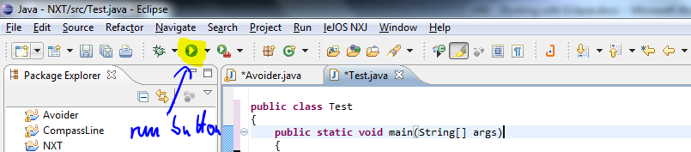
If you press that button for the first time, a “Run as” dialog might come up. Pick “LeJOS EV3 Program” and press OK. First, however, make sure:
- the brick is plugged into your computer via USB cable
- the brick is turn on
The most common mistake at this point is that your brick is no longer connected to your laptop. If everything is going according to plan, the following will happen:
Compiling the Source Code: This process translates the source code from the Java language to machine language (strings of 0’s and 1’s). You might be reminded to save your file (do so), but you should not see any problems or errors.
Transferring the Program to the EV3: Once the program compiled, it is transferred to your brick, as long as it is connected and turned on.
Executing the Program: Your brick will execute your code, i.e. step through it line by line and perform exactly the actions you specified, no more and no less.
Every time you change your source code you need to move through these steps again. Try it now!

