Desktop Environment
Min Hur

CSAS 2213: C and Unix

Dr. Bert G. Wachsmuth

March 1, 2004

Desktop Environments

Desktop environments are both a control framework and an interaction framework for programs that run on X Windows and the user. The desktop environment often includes a window manager that is specifically required by the desktop environment. It is an interaction framework because it provides a means for programs to communicate with one another in a very high-level way. The desktop environment is an optional component, since many window managers offer sufficient functionality to negate it as a requirement, but in order to make more advanced features available, a desktop environment is required.

Following the Authentication Configuration screen, users installing Red Hat Linux 9 will run into the Defaults Packages screen. For example, if you were to perform a Personal Desktop installation, you may see screen such as this:
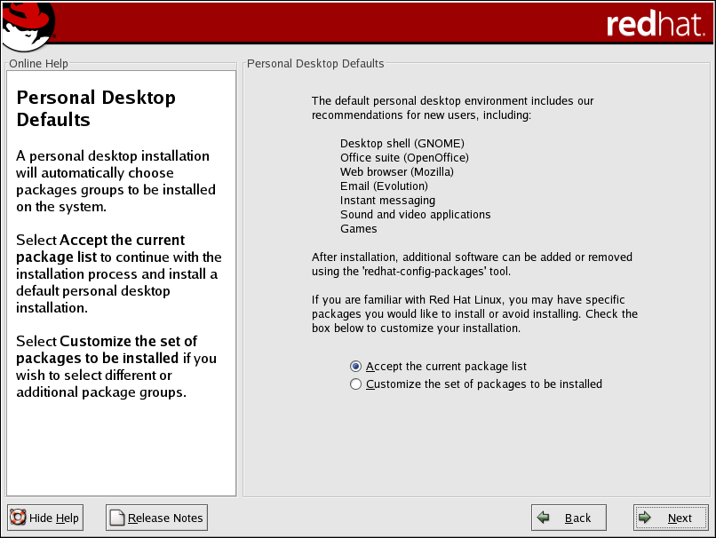
At this point users can either accept the current package list, which will install the default packages recommended by Red Hat Linux, or customize the set of packages to be installed.

Upon choosing to customize the set of packages installed, the following screen will come up next:
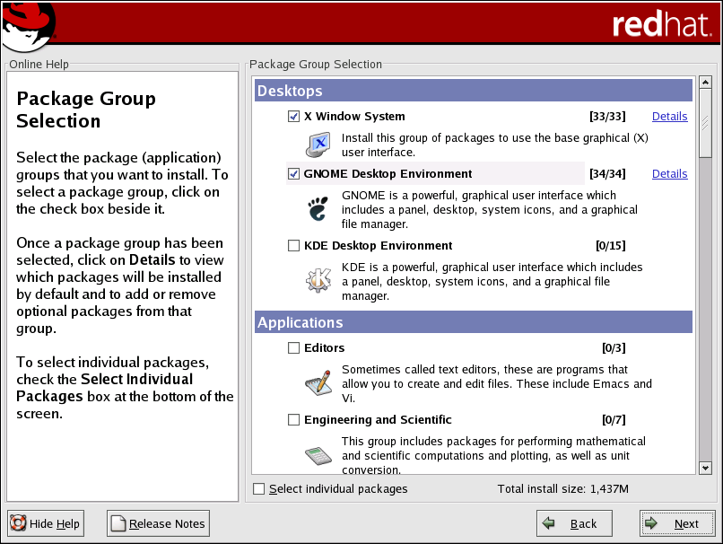

X Window System
X Windows is a graphical user interface for UNIX systems. It is a set of programs and protocols that work together to make a complete interface of familiar features like windows, icons, menus, and a pointer.

Gnome Desktop Environment
GNOME stands for GNU Network Object Model Environment. It is the default desktop environment for Red Hat Linux based on the GTK+ 2 graphical toolkit.

KDE Desktop Environment
KDE stands for K Desktop Environment. It is an alternative desktop environment based on the Qt 3 graphical toolkit.

KDE vs Gnome: Comparison Chart

 | KDE | Gnome
Founder | Matthias Ettrich | Miguel de Icaza
Start Date | October 1996 | August 1997
Current Ver. | KDE 3.2 - FEBRUARY 3, 2004 | GNOME 2.4 - September 2003
Architecture | - Qt (cross platform graphical widget toolkit)  - KParts (lightweight in-process graphical component framework)  - KWin (window manager)  - DCOP (system for communication between processes)  - aRts – (soundserver)  - KHTML – (HTML engine) | - GTK+ (Widget toolkit)  - Pango (Layout and rendering of internationalized text)  - ATK (Accessibility toolkit)  - Orbit (a CORBA ORB for software components)  - Bonobo (a compound document technology)  - GNOME VFS (a virtual File system)  - GConf (for storing application settings)  - Gstreamer (multimedia framework for Gnome applications)
Major Native Applications | - Konqueror - File manager and web browser using KHTML  - Kopete/Kmess* - Instant messager  - Kate – Text editor  - Krita – image editor  - Kword – word processor  - Kspread – spreadsheet  - KMail - Email client | - Nautilus - File manager  - Gabber/Gaim* - Instant messenger  - Galeon - Web browser based on Mozilla  - Gedit - Text editor  - The Gimp - Advanced image editor  - Abiword - Word processor  - Gnumeric - Spreadsheet  - Ximian Evolution - Contacts/Time management and e-mail.
*not strictly a KDE/Gnome Project
K Desktop Environment
KDE is a network transparent contemporary desktop environment for UNIX workstations. KDE seeks to fill the need for an easy to use desktop for Unix workstations, similar to the desktop environments found under the MacOS or Microsoft Windows. KDE offer variety of programs for the user such as:

Kicker
Kicker is the application launcher panel of the K Desktop Environment. Besides the K Menu, where you can start applications, Kicker is also capable of running docked applets like the pager, the taskbar or the clock, and extensions, such as child panels.

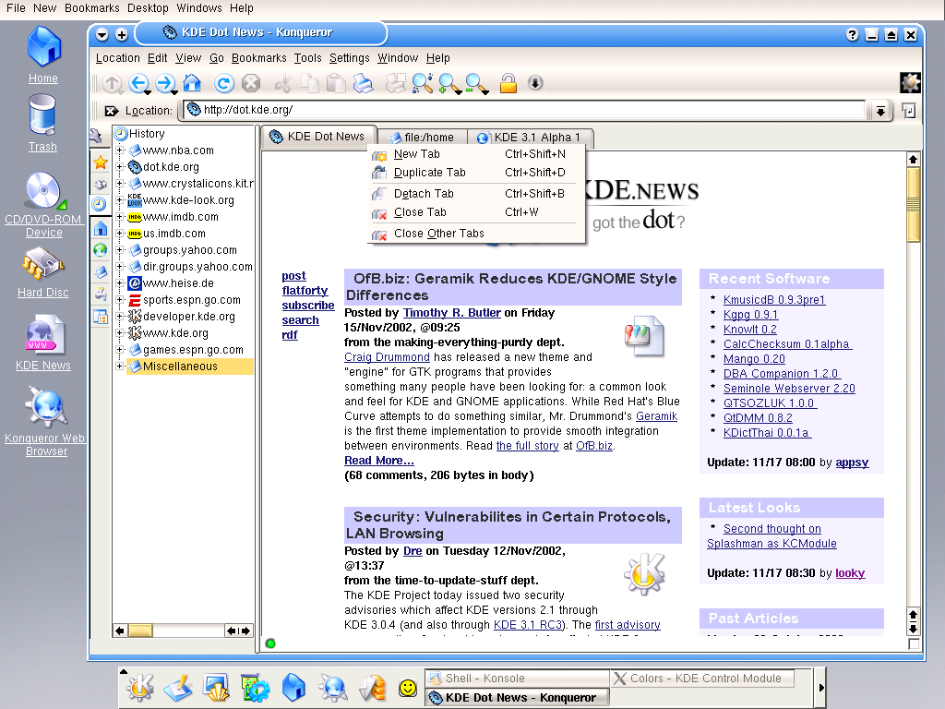
Konqueror Browser
Konqueror is an advanced file manager for the K Desktop Environment, providing file management functions ranging from simple cut/copy and paste operations to advanced local and remote network file browsing. Konqueror can also be used as a highly configurable web browser, FTP client, and a universal viewing application, capable of displaying images and documents without having to launch another application.
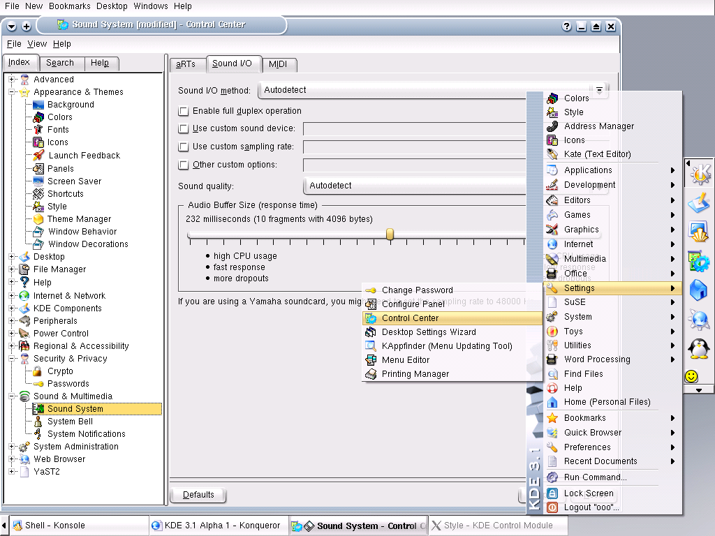
The KDE Control Center
The KDE Control Center (from now on referred to simply as “the control center”) provides you with a centralized and convenient way to configure all of your KDE settings. The control center is made up of multiple modules. Each module is a separate application, but the control center organizes all of these programs into a convenient location.

KOffice - Integrated Office Suite
KOffice is a free, integrated office suite for KDE, the K Desktop Environment.
In the KOffice suite variety of parts are being developed such as:
 KWord - A word processor capable of professional standard documents.
 KSpread - A powerful spreadsheet application,
 KPresenter - A full-featured presentation program.
 Karbon14 - A vector drawing application.
 Krita - A pixel-based image manipulation program.
 KChart - An integrated graph and chart drawing tool.
 Kexi - Integrated Database Environment Access.
 Filters - Import and Export Filters for KOffice.
KDE vs Gnome: the License Debate

The debate over which desktop is better was originally focused on the fact that KDE was not true free software. KDE was started at the end of 1996, and to make a graphical desktop environment, the KDE developers needed a programming toolkit. At the time, no free programming toolkit was available, so the KDE guys started using the Qt toolkit, made by a Norwegian company named TrollTech. However Qt was not free software, so many people started flaming the KDE guys and questioned why they didn't use a completely free environment. Thus the argument over which desktop is better involved some philosophical issues.

In reaction to such bashing on Qt license not being free, Trolltech created the QPL (Q Public License) which was recognized to fit the Open-Source criteria on 1999.
Although this step by Trolltech seemed to have soften the debate at first, it was heated up again by an announcement on August 2000 at the LinuxWorld Expo that Gnome, Sun, Compaq, Red Hat, Turbo Linux and others would support Gnome as the standard desktop for Linux.

Taking the developer’s point of view
First thing that should be covered is the difference in license between Qt and GTK. If you want to sell proprietary Qt-based application on any platform, you’re going to have to purchase development licenses from Trolltech. With this in mind, someone can argue that this will not attract the developers to use Qt library, thus less programs will be “made for KDE.”

What does this mean to the users?
Although it is true that more programs will be written using the GTK library, this does not mean it will be better to use Gnome based on the premise that Gnome is better suited for GTK programs. When an application is "made for Gnome" or "made for KDE" this really only means that the program uses a set of library functions found in their underlying gnome-libs or kdelibs. You do not need to use the actual desktops to use the applications, software made for KDE and Gnome can be used with any window manager/desktop as long as you got the proper libraries installed. There is no reason to use only applications made for the desktop you are using, you will find that the "best software" for one task is made for KDE, the best for another task is made for Gnome. Unless a day comes when GNOME integration is outrageously compelling and you cannot use the integrated features under KDE, you can rest assured from feeling completely limited to using one desktop over the other based on the application you use.

Recommendation
Any knowledgeable Linux user/developer will tell you that there is no such thing as the best desktop in Linux. It’s all a matter of preference. You can argue about it, but can’t really put a stamp on which one really is better. The beauty about open-source is the freedom of choice, so pick the one that is most comfortable for you. However, if you are still unsure as to which desktop to use, here are some guidelines you can follow.

The Default Desktop of Your Distribution
All distribution give preferential support and integration to one or several desktops. If you are installing Red Hat, the default preference of desktop is Gnome, while SuSE prefers KDE. There are also other distributions like Mandrake, where both KDE and Gnome are equally supported. All things aside, it is generally a good idea to use your distribution's favorite desktop. It will be less hassle since it's the default installation and configuration. Integration and the "polish" will also be better, default settings being usually just fine. It's also easier to get support, since most peoples using this distribution will use it as well.

Applications You Use
The fact is that some applications just run better in one desktop than others. If you know that certain application that you intend to use run better in one than the other, pick that as your desktop. If don't know the libraries used by your applications, just try them both desktops and see if it makes any significant difference. For some applications it will, for others it will not. Thus, your favorite applications may help you determine which desktop you should use.

Need for Eye candies
Gnome and KDE certainly have difference in looks. Again, choice between these two is only a matter of personal preferences. You can even decide to apply different themes on the desktops. If you decide to apply the themes, you need to install the desktop that was your theme was intended to be used with. Visit the site http://themes.freshmeat.net for themes you might want to use.
Bibliography

KDE Hompage – Conqueror your Desktop!: http://www.kde.org
GNOME: The Free Linux Desktop Project: http://www.gnome.org
KDE – Wikipedia: http://en.wikipedia.org/wiki/KDE
GNOME – Wikipedia: http://en.wikipedia.org/wiki/GNOME_desktop
GNOME vs. KDE revisited: http://www.linuxworld.com/story/32760.htm
KDE 3.1 vs. GNOME 2.2: http://www.linuxworld.com/story/32640.htm
GNOME vs. KDE: http://www.developer.com/open/article.php/629891

