The Kondratieff Theory
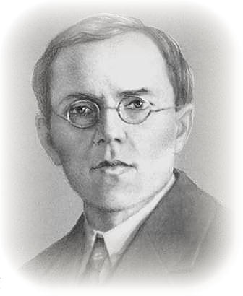
Nikolai Dmyitriyevich Kondratieff (1892 - 1938)

Who Was Kondratieff?
To introduce the Kondratieff Theory, we must go back over seventy years and examine a remarkable story in economic history, encompassed within the life of one still little known man. I am certain that, in time, Kondratieff will rank with the giants of discovery as Einstein and Newton. Like these men, his insights have begun to alter radically and permanently our perceptions of economic history. The Kondratieff wave cycle goes through four distinct phases of beneficial inflation (spring), stagflation (summer), beneficial deflation (autumn), and deflation (winter). Since, the last Kontratyev cycle ended around 1949, we have seen beneficial inflation 1949-1966, stagflation 1966-1982, beneficial deflation 1982-2000 and according to Kondratieff, we are now in the (winter) deflation cycle which should lead to depression.
Professor Nickolai Kondratieff ( pronounced "Kon-DRA-tee-eff") Shortly after the Russian Revolution of 1917, he helped develop the first Soviet Five-Year Plan , for which he analyzed factors that would stimulate Soviet economic growth. In 1926, Kondratieff published his findings in a report entitled, "Long Waves in Economic Life". Based upon Kondratieff's conclusions, his report was viewed as a criticism of Joseph Stalin's stated intentions for the total collectivization of agriculture. Soon after, he was dismissed from his post as director of the Institute for the Study of Business Activity in 1928. He was arrested in 1930 and sentenced to the Russian Gulag (prison); his sentence was reviewed in 1938, and he received the death penalty, which it is speculated was carried out that same year. Kondratieff's major premise was that capitalist economies displayed long wave cycles of boom and bust ranging between 50-60 years in duration. Kondratieff's study covered the period 1789 to 1926 and was centered on prices and interest rates. Kondratieff's theories documented in the 1920's were validated with the depression less than 10 years later.
Today, we are faced with another Kondratieff Winter (depression) when the majority of the world anticipates economic expansion. Each individual needs to weigh the risk of depression in light of Kondratieff's work.

Accumulation and Consumption
U. S. wholesale prices dating back to 1800 show several periods of accumulation followed by periods of over consumption. Because these periods are statistically difficult to measure our outline follows historical events, pinpointing major changes in trend. During periods of relatively cheap prices, assets accumulate. As prices increase, the consumption of assets are necessary to maintain a standard of living. When new production fails to keep up with consumption, due to relatively high prices, the economy begins to decline to another period of cheap prices, and a new growth cycle begins.

Four Phases of One Cycle
A Kondratieff cycle consists of four distinct phases, or distinguishable, dramatic mood changes, the tone of which determines the actions of individuals involved in the economy. The awareness of these characteristics allows for the anticipation of the change in the economy and the psychological mood that will prevail.

SPRING - Inflationary Growth Phase
A common premise among business cycle economists supposes inflation as an inevitable part of growth. Government becomes a passive participant in the inflation cycle. Growth begins from a depressed economic base and expands in an ever-increasing spiral. The interaction of the participants within the economy causes wealth, as represented by savings, and the production of capital equipment to be accumulated for the future. The expansion of production and affluence causes prices to rise, and the increased volume of goods requires a higher velocity of money, thus creating a higher price structure.
Historically, the growth phase requires 25 years to complete. During this time, unemployment falls, wages and productivity rise and prices remain relatively stable. The mood of the growth phase is one of accumulation and the desire for new product manufacture.
Accompanying growth is a shift in social demands. As wealth is accumulated and new innovation introduced great upheavals and displacements take place. The process of social unrest builds with growth culminating in massive shifts in the way work is defined and the role of the participants in society.

SUMMER - Stagflation (Recession)
Eventually, the continuation of exponential growth reaches its limits. Excess capital produces a shortage of key resources and the economy enters a period where growth creates a shortage of resources. An economy will only support expansion to the limits of its resources, both human and material.
The mood of affluence also brings a change in attitude towards work. As an economy gets closer to its limits inefficiencies build up
The imbalances of this period have been historically exaggerated by what can be labeled a "peak war". Examples such as War of 1812, the Civil War, World War I and Vietnam, came at the end of a very affluent period. These Wars produce strains on the economy increasing the impact of inflation. A dramatic drop in output, rapid rise in unemployment and unusually severe recession characterize this period. Although this primary recession is short lived lasting only three to five years, it is key in altering perceptions and the structure of the economy. No longer does excess create an abundance. The "Limits to Growth" now define a maximum level of economic activity that traps the economy into consolidation and tight bounds for the next 20-25 years. With the change comes a conservative shift in the popular mood reinforcing the limits..

AUTUMN - Deflationary Growth (Plateau Period)
The primary recession occurs out of an imbalance forced upon the economy by real limitations. The rapid rise in prices and changes in production correct this imbalance -- at least temporarily. The change in price structure, along with the mood of a population used to consumption accompanied by the vast accumulation of wealth from the past 30 years, causes the economy to enter a period of relatively flat growth and mild prosperity. Due to structural changes and the limits of the existing paradigm the economy becomes consumption oriented.
Excesses of an unpopular war, along with fiscal liberalism, cause popular reaction toward stability or normalcy. A mood of isolationism permeates . The plateau period generally lasts seven to ten years and is characterized by selective industry growth, development of new ideas ( both technological and social ) and a strong feelings of affluence, terminating in a feeling of euphoria. The inflated price structure from the primary recession, along with the desire for consumption, produces a rapid increase in debt. Eventually, wealth consumption expands beyond all practical limits, and economy slips into a severe and protracted depression.

WINTER - Depression
Excesses of the plateau period effect a collapse of the price structure. This exhaustion of accumulated wealth forces the economy into a period of sharp retrenchment. Generally, the secondary depression entails a three year collapse, followed by a 15 year deflationary work out period. The deflation can best be seen in interest rates and wages that have shown a historic alignment with the timing of the Long Wave - peaking with and bottoming at the extremes.
Kondratieff viewed depressions as cleansing periods that allowed the economy to readjust from the previous excesses and begin a base for future growth. The characteristic of fulfilling the the expectations of the previous period of growth is realized within the Secondary Depression or Down Grade. This is a period of incremental innovation where technologies of the past period of growth are refined, made cheaper and more widely distributed. Incremental innovation consolidates industries.
As increment innovation narrows profits and increases
The Down Grade sees one final period of recession before transitioning to a new period of growth. The final recession is mild with very low inflation and appears far more severe than it will be remembered for later in the Growth Cycle.
Within the Down Grade is a consolidation of social values or goals. Ideas and concepts introduced in the preceding period of growth while radical sounding at the time become integrated into the fabric of society. Often these social changes are supported by shifts in technology. The period of incremental innovation provides the framework for social integration.
It is important to realize the Long Wave as global. While global issues are of prime importance today with increased air travel and communication, the Long Wave defines a time table for geo political events. The Growth Period is one of political stability. Staring a the peak old alliances become challenged. Through the process of the Down Grade old alliances fail and new alliances are formed. The final stages of the Down Grade is a period of coalescing or "quickening" of the alliances that will govern the next period of growth.

Current Economic Cycles
With four distinct phases in the K-wave a number of analysts have compared them to the seasons. Spring (inflationary growth, expansion), summer (stagflation, recession), autumn (deflationary growth, plateau) and winter (depression).
Our chart below summarizes the generally accepted phases since 1784 in the United States. We have noted the significant wars that accompanied the recession (price peak) and depression (trough) phase. We have also noted the tag name for the Autumn periods that were characterized by massive debt growth and speculative bubbles.
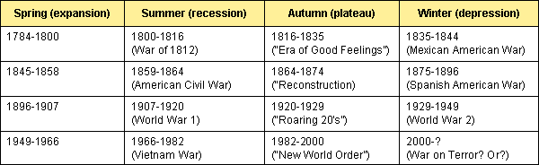

Many have argued as to whether the Kondratieff wave is valid for the post WW2 economy given the fiscal and monetary tools of a modern economy. Others have argued that trough of the K-wave has already passed. Their count is from the stock market trough of the Great Depression in 1932. Add the average 54-year K-wave period and we are in the spring expansion of the new K-wave.
But what the Kondratieff wave is about is a study of long cycles of debt buildup and repudiation. It is not exclusively about price inflation and deflation periods. Deflation is caused in part by the debt collapse. It is also a generational thing as the next cycle of debt buildup and collapse is renewed every 2-3 generations as the previous generation that went through comparable periods dies off. The old adage that "this time it is different" means the circumstances are different, yes, but they fail to recognize that the previous period was the same in terms of excesses and therefore the end result is the same.
Most analysts take the last K-wave to have made its final trough in 1949 when interest rates and prices bottomed. The effects of the Great Depression were softened by WW2 and it was in the 1950's that the world firmly started to shake off the long two decades of depression and war. The K-wave has followed quite true to form with the solid growth and low inflation of the 1950's and 1960's followed by the commodity/price inflation and recession driven 1970's. Commodity prices peaked in 1980.
Following the steep secondary recession of the early 1980's the markets embarked into the Autumn K-wave plateau. We had stock market and real estate bubbles, a collapse in commodity prices, a collapse in interest rates and low inflation. But we also had a huge build up in debt that allowed us to buy our way out of the recessions of the early 1980's and early 1990's. Each succeeding recession required higher levels of debt to purchase an additional dollar of GDP.
Now the debt has become unsustainable and the ability to buy our way out of further problems is severely compromised. One only needs to look at the decade long nightmare of Japan to see that zero interest rates and all the stimulation in the world has failed to bring it out of its slump. We are witnessing merely the beginning of the debt implosion that inevitably follows the excesses.
The collapse of the tech market and NASDAQ, Enron, Aldelphia, K-Mart, Global Crossing, WorldCom, Arthur Anderson and numerous others are the corporate face of the scandals and the debt collapse. On the country side we have the implosion of Argentina and possibly Brazil, which would imperil all of Latin America. African countries never seem to be out of bankruptcy. As the job losses mount the consumer driven economy will fall into a deep funk and the consumer will go through their own debt implosion.
As occurred at the end of previous Autumn plateau K-wave's (1920-1929) the winter that followed revealed numerous financial scandals. This one has been no different. Enron and WorldCom are big and visible but are they merely the tip of the iceberg? The Autumn plateau K-wave brings on excesses in both the stock market and the board room. Even the early part of the Autumn plateau K-wave had its share of scandals and debt implosions with the insider trading scandals of the 1980's followed by the debt implosion and scandals of the Savings & Loans. If the 1990's were a decade of loss of faith in government for its excesses of debt buildup then the first decade of the millennium will see the same occur with capitalism and the corporation..
We have entered the downside of the current K-wave. This wave could last anywhere from nine to twenty years as we saw in earlier winter K-waves. The K-wave is the rise and fall of a generation and covers both the social and economic life of the period. The ancient Mayans knew of the inevitability of the cycle and took steps to mitigate its effects (although ironically in the end it did not save them). Our challenge will be to see that we come through so that once again we can rebuild.
The current winter K-wave is still young. We have noted in the past that following a speculative bubble things have a tendency to return to where they started or stated another way the gains of the previous period are wiped out. Already some stocks such as Nortel Networks have fallen 98%. Other big names are just disappearing period. We highly suspect that the NASDAQ will ultimately lose at least 90% of its value from the top. That means a fall to at least 500 over the next decade. We have already fallen about 75%.
For the Dow Jones Industrials, in theory at least that could translate into a fall back to 1000. While that may be only for some super bears vivid imagination we believe that at a minimum the Dow Jones Industrials will ultimately fall at least 50%-60% or down to around 5000. The highs of January 2000 are but a dream for years to come.
The current 4-year stock cycle is coming to an end. Some thought it ended last September 21, 2001. It may still be in play and could bottom in early July 2002 although we suspect it will, following a summer rally, bottom later in the fall of 2002. That should set up a decent run in 2003, which should allow for graceful exits for those still caught in the malaise of the first big drop. That would set the next cycle bottom for around 2005/2006, which could be the ultimate low for the markets. Time of course will tell.
The Winter of the K-wave is a dangerous period. But it will be eased for those holding gold or gold stocks. That new bull market is still in its infancy and may yet face a significant shakeout to make its final bottom. But we would all be wise to hold at least a little gold. The winter of the K-wave is upon us.
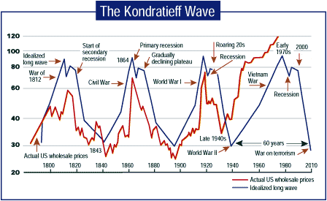
THE KONDRATIEFF WAVE. Peaks and troughs are associated with major political or cultural events.
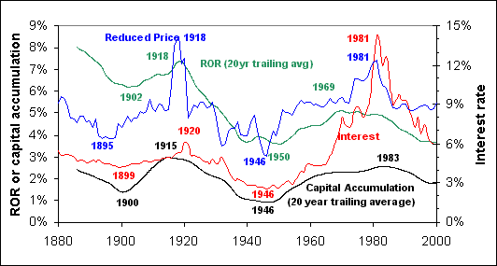

Summary
Probably Kondratieff's greatest contribution to the science of investment is not his observation the world economy operates in long cycles. Cycles would suggest a repetitive nature to events. While the underlying economic conditions will repeat over time due just to the physical nature of our world, our reactions will always be tempered by knowledge and experience. The history of man has been one long climb higher. Kondratieff recognized progress as the irreversible trend.
Imposed upon our progressive nature are the physical limits of life. It is the interaction of these physical limits with our dreams and aspirations that creates the constant push pull of the economy known as the Long Wave.

