Lebesgue Integration
Part 3: Lebesgue Integration
We previously defined the Riemann integral roughly as follows:
- subdivide the domain of the function (usually a closed, bounded interval) into finitely many subintervals (the partition)
- construct a step function that has a constant value on each of the subintervals of the partition (the Upper or Lower sum)
- take the limit of this step function as you add more and more points to the partition.
If the limit exists it is called the Riemann integral and the function is called Riemann integrable. Actually, the true definition is more complicated (involving upper and lower integral) but the above “description” of the Riemann integral is actually due to Riemann’s lemma. Now we will take, in a manner of speaking, the "opposite" approach:
- subdivide the range of the function into finitely many pieces
- construct a simple function by taking a function whose values are those finitely many numbers
- take the limit of this simple function as you add more and more points to the range of the original function
If the limit exists it is called the Lebesgue integral and the function is called Lebesgue integrable. To define this new concept, we use several steps:
- we define the Lebesgue Integral for "simple functions"
- we define the Lebesgue integral for bounded functions over sets of finite measure
- we extend the Lebesgue integral to positive functions (that are not necessarily bounded)
- we define the general Lebesgue integral
First, we need to clarify what we mean by "simple function". Note that whenever we mention “measurable” in this section, we are always referring to Lebesgue measurable.
Definition (Characteristic Function): For any set A the function $χ_{A}\left(x\right)=\left\{\begin{aligned}1, &x∈A \\ 0, &x∉A\end{aligned}\right.$ is called the characteristic, or indicator, function of the set A
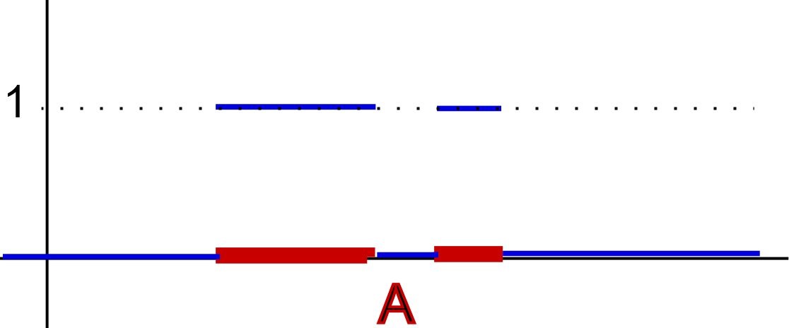
Definition (Simple Function): A finite linear combination of characteristic functions $s\left(x\right)=\sum_{j=1}^{n}{a_{i}χ_{A_{i}}(x)}$ is called simple function if all sets $A_{i}$ are measurable.
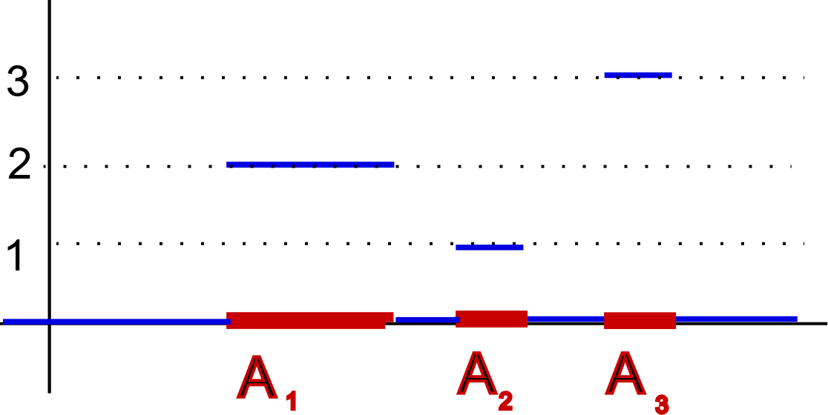
Note that every step function is also a simple function, but not every simple function is a step function. For example, the step function
$$s\left(x\right)=\left\{\begin{aligned}0, & x≤1 \\ -1, &1<x≤2 \\ 3, &2<x≤3 \\ 2, &3<x\end{aligned}\right.$$
can be written as the simple function
$$s\left(x\right)=-χ_{\left(1,2\right]}\left(x\right)+3χ_{\left(2,3\right]}\left(x\right)+4χ_{\left(3,∞\right)}(x)$$
because all intervals are measurable. On the other hand, the simple function $χ_{C}\left(x\right)$, where $C$ is the Cantor middle third set, or the Dirichlet function $χ_{Q ∩ [0,1]} (x)$ or the simple function ${s\left(x\right)=-2χ}_{C}\left(x\right)+3 χ_{Q ∩\left[0,1\right]}\left(x\right)+5χ_{\left[1,4\right]}(x)$ cannot be written as a step function.
Thus, simple functions are a generalization of step function. For simple functions we define their Lebesgue integral:
Definition (Lebesgue Integral of a Simple Function):
Suppose $s\left(x\right)=\sum_{j=1}^{n}{a_{i}χ_{A_{i}}(x)}$ is a simple function with $m\left(A_{j}\right)<∞$ for all $j$. Then $s$ is Lebesgue integrable and the Lebesgue integral of s is
$$\int{s(x)}dx=\int{\sum_{j=1}^{n}{a_{j}χ_{A_{j}}\left(x\right)}}dx=\sum_{j=1}^{n}{a_{j}m(A_{j})}$$
If E is a measurable set, then we define
$$\int_{E}{s(x)}dx=\int{χ_{E}\left(x\right)s\left(x\right)}dx$$

Example: Define two simple functions $s_{1}\left(x\right)=2 χ_{\left[0,2\right)}\left(x\right)+4χ_{[1,3]}(x)$ and $s_{2}\left(s\right)=2χ_{\left[0,1\right)}\left(x\right)+6χ_{\left[1,2\right)}\left(x\right)+4χ_{(2,3]}(x)$. Show that $s_{1}\left(x\right)=s_{2}(x)$ and $\int{s_{1}(x)}dx=\int{s_{2}\left(x\right)dx}$
Left for the reader.
Using simple function, we define the Lebesgue integral of a bounded function as follows:
Definition (Lebesgue Integral of Bounded Function):
Suppose f is a bounded function defined over a measurable set E with finite measure. Define the upper and lower Lebesgue integrals, respectively, as:
$$I^{*}{\left(f\right)}_{L}=\inf\left\{ \int{s\left(x\right)}dx:s \text{is simple and }s\left(x\right)≥f\left(x\right) \text{on} E\right\}$$
$$I_{*}{\left(f\right)}_{L}=\sup\left\{ \int{s\left(x\right)}dx:s \text{is simple and }s\left(x\right)≤f\left(x\right) \text{on} E\right\}$$
Then if $I^{*}{\left(f\right)}_{L}=I_{*}{\left(f\right)}_{L}$the function $f$ is called Lebesgue integrable over $E$ and the Lebesgue integral of $f$ over $E$ is written as $\int_{E}{f(x)}dx$
Example: Show that the function $f\left(x\right)=x$ is Lebesgue integrable over $[0, 1]$ and find $\int_{[0,1]}{x}dx$
If we had to prove Riemann integrability, we would go as follows (assuming that all we knew was just the definition of Riemann integral): Given any $ϵ>0$, take any partition $P=\{0=x_{0}, x_{1}, x_{2}, …, x_{n-1}, x_{n}=1\}$ with $|P|<ϵ$. Then:
$$\left|U\left(f,P\right)– L\left(f,P\right)\right|=\sum_{j=0}^{n}{\left(d_{j}-c_{j}\right)\left(x_{j}-x_{j-1}\right)}=\sum_{j=0}^{n}{\left(x_{j}-x_{j-1}\right)\left(x_{j}-x_{j-1}\right)}≤$$
$$\sum_{j=0}^{n}{ϵ\left(x_{j}-x_{j-1}\right)}=ϵ\left(1-0\right)=ϵ$$
because $d_{j}=x_{j}$ is the $sup$ and $c_{j}=x_{j-1}$ is the $inf$ of $f\left(x\right)=x$ over any interval $[x_{j-1}, x_{j}]$. Since $ϵ>0$ was arbitrary, it means that the upper and lower Riemann integrals agree and hence the function is Riemann integrable. Now that we know the function is Riemann integrable, we can deploy a particular, suitable partition of $\left[0, 1\right]$ to work out its actual value. Take, for example, $x_{j}=\frac{j}{n}$ for $j=0, 1, …, n$ as our partition. Then the upper sum $U(f,P)$ is:
$$U\left(f,P\right)=\sum_{j=0}^{n}{d_{j}(x_{j}-x_{j-1})}=\sum_{j=0}^{n}{\frac{j}{n}(\frac{j}{n}-\frac{j-1}{n})}=\frac{1}{n^{2}}\sum_{j=0}^{n}{j^{2}-j^{2}+j}=\frac{1}{n^{2}}\sum_{j=0}^{n}{j}=\frac{1}{n^{2}} \frac{n (n+1)}{2}=\frac{n+1}{2n}$$
which in the limit converges to $\frac{1}{2}$. Thus, we proved that $\int_{0}^{1}{x} dx=\frac{1}{2}$, i.e. the Riemann integral of x over $[0, 1]$ is $\frac{1}{2}$. However, that was just for fun, or – perhaps my idea of fun is slightly different from yours - for review.
So, how about our real question: what about the Lebesgue integral of $f(x)=x$? Just as we partitioned the domain of $f$, i.e. the $x$-axis, to find the value of the Riemann integral, we will now partition the range of $f$, i.e. the $y$-axis, into suitable intervals to find the Lebesgue integral. We will prove that this particular function $f(x)=x$ is Lebesgue integrable, but if possible we will keep the discussion valid for a general function $f(x)$. So, here we go.
We know that $0≤f(x)≤1$. Define the sets:
$$E_{1}=\left\{x∈\left[0,1\right]:0≤f\left(x\right)<\frac{1}{n}\right\}$$
$$E_{2}=\left\{x∈\left[0,1\right]:\frac{1}{n}≤f\left(x\right)<\frac{2}{n}\right\}$$
$$E_{3}=\left\{x∈\left[0,1\right]:\frac{2}{n}≤f\left(x\right)<\frac{3}{n}\right\}$$
$$….$$
$$E_{n}=\left\{x∈\left[0,1\right]:\frac{n-1}{n}≤f\left(x\right)≤\frac{n}{n}=1\right\}$$
These sets are disjoint and their union equals [0, 1]. Also note that because $f\left(x\right)=x$, each $E_{j}$ is measurable with finite measure. Now define two simple functions:
$$s_{n}\left(x\right)=\sum_{j=1}^{n}{\frac{j-1}{n}} χ_{E_{j}}\left(x\right)\text{ and }S_{n}\left(x\right)=\sum_{j=1}^{n}{\frac{j}{n}} χ_{E_{j}}\left(x\right)$$
Fix an integer n and take any $x∈[0,1]$. Then $x$ must be contained in exactly one set $E_{j}$ and on that set we have
$$s_{n}\left(x\right)=\frac{j-1}{n}≤f\left(x\right)≤\frac{j}{n}=S_{n}(x)$$
Thus, $s_{n}\left(x\right) f\left(x\right) S_{n}(x)$ for all $x∈[0,1]$ so that
$$I^{*}{\left(f\right)}_{L}≤\int{S_{n}\left(x\right)}dx=\frac{1}{n}\sum_{j=1}^{n}{j m\left(E_{j}\right)}\text{ and }I_{*}{\left(f\right)}_{L}≥\int{s_{n}\left(x\right)}dx=\frac{1}{n}\sum_{j=1}^{n}{(j-1) m(E_{j})}$$
Therefore
$$I^{*}{\left(f\right)}_{L}-I_{*}{\left(f\right)}_{L}≤\frac{1}{n}\sum_{j=1}^{n}{j m\left(E_{j}\right)}-\left(j-1\right)m\left(E_{j}\right)=\frac{1}{n}\sum_{j=1}^{n}{m\left(E_{j}\right)}=\frac{1}{n} m\left(\left[0,1\right]\right)=\frac{1}{n}$$
Since $n$ was arbitrary the upper and lower Lebesgue integrals must agree, hence the function $f$ is Lebesgue integrable.
It remains, though, to find the actual value of the integral, for which we will use the actual definition of $f(x)=x$. For a fixed $n$ we have:
$$m\left(E_{j}\right)=m\left(\left\{x∈\left[0,1\right]:\frac{j-1}{n}≤f\left(x\right)<\frac{j}{n}\right\}\right)=m\left(\left\{x∈\left[0,1\right]:\frac{j-1}{n}≤x<\frac{j}{n}\right\}\right)=m\left(\left[\frac{j-1}{n},\frac{j}{n}\right]\right)=\frac{1}{n}$$
From the above computation it follows that
$$\int{f\left(x\right)}dx=\lim_{n→∞}{\sum_{j=1}^{n}{\frac{j}{n}m\left(E_{j}\right)= \lim_{n→∞}{\frac{1}{n^{2}}} \sum_{j=1}^{n}{j}}}=\lim_{n→∞}{\frac{n\left(n+1\right)}{2n^{2}}}=\frac{1}{2}$$

Note that with a few modifications this proof could show that every bounded function f which has a certain property is Lebesgue integrable. However, it is not true that every bounded function is Lebesgue integrable.

The fact that in the above case the Lebesgue integral is the same as the Riemann integral for the function $f(x)=x$ is no coincidence.

Theorem (Riemann integrable implies Lebesgue integrable)
If $f$ is a bounded function defined on $[a, b]$ such that $f$ is Riemann integrable, then $f$ is Lebesgue integrable and
$$\int_{a}^{b}{f(x)}dx=\int_{[a,b]}{f(x)}dx$$
Proof: This proof, for once, is straight-forward: recall that every step function is also a simple function, but not the other way around. Thus, when considering $I^{*}{\left(f\right)}_{L}$ as compared to $I^{*}(f)$, the first expression takes the infimum over more items, so that $I^{*}{\left(f\right)}_{L}≤I^{*}\left(f\right)$. Similarly, $I_{*}{\left(f\right)}_{L}≥I_{*}(f)$. But then we have
$$I_{*}\left(f\right)≤I_{*}{\left(f\right)}_{L}≤I^{*}{\left(f\right)}_{L}≤I^{*}(f)$$
But now if $f$ is R-integrable, then $I^{*}(f)=I_{*}(f)$, so that $I^{*}{\left(f\right)}_{L} = I_{*}{\left(f\right)}_{L}$, i.e. $f$ is Lebesgue integrable.

We will conclude this section with two important propositions that are frequently used:

Theorem (Lebesgue Bounded Convergence Theorem)
Suppose $\{f_{n}\}$ is a sequence of L-integrable functions defined on a set $E$ with finite measure. Assume that the $f_{n}$’s are uniformly bounded, i.e. $\left|f_{n}\left(x\right)\right|≤M$ for all $x$ and all $n$ and some constant $M$. If $f(x)=lim f_{n}(x)$ for all $x in E$, then $f$ is L-integrable and
$$\int_{E}{f(x)}dx= \lim_{}{\int_{E}{f_{n}(x)} dx}$$
Proof: The proof involves one of “Litttlewood’s three principles”:
- If a set $E$ is measurable it is “almost” an open set, i.e. there exists an open set O such that $E⊂O$ and $m^{*}\left(O-E\right)<ϵ$ for any $ϵ>0$
- If a function $f$is measurable/integrable it is “almost” a continuous function, i.e. there exists a continuous function $g$ such that $|f(x)-g(x)|<ϵ$ except on a set of measure $ϵ$.
- If a sequence of measurable/integrable functions $f_{n}(x)$ converges to a measurable/integrable function $f(x)$ for all$x∈E$, $E$ measurable with finite measure, then the convergence is “almost” uniform, i.e. there is a subset $A$ of E with $m(A)<ϵ$ such that $f_{n}$ converges uniformly to $f$ on $E-A$.
Littlewood claims that most problems in analysis can be explained by one of these principles. In other words, if a statement was true for an open set, or a continuous function, or a uniformly convergent sequence of functions, it is likely true for measurable sets, measurable functions, or convergent sequences, respectively.
In our case we will use the third principle: the statement was true if a sequence of integrable functions $f_{n}$converges uniformly to $f$ on a set $E$ of finite measure (see exercises).
Now, by the third Littlewood principle there is a set $A⊂E$ with $m(A) <\frac{ϵ}{4M}$ and $|f_{n}(x)-f(x)|<\frac{ϵ}{2 m\left(E\right)}$ for all $x∈ E-A$ and for $n≥N$ such that
$$\left|\int_{E}{f_{n}}dx- \int_{E}{f dx}\right|=\left|\int_{E}{f_{n}-f}dx\right|≤\int_{E}{\left|f_{n}-f\right|}dx=$$
$$=\int_{E-A}{\left|f_{n}-f\right|}dx+\int_{A}{\left|f_{n}-f\right|}dx<\frac{ϵ}{2 m\left(E\right)}m\left(E-A\right)+2Mm\left(A\right)≤\frac{ϵ}{2}+\frac{ϵ}{2}=ϵ$$
which again implies that $\int_{E}{f_{n}(x)} dx→\int_{E}{f(x)} dx$

Note that this theorem is one of the ones that makes the Lebesgue integral “easier” to work with than the Riemann integral:
- If $\left\{f_{n}\right\}$ is a sequence of R-integrable functions converging to $f$ on a set $[a,b]$ and $\left\{f_{n}\right\}$ is uniformly bounded by M, then it does not necessarily follow that $\lim_{n → ∞}{\int_{a}^{b}{f_{n}(x)}dx= \int_{a}^{b}{f(x)}dx}$. However, for L-integrable functions this is true.
The final word in identifying Riemann integrable functions for bounded functions is Lebesgue’s Theorem:
Theorem (Lebesque)
A bounded function $f$ defined on $[a, b]$ is Riemann integrable if and only if the set of discontinuities of $f$ has measure zero.
The proof of this theorem will be discussed later.

Excercises:
  - Are simple functions uniquely determined? In other words, if $s_{1}$ and $s_{2}$ are two simple functions with $s_{1}\left(x\right)=s_{2}(x)$, do they have to have the same representation?
  - Is it true that if $A$ and $B$ are two (measurable) sets then the characteristic function of the union of $A$ and $B$ is the sum of the characteristic functions of $A$ and $B$? How about if $A$ and $B$ are two (measurable) sets then what is the characteristic function of the intersection of $A$ and $B$ equal to?
  - Find the Lebesgue integral of the Dirichlet function restricted to [0, 1] and of the characteristic function of the Cantor middle-third set.
  - Show that the function $f\left(x\right)=x^{2}$ is Riemann integrable over [0,1] and find $\int_{0}^{1}{x^{2}}dx$
  - Show that the function $f\left(x\right)=x^{2}$ is Lebesgue integrable over $[0, 1]$ and find $\int_{[0,1]}{x^{2}}dx$
  - Is the function $f\left(x\right)=x^{2}$ Lebesgue integrable over the set $E$ of rational numbers in $[0, 1]$? If so find $\int_{E}{x^{2}}dx$
  - Identify the unnamed property referred to in the proof that $f(x)=x$ is Lebesgue integrable.
  - Repeat the proof that $f(x)=x$is measurable for$f\left(x\right)= x^{2}(x^{2}-1)$ over$[-1, 1]$. Make sure to illustrate the proof by drawing the sets $E_{j}$ used in the proof.
  - Prove that every bounded function defined on a measurable set $E$ with finite measure with the property that the sets
$$E_{j}=\left\{x∈E:\frac{(j-1)M}{n}≤f\left(x\right)<\frac{jM}{n}\right\} \text{ for }-n≤j≤n$$
are measurable is Lebesgue integrable. Give an example of a class of functions that have this property and state it as a corollary of your theorem.
  - In the theorem of the previous exercise you assume that the function $f$ is bounded. Where do you need that fact in the proof?
  - Is the converse of the above theorem that every R-integrable function is also L-integrable true or false (prove or provide counterexample.
  - Prove that if a sequence of integrable functions $f_{n}$ converges uniformly to an integrable function $f$ on a set $E$ with finite measure then $\int_{E}{f(x)}dx= \lim_{}{\int_{E}{f_{n}(x)} dx}$
  - Is the Lebesgue bounded convergence theorem true for R-integrable functions?
PROJECT 2: Find a bounded function $f$ that is not Riemann integrable, and a bounded function $g$ that is not Lebesgue integrable.
PROJECT 3: Who is this guy Littlewood and what do his “three principles” say?

