**Sounds and Fourier Transform**

*Part 2: The Fourier Transform*

So far we have learned that sine (and cosine) waves correspond to sounds, from easy, single notes (such as a 440 Hz sine wave) to complete songs (with some wave function representing the sound). We have also created more complex sounds from simple ones by adding their wave functions. In this chapter we will tackle the reverse problem: given a complex sound, what are the individual sine and cosine functions that add up to the sound. In other words, we want to figure out how we can decompose for example a 3-tone chord into its 3 tones.

That should sound hard (maybe even impossible). For example, once you mix different colors together and all you have is the final color, it is difficult to figure out the original colors that make up this mixed color. But in case of sounds – and really in general as well - it *is* possible, which has a wide range of applications.

**Definition**: Given a function $f(t)$ the Fourier Transform of $f(t)$ is given by

$$F\left(f\right)=F\left(ω\right)=\int_{-∞}^{∞}{f\left(t\right) e^{-i ω t}dt}$$

where $i=\sqrt{-1}$ is the imaginary unit for complex numbers.

First, some easy observations:

* By Euler’s formula we know that $e^{it}=\cos\left(t\right)+i\sin\left(t\right)$ so we can rewrite the above formula as

$$\int_{-∞}^{∞}{f\left(t\right) e^{-i ω t}dt}=\int_{-∞}^{∞}{f\left(t\right)\left(\cos\left(-ωt\right)+i\sin\left(-ωt\right)\right)dt}=$$

$$=\int_{-∞}^{∞}{f\left(t\right)\cos\left(ωt\right)}dt- i\int_{-∞}^{∞}{f\left(t\right) sin⁡(ωt)}dt$$

because $cos$ is even and $sin$ is odd. The exponential form of the Fourier transform is used for simplicity: one integral is less work than two, and the exponential function is easy to integrate.

* The Fourier transform of a function results in a real part and an imaginary part. The absolute value of the Fourier transform is called the **amplitude spectrum**, while its angle is called the **phase spectrum** of $f$
* The function $f(t)$ is time-dependent: it gives the amplitude of the wave at a given time. The Fourier transform depends on the frequency: it gives the amplitude of the wave for any given frequency. Thus, the Fourier Transform maps a time-dependent function into a frequency-dependent one.
* There is also an inverse Fourier Transform, but we don’t have time to cover that here.

To understand how this transform works and – more importantly – what it means, let’s consider a few examples:

**Example 1**: Find the Fourier transform of a simple square pulse between -T and T. In other words, find $F\left(f\right)$ for $f\left(x\right)=\left\{\begin{aligned}A, & -T<x<T \\ 0, & \text{otherwise}\end{aligned}\right.$

We can apply the Fourier Transformation formula above, using the complex exponential form as well as the identity $\frac{1}{2i}\left(e^{it}-e^{-it}\right)=sin⁡(t)$, to get

$$F\left(f\right)=F\left(ω\right)=\int_{-T}^{T}{A e^{-iωt}}dt={\left.\frac{A}{-iω} e^{-iωt}\right|}_{-T}^{T}=\frac{A}{iω}{(e}^{iTω}-e^{-iTω})=\frac{2A}{ω}sin⁡(Tω)$$

Below are two concrete graphs for this Fourier Transform for $A= 3$ and $T=1$ (top) as well as $T=5$ (bottom). On the left is the pulse, or wave, in time, on the right is its Fourier transform as a function of the frequency:

 

Time-dependent wave Frequency-dependent Fourier Transform

 

Time-dependent wave Frequency-dependent Fourier Transform

This says that a short pulse (T = 1) produces a wider spectrum, composed of many frequencies, while wider pulses (T = 5) produces a narrower, more constrained spectrum This fact is true in general: rapidly changing functions require more frequencies, especially higher ones. Functions that are changing more slowly in time will have less high frequency energy.

Note that for the Fourier transform to work, the wave function does not have to be periodic. If we want to represent a wave as a Fourier series, on the other hand, the wave must be periodic.

**Example 2**: Find the Fourier transform of part of the main diagonal for which $-1≤t≤1$. In other words, find $F\left(f\right)$ for $f\left(t\right)=\left\{\begin{aligned} t, & -1≤t≤1 \\ 0, & \text{otherwise}\end{aligned}\right.$

Again, we apply the Fourier transform to $f(t)$:

$$F\left(f\right)=F\left(ω\right)=\int_{-1}^{1}{t e^{-iωt}}dt=-\frac{2ⅈ(-w cos(w)+sin(w))}{w^{2}}$$

**Example 3**: Find the Fourier transform of a sin wave $f\left(t\right)=sin⁡(t)$.

Once more:

$$F\left(f\right)=F\left(ω\right)=\int_{-∞}^{∞}{sin⁡(t) e^{-iωt}}dt=TBD$$

**Finding the fundamental frequencies via Audacity**

We can use Audacity to decompose a signal into its component frequencies. In other words, Audacity can determine which frequencies are contained in a signal, which we could do by finding the Fourier series.

**Example**: Download the sound file **d-major.wav** from <http://pirate.shu.edu/~wachsmut/Teaching/MATH4516/2017-01/03-chord-D-major.wav>. Open it in Audacity and play it. It consists of a 3-note chord. Find the notes this chord is made of.

The sound wave looks like this in Audacity (press CTRL-1 to zoom in)

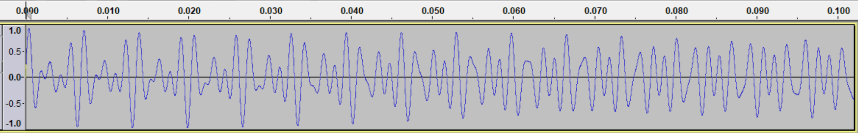

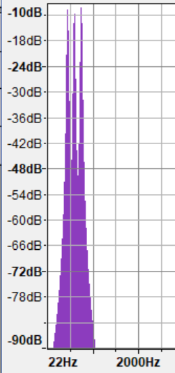It is difficult to identify the frequencies of the three simple sine waves that make up this wave just by looking, but we can perform a Fast Fourier Transform of the signal to compute the constituent frequencies. We will describe this numerical procedure called “Fast” Fourier Transform in the next segment. For now, pick “Analyze | Plot Spectrum” to compute, via Fourier Transform, the frequencies comprising this wave. We can see three peaks, one at 440 Hz, one at around 588 Hz, and the third one at around 741 Hz. If you move the mouse close to one of these peaks, the “Peak” field locks on to the closest peak value. It conveniently displays the frequency as well as the corresponding note. In this case we can see that the chord consists of a 440 Hz A, a 588 Hz D, and a 741 Hz F#. You could also look up the note corresponding to the given frequency in the table from the first lecture.

**Exercises:**

1. Use Euler’s theorem to show that $\cos\left(t\right)=\frac{1}{2}\left(e^{it}+e^{-it}\right)$ and $\sin\left(t\right)=\frac{1}{2i}\left(e^{it}-e^{-it}\right)$
2. Find the Fourier Transform of
   1. $f\left(t\right)=\left\{\begin{aligned} 1, & -1≤t≤1 \\ 0, & \text{otherwise}\end{aligned}\right.$ b. $f\left(t\right)=\left\{\begin{aligned} |t|, & -1≤t≤1 \\ 0, & \text{otherwise}\end{aligned}\right.$ c) $f\left(t\right)=\left\{\begin{aligned} e^{-t}, & t≥0 \\ 0, & \text{otherwise}\end{aligned}\right.$
3. Use Audacity to determine the notes that the chord located at <http://pirate.shu.edu/~wachsmut/Teaching/MATH4516/2017-01/03-chord1.wav> consists of
4. Use Audacity to load and play the sound at <http://pirate.shu.edu/~wachsmut/Teaching/MATH4516/2017-01/03-note-guitar.wav>. This is a recording of me playing a single note on my guitar. Which note am I playing?
5. Use Audacity to load and play the sound at <http://pirate.shu.edu/~wachsmut/Teaching/MATH4516/2017-01/03-note-piano.wav>. This is a recording of me playing a single note on my piano. Which note am I playing? Describe the difference in the spectrum for this note to the previous note. Generate a pure sine wave for the same note and compare its spectrum to the previous ones.
6. Use Audacity to record your voice, saying: “unlock my computer”. What are the three major frequencies of your voice? Record your voice again, saying a different phrase. What are the major frequencies now?