Creating a Star in Mathematica

Recall that we generate a regular polygon by creating a list of unit vectors at angles 2 Pi/n, 4 Pi/n, … 2 Pi. For example, if n = 8, our list consists of the vectors with angles depicted below:
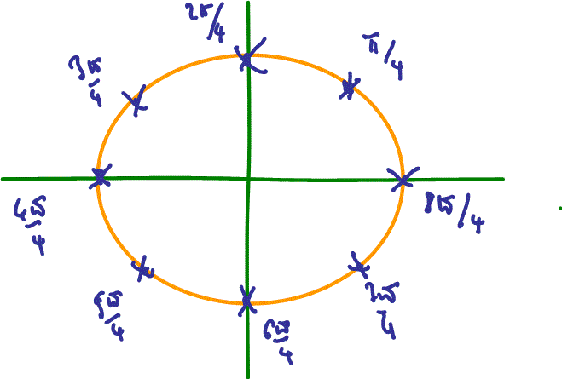
If we connect these points in order via the Polygon command, we get the regular closed and filled-in octagon shown below:
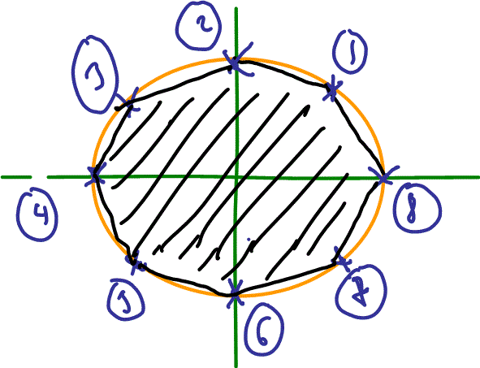
The angles of the vertices are, in order, Table[i,{i,2Pi/8, 2Pi, 2Pi/8}], which evaluates to:
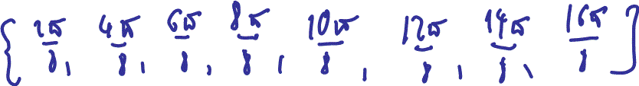
If we multiply these angles by any integer, we will always get the same angles back (perhaps not all of them) but in a different order. For example:
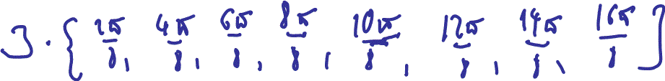
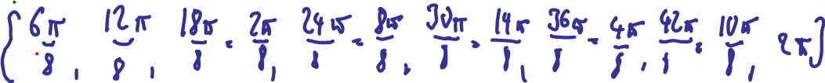
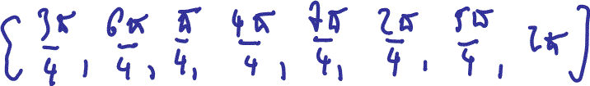
(see next figure). If we now connect the vectors at these angles by the usual Polygon command in the order they are now listed, we get a nice star:
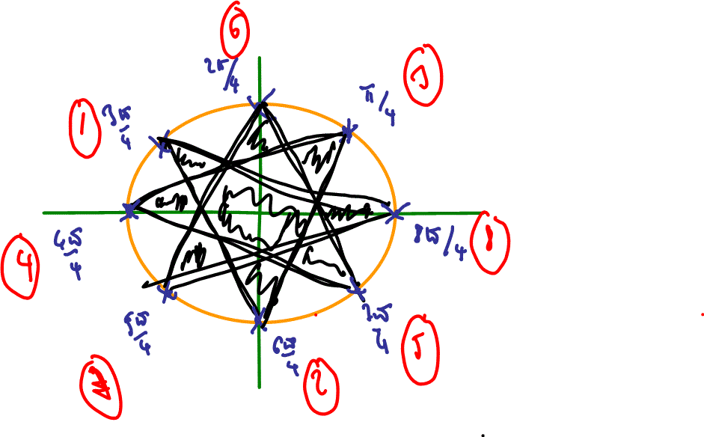

Thus, to generate regular stars, we need the following three functions:
1. Define a function that creates a unit vector with the given angle
- Name: UnitVectorAtAngle
- Input: t (angle)
- Result: unit vector with the given angle (we have already created this function somewhere (I think)
2. Define a function that creates a list of n unit vectors with angles 2 Pi / n but shifts their order by listing every kth angle
- Name: StarVectorList
- Input: n (number of vertices of polygon), k (the number to shift the order by)
- Result: a list of n vectors forming a regular n polygon, listing every k-th vector in that new order
3. Define a function that creates and draws a polygon made out of a list of points
- Name: DrawPolygon
- Input: list (of points to draw)
- Result: image of polygon
With these function in place, we should be able to generate stars like this:
DrawPolygon[StarVectorList[8, 3]]
DrawPolygon[StarVectorList[8, 5]]
DrawPolygon[StarVectorList[22, 7]]
DrawPolygon[StarVectorList[23, 2]]

Homework:
- Implement these functions to generate the stars above.
- Use the StarVectorList function in your code to animate a regular polygon and animate your star instead
- What happens if you execute DrawPolygon[StarVectorList[8, 4]] or DrawPolygon[StarVectorList[8, 2]]. Explain.

