Math 3515 Midterm Outline
- Some simple true/false questions
Do any 6 of the following. Any additional problem counts as extra credit
- Two set questions
- Two countable question
- Find lim inf and lim sup for the following sets
  - Sequence or set 1
  - Sequence or set 2
- Another sequence question
- Do the following series converge conditionally, absolutely, or diverge:
  - Series 1
  - Series 2
- Another series question
- Some concrete topology questions, like union or intersections of some sets
- Another abstract topology question

Analysis 1 – Midterm Sample Problems:
1. True/false:
If $∑a_{n}+b_{n}$ converges, then at least one of $∑a_{n}$ and $∑b_{n}$ also converge.
If $\frac{a_{n}}{b_{n}}→1$ as $n→∞$, then $∑a_{n}$ and $∑b_{n}$ either both converge or both diverge
$f\left(f^{-}1\left(B\right)\right)=B$ for any function $f$
Let A, B be non-empty subsets of R, and define $M=\{ab:a∈A, b∈B\}$. Is $\sup\left(M\right)=\sup\left(A\right)\sup\left(B\right)$?
2. Prove that is A, B are countable, then A x B is countable
3. Prove that the set of all finite subsets of N is countable. Use that result to prove that the set of all infinite subsets of N must be uncountable.
4. Prove that the set of all subsequences of the sequence $\{\frac{1}{n}\}$ is uncountable
5.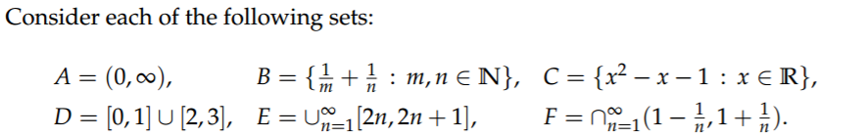
For each set find its min and max, if they exist, and the sup and inf.
6. Let A be a set of real numbers with greatest lower bound l. Prove that for any $ϵ>0$ there exists an $x∈B$ such that $l≤x≤l+ϵ$
9. Compute $lim sup{a_{n}}$ and $lim inf{a_{n}}$ for:
${\left(-1\right)}^{n}/n$ ${\left(1+\frac{1}{n}\right)}^{n}$ ${\left(-1\right)}^{n}(1-\frac{1}{n})$
10. If $\left\{a_{n}\right\}$ is a sequence with $\lim_{n→∞}{a_{n}}=L$ then $\lim_{n→∞}{{|a}_{n}|}=|L|$
11. What is $\lim_{n→∞}{\sqrt{n+1}-\sqrt{n}}$ ?
13. Find the following limits:
$\lim_{n→∞}{{\left(1+\frac{1}{n^{2}}\right)}^{n^{2}}}$ $\lim_{n→∞}{{\left(1+\frac{1}{n+1}\right)}^{n}}$ $\lim_{n→∞}{{\left(1+\frac{1}{n}\right)}^{n+1}}$ $\lim_{n→∞}{{\left(1+\frac{1}{n^{2}}\right)}^{n}}$ $\lim_{n→∞}{{\left(1+\frac{1}{n}\right)}^{n^{2}}}$
14. Let $a_{1}>1$ and $a_{n+1}=2-1/a_{n}$. Show that $\left\{a_{n}\right\}$ converges and find the limit.
15.
16. 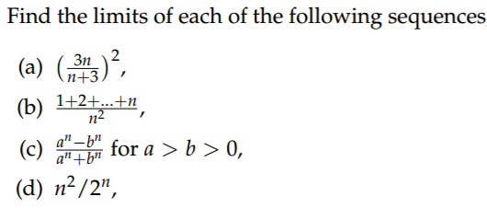
(e) $\{\frac{n!}{n^{n}}\}$
18. Suppose the series $∑a_{n}$ and $∑b_{n}$ converge absolutely. Show that $∑\sqrt{{|a}_{n}b_{n}|}$ also converges.
19. Prove that $\sum_{n=1}^{∞}{\frac{1}{n(n+3)}}$ converges and find the sum. Do the same for $\sum_{n=5}^{∞}{{\left(\frac{6}{11}\right)}^{n}}$
20. 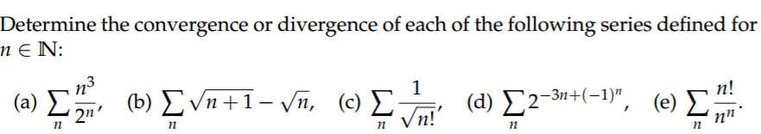
21. Prove that 0.99999… = 1
22. If $C⊂R$ is compact and $F⊂R$ is closed, show that $C∩F$ is compact. What about their union, i.e. is $C∪F$ compact?
23. Prove that the union and intersection of two compact subsets of R are both compact. How about the countable union of compact sets? How about the countable intersection of compact sets, assuming it is not empty?
24. Prove that $f^{-1}\left(C∪D\right)=f^{-1}\left(C\right)∪f^{-1}\left(D\right).$ How about $f\left(C∪D\right)=f\left(C\right)∪f\left(D\right)$?
25. Find the following unions or intersections:
  - $\bigcap_{n=1}^{∞}{[2n, 2n+1]}$
  - $\bigcup_{n=1}^{∞}{(2n, 2n+1)}$
  - $\bigcap_{n=1}^{∞}{(-∞,-n]}$
  - $\bigcup_{n=1}^{∞}{[-2+\frac{1}{2n},2-\frac{1}{2n}]}$
  - $\bigcap_{n=1}^{∞}{(-\frac{1}{n},\frac{1}{n})}$

26. Consider the set $(1,3)∪\{\frac{3n+1}{n}:n∈N\}$, i.e. the interval from 1 (excluded) to 3 (excluded), together with the point {4/1, 7/2, 10/3, 13/4, …}. Is it open or closed, or neither? Which points are interior points and boundary points? Which points are isolated and which ones are accumulation points?

