Sample Quiz
- One of the two vector fields shown below is conservative, the other one is not. Which one is not conservative?
Hint: We know that if $\vec{F}$ was conservative, then $\oint_{C}{\vec{F}∙d\vec{r}}=0$ for every closed curve $C$
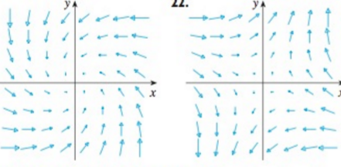

- Find $\int_{C}{3xydx+\left(x^{2}-y^{2}\right)dy}$, where C is the straight line segment from (-1,0) to (2,1)

- Find $\int_{C}{\vec{F}∙d\vec{r}}$ where $\vec{F}=<2xz+y^{2},2xy,x^{2}+3z^{2}>$ and C is a curve from (0,1,0) to (2, 4, 6)

- Find $\int_{C}{2x\sin\left(y\right)dx+x^{2}\cos\left(y\right)dy}$ where C is the upper half circle centered at the origin from (2,0) to (-2,0) using whichever method you find easier.

