**Definitions and Concepts:**

* Vector, Angle between two vectors, Unit vector, dot product, cross product, projections
* Tangent vector to a curve, normal vector to a curve, binormal vector
* Velocity, speed, and acceleration, tangential and normal component of acceleration, curvature
* Lines, planes, and distances
* Limit of a function 
* Continuity of a function 
* partial derivative of a function f(x,y), directional derivative



* gradient and its properties, curl and divergence
* the procedure to find relative extrema of a function f(x, y)
* double and triple integrals, including polar coordinates
* vector fields, curl and divergence
* conservative vector fields and consequences
* What does it mean when a “line integral of a vector field F is independent of the path”?
* What is Green’s Theorem?
* What is Gauss’ Theorem?
* For what type of curve can you apply Green’s theorem?
* For what type of surface can you apply the Divergence theorem?

**Picture problem:** Match the following pictures with the algebraic expressions below.

[A] 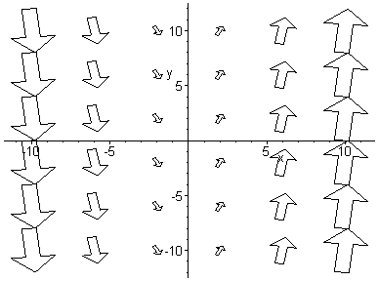 [B]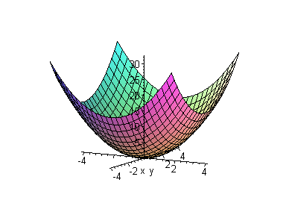 [C]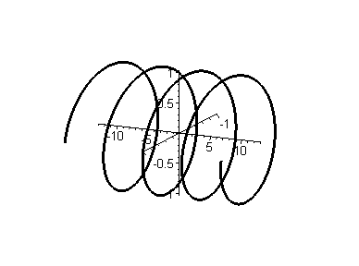

[D] 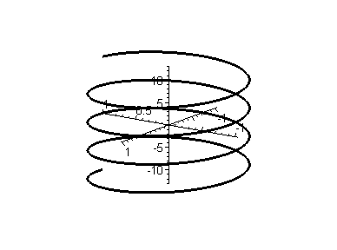 [E]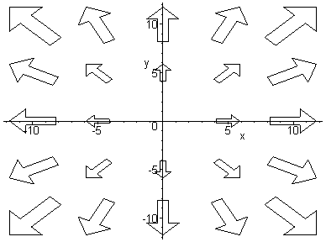 [F] 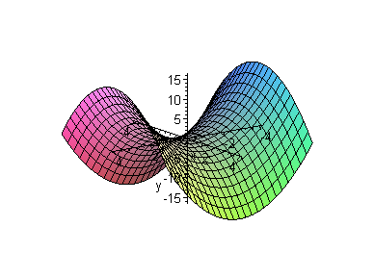

(1)  (2)  (3) 

(4)  (5)  (6) 

**Vectors**: Suppose , , and 

* Are *u* and *v* orthogonal, parallel, or neither?
* Find the (cos of the) angle between *v* and *w*
* Find  (dot product),  (cross product), , and 
* Find the projection of *w* onto *u* and the projection of *u* onto *w*

**Lines and Planes**

* Find the equation of the plane spanned by and  through the point 
* Find the equation of the plane through , , and 
* Find the equation of the plane parallel to  through 
* Find the equation of the line through  and 
* Some distance questions

**Vector valued functions**:

* If , find , , 
* If  some curve, find 
* If , find *T(t)*, *N(t)*, *at* and *an*
* Repeat the previous exercise for  for 

**Motion in space:**

* If  represents the position vector of a particle, find the velocity, speed, and acceleration, as well as tangential and normal components of the acceleration
* A baseball is hit 3 feet above ground at 100 feet per second and at an angle of Pi/4 with respect to the ground. Find the maximum height reached by the baseball. Will it clear a 10-foot high fence located 300 feet from home base?

**Limits and Continuity**: Determine the following limits as *(x,y) -> (0,0)*, if they exist.

  

 

**Gradient and Friends.** Find the indicated expressions:

(a) If , find  (i.e. the gradient of *f*)

(b) If , find *div(f)* (i.e. the divergence of *f*)

(c) If , find *curl(f)*

**Differentiation**: Find the indicated derivatives for the given function:

* Suppose , find fx, fy, fxx, fxy, fyy, fyx, fxyy, fyxy, and fyyx
* Suppose . Find the maximum value of the directional derivative at (-2, 0) and compute a unit vector in that direction.
* Use the definition of *fx* to find it

**Max/Min Problems:** Compute the relative extrema for  and .

# Conservative vector fields: TBA

# Integration: Find the following integrals. As always, you may use Mathematica to help you out.

* 
* 
* evaluate  where R is a triangle bounded by , , 
*  where R is the triangular region bounded by y = 0, y = x, and x = 1
* $\iiint_{E}{z}dV$, where E is the solid tetrahedron bounded by the planes *x = 0, y = 0, z = 0*, and *x + y + z = 1*
*  where C is a line segment given by , 
*  where  and C is the curve given by , 
* Find the work done by a force field  on a particle as it moves along the helix C given by , 
*  where C is the curve , 
*  where  and C is the boundary of the square with corner point (0,0), (1,0), (1,1), and (0, 1), oriented counter-clockwise.
*  where  and C is the lower half of the unit circle, from (-1,0) to (1,0).
*  where C is the boundary of the square with corner point (0,0), (1,0), (1,1), and (0, 1), oriented counter-clockwise.
* Find the surface integral ****, where S is the surface  such that x is between 0 and 2 and y is between 0 and 4.
* Evaluate the flux integral where  and S is 
*  where  and *S* is given by 
*  where $F=<xy,yz,xz>$ and *S* is given by $x+2y+3z=6$ in the 1st quadrant