Vector Fields and Line Integration
Last time: $div(F)$, $curl\left(F\right)$, $grad(f)$, conservative vector field
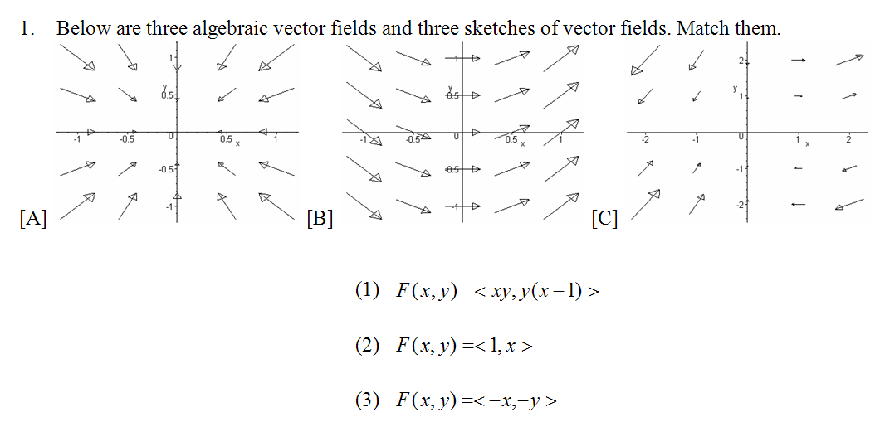
Theorem: (Conservative Vector Fields)
If a vector field F is conservative, then $curl\left(F\right)=0$. For a 2D vector field, this reduces to the condition $N_{x}=M_{y}$. The converse is true in most cases (but not in general).
Proof:

Example: Which of the following vector fields are not conservative?
- $\vec{F}\left(x,y\right)=<x, y>$
- $\vec{F}\left(x,y\right)=<x^{2}+y^{2},2xy>$
- $\vec{F}\left(x,y\right)=<e^{x}\cos\left(y\right),-e^{x}sin⁡(y)>$
- $\vec{F}\left(x,y\right)=<x^{2}\cos\left(y\right),-y^{2}sin⁡(x)>$
- $\vec{F}(x,y,z)=<y^{2},2xy+e^{3z},3ye^{3z}>$
- $F\left(x,y,z\right)=<2xy^{2}-2xz^{3},2x^{2}y+3y^{2}z,y^{3}-3x^{2}z^{2}>$

Example: Find the potential function, if there is one, for
- $\vec{F}=<3+2xy,x^{2}-3y^{2}>$

- $\vec{F}=<x^{2}cos⁡(y),-y^{2}sin⁡(x)>$

- $\vec{F}=<y^{2},2xy+e^{3z},3ye^{3z}>$

- $\vec{F}=<2xy^{2}-2xz^{3},2x^{2}y+3y^{2}z,y^{3}-3x^{2}z^{2}>$
Occasionally you can guess (and check) the potential function: The gravity field of an object at $(x,y,z)$ is:
$$\vec{G}\left(x,y,z\right)=〈\frac{-x}{{\left(x^{2}+y^{2}+z^{2}\right)}^{\frac{3}{2}}},\frac{-y}{{\left(x^{2}+y^{2}+z^{2}\right)}^{\frac{3}{2}}},\frac{-z}{{\left(x^{2}+y^{2}+z^{2}\right)}^{\frac{3}{2}}}〉$$
Its potential function is:

