Vector Fields
- 2D vector fields $\vec{F}:R^{2}→R^{2}$ where $F\left(x,y\right)=<M\left(x,y\right), N\left(x,y\right)>$
- 3D vector fields $\vec{G}:R^{3}→R^{3}$ where $\vec{G}\left(x,y,z\right)=<M(x,y,z),N\left(x,y,z\right), P\left(x,y,z\right)>$
Examples: $\vec{F}\left(x,y\right)=<x^{2}-y^{2},2xy>$ or $\vec{G}\left(x,y,z\right)=<\sin\left(xy\right),\cos\left(yz\right),\tan\left(xz\right)>$

- Visualize
Vector fields are everywhere: water flowing down a stream, magnetic field of the earth, electric fields, gravity, etc. As usual, the best and quickest way to draw a vector field is, of course, Mathematica.
$$VectorPlot\left[\left\{-y,x\right\},\left\{x,-2,2\right\},\left\{y,-2,2\right\}\right]$$  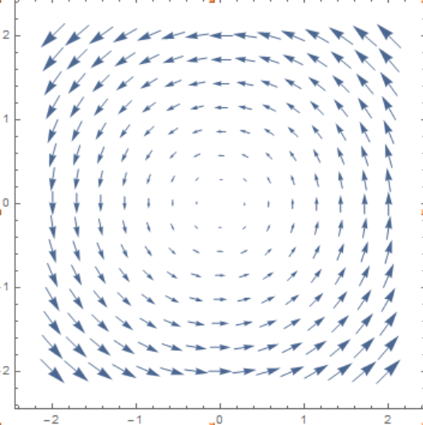 | $$VectorPlot3D[\left\{-x,-y,-z\right\},\left\{x,-2,2\right\},\left\{y,-2,2\right\},\{z,-2,2\}]$$  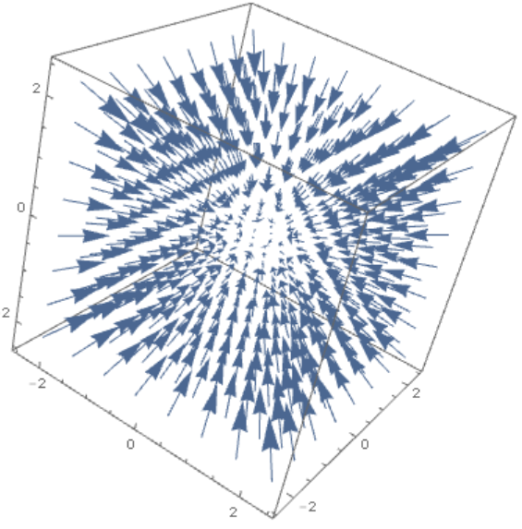
- Limits and Continuity
A vector field $\vec{F}=<M(x,y),N\left(x,y\right)>$ is continuous iff $M$ and $N$ are continuous. So, nothing new here.
- Derivatives
A 2D vector field $\vec{F}=<M(x,y),N\left(x,y\right)>$ has 4 partial derivatives: $\frac{∂M}{∂x}, \frac{∂M}{∂y}, \frac{∂N}{∂x}, \frac{∂N}{∂y}$. How many partials does a 3D vector field have?

Definitions
- Divergence: With $∇=<∂_{x},∂_{y},∂_{z}>$ we define the divergence of a vector field $\vec{F}=<M,N,P>$ as:
$$div\left(F\right)=∇∙F=<∂_{x},∂_{y},∂_{z}>∙<M,N,P> = ∂_{x}M+∂_{y}N+∂_{z}P=M_{x}+N_{y}+P_{z}$$
- Curl: With $∇=<∂_{x},∂_{y},∂_{z}>$ we define the curl of a vector field $\vec{F}=<M,N,P>$ as:
$$curl\left(\vec{F}\right)=∇×\vec{F}=<∂_{x},∂_{y},∂_{z}>×<M,N,P> =\left(\begin{matrix}i & j & k \\ ∂_{x} & ∂y & ∂z \\ M & N & P\end{matrix}\right)=<P_{y}-N_{z},-\left(P_{x}-M_{z}\right),N_{x}-M_{y}>$$
- Conservative: A vector field $\vec{F}$ is conservative if there is a function $f$ such that $grad(f)=\vec{F}$. The function $f$ is called the potential function of $\vec{F}$.

Note that the gradient of a function $f\left(x,y,z\right), ∇f=<∂_{x}f,∂_{y}f,∂_{z}f>,$ is a vector field, the divergence of a vector field $\vec{F}$, $∇∙\vec{F}$, is a function, and the curl of a vector field $\vec{F}$, $∇×\vec{F}$, is a vector field.
What is the one-variable equivalent of a potential function?
Problems to Work Out
- Let $\vec{F}=<xy,yz,xz>$, find the divergence and the curl of $\vec{F}$
$div(\vec{F})$ =

$curl(\vec{F})$ =

- Let $\vec{F}=<xy^{2}z^{4},2x^{2}y+z,y^{3}z^{2}>$, find the divergence and the curl of $\vec{F}$
$div(\vec{F})$ =

$curl(\vec{F})$ =

- If $f$ is a function and $\vec{F}$ is a vector field, which of the following expressions make sense:
- curl(f)
- grad(f)
- div(F)
- grad(F)
- curl(grad(f))
- grad(curl(F))
- grad(div(F))
- div(grad(F))
- grad(grad(f))
- curl(curl(F))
- div(div(F))

- Prove the “product” rule: $∇∙\left(f\vec{F}\right)=f\left(∇∙\vec{F}\right)+\left(∇f\right)∙\vec{F}$

- Find a vector field that has the potential function $f\left(x,y,z\right)=x^{2}-3y^{2}+4z^{2}$. Is F conservative?

- Prove that if a 3D vector field $\vec{F}$ is conservative, then $curl(\vec{F})=\vec{0}$. What about a 2D conservative vector field?

- Which of the following vector fields are not conservative?
- $\vec{F}\left(x,y\right)=<x, y>$

- $\vec{F}\left(x,y\right)=<x^{2}+y^{2},2xy>$

- $\vec{F}\left(x,y\right)=<e^{x}\cos\left(y\right),-e^{x}sin⁡(y)>$

- $\vec{F}\left(x,y\right)=<x^{2}\cos\left(y\right),-y^{2}sin⁡(x)>$

- Find the potential function for $\vec{F}=<3+2xy,x^{2}-3y^{2}>$ if there is one

- Find the potential function for $\vec{F}=<x^{2}cos⁡(y),-y^{2}sin⁡(x)>$ if there is one

- Find the potential function for $\vec{F}=<y^{2},2xy+e^{3z},3ye^{3z}>$ if there is one

