Calc 3 Homework Problems
- Find the flux integral over the vector field $F=<z,y,x>$ through the closed surface $x^{2}+y^{2}+z^{2}=1$

- Find the flux of the vector field $F=<xy,y^{3}+x^{3},\sin\left(xy\right)>$ through the region bounded by the parabolic cylinder $z=1-x^{2}$ and the planes z = 0, y = 0, and y + z = 2.

- Consider the vector field $F=<{z x}^{2},x y z, {x z}^{3}>$ and the surface S given by $z=4-x^{2}-y^{2}$ and $z=0$. Compute $\iint_{S}{F n dS}$ (a) using the divergence theorem and (b) the old-fashioned way, i.e. using standard surface integration (which would involve two integrations).

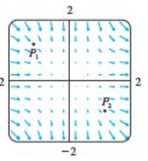
- Compute the flux for $F=<xy sin\left(z\right),\cos\left(xz\right),y cos(z)>$ over the ellipsoid $\frac{x^{2}}{a^{2}}+\frac{y^{2}}{b^{2}}+\frac{z^{2}}{c^{2}}=1$

- Consider the vector filed F as shown. Is div(F) positive, negative, or zero at the points P₁ and P₂ ?

