**Calc 3 – Final Exam**

This is a take-home, open-book, open notes exam; you even may use Maple to assist you in calculations. You must, however, complete it *entirely on your own*. It is due on the last day of exams – no exception. Please indicate clearly where each problem starts and do not forget to put your name on your exam.

1. Please state the following:
2. an equation relating the dot product of two vectors with the angle between them
3. the definition of the gradient of a function $f(x,y,z)$ and its properties
4. the main difference between Green’s and Stoke’s Theorem as far as the vector field $\vec{F}$ is concerned
5. the Divergence Theorem (also known as Gauss’ Theorem)

2. Match the following pictures with the algebraic expressions below.

[A] 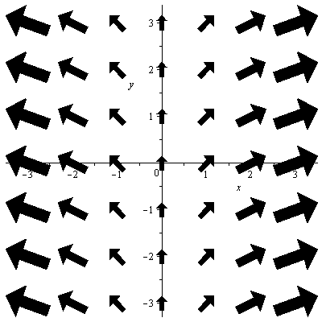 [B] 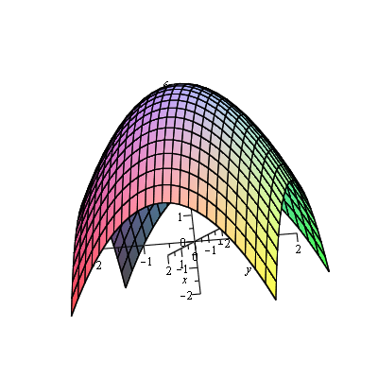 [C]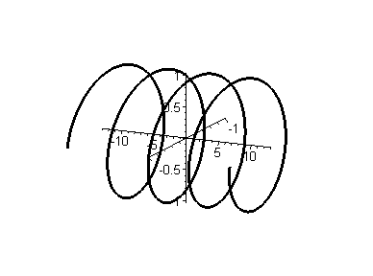

[D] 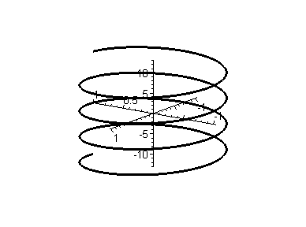 [E] 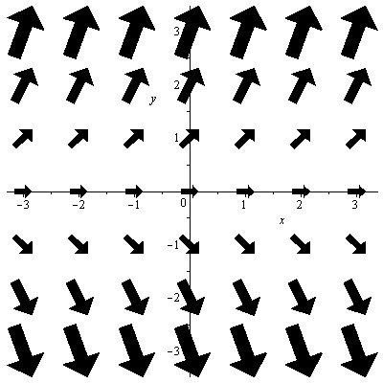 [F] 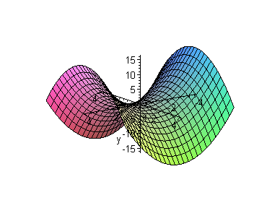

(1)  (2)  (3) 

(4)  (5)  (6) 

3. Determine if the plane through the points $P(1,0,0)$, $Q(0,2,0)$, and $R(0,0,3)$ is perpendicular to the plane given by the equation

4. A baseball is hit 4 feet above ground at an initial velocity of $<80, 80>$ feet per second. Find the maximum height reached by the baseball. Will it clear a 15-foot high fence located 350 feet from home base?

5. Determine the following limits, if possible, or explain why they don’t exist.

$\lim_{(x,y)→(0,0)}{\frac{x+2y+3}{x^{2}+2y^{2}+3}}$ $\lim_{(x,y)→(0,0)}{\frac{x^{2}-y^{2}}{x^{2}+y^{2}}}$ $\lim_{(x,y)→(0,0)}{\frac{xy^{2}}{x^{2}+y^{4}}}$

# 6. Find all critical points and test them for relative extrema for the function (*Hint: There are two critical points*)

7. Evaluate the following integrals:

1. $\iint_{R}{e^{x^{2}}}dA$, where *R* is the triangular region bounded by *y = 0*, *y = x*, and *x = 1*
2. $\int_{C}{x^{2}+y^2}ds$, where *C* is the curve given by $r\left(t\right)=<2\cos\left(t\right),2\sin\left(t\right)>$ for $0≤t≤π$
3. $\int_{C}{\vec{F} d\vec{r}}$, where $\vec{F}\left(x,y\right)=<-y,x>$ and *C* is the line segment from $P(-1,-1)$ to $Q(2,3)$
4. The flux of the vector field $\vec{F}\left(x,y,z\right)=<x,y,z>$, where S is the portion of the surface $z=10-2x-2y$ between the coordinate planes.

# 8. For the following integrals there are at least two ways to evaluate them. Use the most convenient method and quote the appropriate theorem.

1.  where  and *C* is the closed curve given by the boundary of the square with corner points (-1,-1), (-1,1), (1, -1), and (1,1).
2.  where *C* is the closed curve given by the boundary of the triangle with corner points (0,0), (0,1), and (1, 0), oriented counter-clockwise.
3.  where  and *S* is given by 
4.  where  and C is the boundary of the surface *S* given by , oriented counter-clockwise.