**Math 1401: Practice Exam 2**

**Disclaimer:** This is a *practice exam* only. It is longer than the actual exam.

What is the definition of derivative f ’(x)?

Definition of the second derivative:

**f ‘’(x) is the derivative of the derivative: f ‘’ = (f ‘) ‘**

What is the Chain Rule?

What are the derivatives of sin(x), cos(x), tan(x), sec(x), csc(x), and cot(x)?

$\frac{d}{dx}\sin\left(x\right)=cos\left(x\right), \frac{d}{dx}\cos\left(x\right)=-\sin\left(x\right), \frac{d}{dx}\tan\left(x\right)=\frac{d}{dx} \frac{\sin\left(x\right)}{\cos\left(x\right)}=\frac{\cos^{2}\left(x\right)+\sin^{2}\left(x\right)}{\cos^{2}\left(x\right)}=\sec^{2}{(x)}$

$\frac{d}{dx}\sec\left(x\right)=\sec\left(x\right)\tan\left(x\right), \frac{d}{dx}\csc\left(x\right)=-\csc\left(x\right)\cot\left(x\right), \frac{d}{dx}\cot\left(x\right)=-\csc^{2}{(x)}$

What is a necessary condition for a function f to have a local extrema at x=c

What is a necessary condition for a function f to have an inflection point at x=c

**f ‘’ is zero at x = c or undefined**

What can you say about a continuous function on a closed, bounded interval and absolute extrema?

What information about f(x) does f ’(x) provide?

What information about f(x) does f ’’(x) provide?

What are horizontal and vertical asymptotes?

**h.a: $y=\lim_{x→∞}{f(x)}$ if it exists**

**v.a.: points x = c that are not in the domain and where f(x) goes to plus or minus infinity as x goes to c**

How does “curve sketching” work?

**See questions below**

What is implicit differentiation?

**When you differentiate an equation that defines y as a function of x implicitly by applying the chain rule each time you differentiate any expression involving y**

What is the “profit function”, “revenue function”, “cost function”, marginal cost”, etc.

**P(x) = R(x) – C(x), R(x) = x p(x) (p(x) is demand function)  
“marginal” means “derivative” so marginal cost is C’(x)**

True/False?

If f ‘(x) < 0 then f is concave down

If f ‘’(x) = 0 then f has an inflection point at x.

If f ‘(x) = 0 then f could have a maximum, or a minimum, or neither

If f is differentiable then f must be continuous

If f ‘(x) = 0 or f ‘(x) is undefined, then x is called critical point

If x=c is a critical point for f, then f must have a relative extrema at x=c

Picture Problems: Consider the graph of a function as shown:

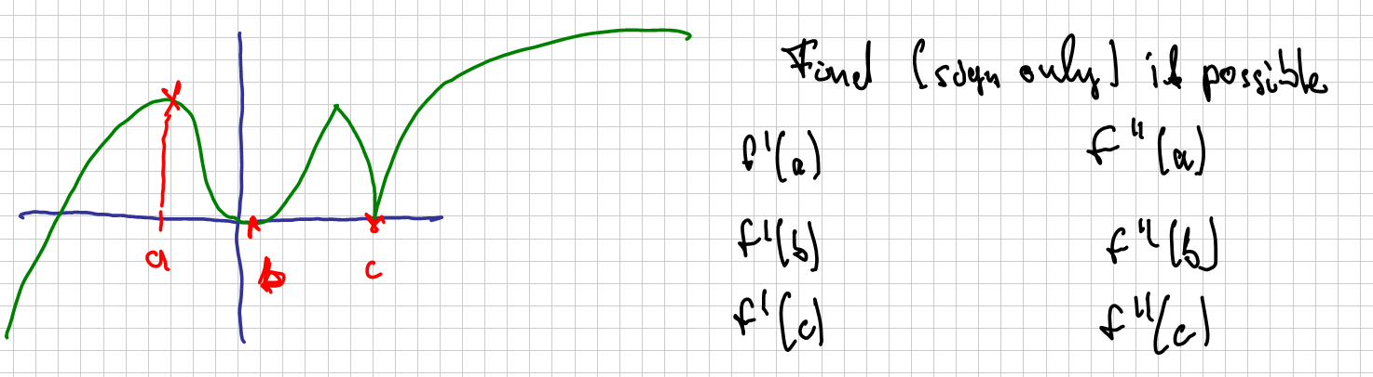

In the coordinate system below you can see the graphs of *f(x)* and its derivative *f ’(x)*. Who is the function, who is the derivative?



For the graph shown below, draw the derivative f ‘(x) as best as you can.



5. For the function displayed below, find the following limits and derivatives:

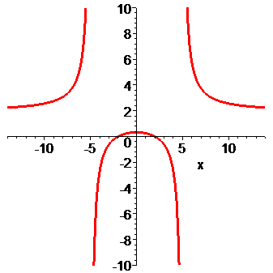a)  **= 2** b) f ‘(0) **= 0**

c) **= 2** d) f ‘’(0) **negative**

e)  **= + infty** f) f ‘(10) **negative**

g)  **= -infty** h) f’’(10) **positive**

Please find the derivative for each of the following functions (do not simplify unless it is helpful).

















, find 

, find 

Suppose a function y is implicitly defined as a function of x via the equation .

1. Find the derivative of y using implicit differentiation.

b) What is the equation of the tangent line at the point (1, 2).

Find the slope of the tangent line to the graph of  at the point (1, -2), assuming that the equation defines *y* as a function of *x* implicitly.

Find $\frac{dy}{dx}$ if $y^{3}=x^{2} cos⁡(xy)$, assuming that *y = y(x)* is an implicitly defined function of *x*.

Find $\frac{dx}{dy}$ for $y^{3}=x^{2}\sin\left(xy\right)$, assuming that *x = x(y)* is an implicitly defined function of y.

Find all asymptotes, horizontal and vertical, if any, for the functions







If , find the intervals on which f is increasing and decreasing, and find all relative extrema, if any.

Determine where the function  is increasing and decreasing and find all relative extrema, if any.

Find the local maxima and minima for the function 

Find the absolute extrema (i.e. absolute maximum and absolute minimum) for the function  on the interval [0, 2]

Find the absolute maximum and minimum of the function  on the interval [0, 4]. Do the same for  on [0, 3], or for  on [-2, 0].

If , determine intervals on which the graph of *f* is concave up and intervals on which the graph is concave down.

If , find all points of inflection and discuss the concavity of *f*. Do the same for ,

Find the interval where  is concave up, if any.

Graph the function . Note that  and .

Make sure to find all asymptotes (horizontal and vertical) and clearly label any maximum, minimum, and inflection points. Then do the same for the function , or , or 

A liquid form of penicillin manufactured by a pharmaceutical firm is sold in bulk at a price of $200 per unit. If the total production cost (in dollars) for x units is C(x) = 500,000 + 80x + 0.003x2 and if the production capacity of the firm is at most 30,000 units in a specified time, how many units of penicillin must be manufactured and sold in that time to maximize the profit ?

A farmer wants to fence in a piece of land that borders on one side on a river. She has 200m of fence available and wants to get a rectangular piece of fenced-in land. One side of the property needs no fence because of the river. Find the dimensions of the rectangle that yields maximum area. (Make sure you indicate the appropriate domain for the function you want to maximize). Please state your answer in a complete sentence.

Find the dimensions of the rectangle of maximum area that can be inscribed in a semicircle of radius 16,

if one vertex lies on the diameter.

An open box with a rectangular base is to be constructed from a rectangular piece of cardboard 16 inches wide and 21 inches long by cutting out a square from each corner and then bending up the sides. Find the size of the corner square which will produce a box having the largest possible volume.

