**Calculus 1501: Practice Exam 1**



1. State the following definitions or theorems:

a) Definition of a function f(x) having a limit L

1. Special limits and limits at infinity
2. Definition and geometric meaning of a function f(x) being continuous at x = c
3. Types of discontinuities
4. c) Definitions (there are two) and geometric meaning of the derivative f’ of a function f(x)
5. The “Squeezing Theorem”
6. The “Intermediate Value Theorem” and its consequence
7. Derivatives of sin(x) and cos(x)
8. Power rule, product rule, and quotient rule

2. The picture on the left shows the graph of a certain function. Based on that graph, answer the questions:

a) 



b) 



c) 



d) 



e) Is the function continuous at x = -1?

f) Is the function continuous at x = 1?

g) Is the function differentiable at x = -1?

h) Is the function differentiable at x = 1?

i) Is f’(0) positive, negative, or zero?



k) What is f’(-2) ?



3. Find each of the following limits (show your work):

a)  b)  c) 

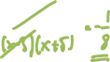

d)  e)  f) 



g)  h)  i) 



j)  k)  l) 



m)  n) 

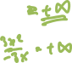

4. Consider the following function: 



a) Find  b) Find 



c) Find  (note that x approaches *two*, not *zero*) d) Is the function continuous at x = 0

f) Is  continuous at -1 ? If not, is the discontinuity removable?



g) Is there a value of *k* that makes the function *g* continuous at *x = 0*? If so, what is that value?  




5. Please find out where the following functions are continuous:

a)  b) 



c)  d) 



6. Find the value of *k*, if any, that would make the following function continuous at *x = 4*.





7. Prove that the function  has at least one solution in the interval [1, 2]. Also, prove that the function has at least one solution in the interval 



8. Use the *definition* of derivative to find the derivative of the function . Note that we of course know by our various shortcut rules that the derivative is . Do the same for the function  and for  (use definition!)

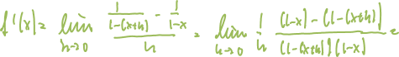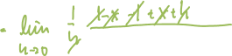

9. Consider graph of *f(x)* you see below, and find the sign of the indicated quantity, if it exists. If it does not exist, please say so.

|  |  |
| --- | --- |
|  | *f(0)*  *f’(0)*  *f(-2)*  *f’(-2)*  *f(2)*  *f’(2)* |

10. Consider the function whose graph you see below, and find a number *x= c* such that



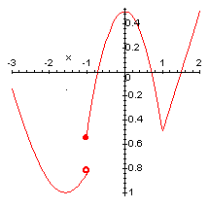

a) *f* is not continuous at *x= a*



b) *f* is continuous but not differentiable at *x= b*



c) *f’* is positive at *x= c*



d) *f’* is negative at *x= d*



e) *f’* is zero at *x= e*



f) *f’* does not exist at *x= f*



10. Please find the derivative for each of the following functions (do not simplify unless you think it is helpful).   


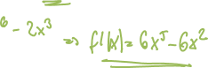































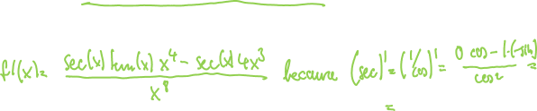





























, find 



, find 



, find 



11. Find the equation of the tangent line to the function at the given point:

a) , at x = 0



b) , at x = 1



12. For the function displayed below, find the following limits:

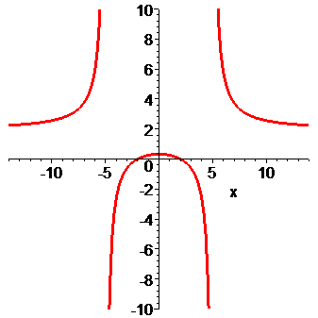



a) 



b) 

c) 



d) 



12. Suppose the function  indicates the position of a particle.



a) Find the velocity after 10 seconds

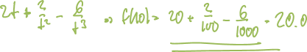

b) Find the acceleration after 10 seconds



c) When is the particle at rest (other than for t = 0)



d) When is the particle moving forward and when backward



14. Find the following limits at infinity:

 



 



 

