Finding local Extrema and Increasing/Decreasing Intervals
Recall that a local extrema is either a local minimum or a local maximum. We already know that if a function $f$ has a local extremum at $x = c$ and it is differentiable at $c$, then $f’(c) = 0$. Thus, to find out local max/mins we can follow the following recipe:
- Compute the derivative$f’(x)$
- Solve $f’(x) = 0$ as well as where $f’(x)$ does not exist. These points are called critical points or potential extrema
- Create a table with $f’$ and $f$ in the rows and the critical points defining the columns. Determine the sign of $f’$ in each column and write down what that means for $f$: if $f’$ is positive, $f$ is increasing (goes up), if $f’$ is negative, $f$ is decreasing (goes down).
Read off the local extrema and write down your answers.
Example: Find all relative extrema for $f\left(x\right)={2x}^{3}-3x^{2}$
- $f^{'}\left(x\right)=6x^{2}-6x$
- $6x^{2}-6x=6x\left(x-1\right)=0$ so that $x=0$ and $x=1$ are critical points
- Setting up the table:

 | -1 0 |  | ½ 1 |  | 2
$$f’$$ | + | - |  | +
$$f$$

To determine the signs of the derivative, I used ‘test numbers’ in the various intervals, substituted them into the derivative (factored version) and figured out the sign only. It is easy, since I only need to figure out the signs of the various factors, from which it is easy to find the overall sign.

Now $x=0$ is a relative max, while $x= 1$ is a relative min.

Example: Find all relative extrema for $f\left(x\right)=x^{5}-10x^{3}$
- $f^{'}\left(x\right)=5x^{4}-30x^{2}$
- $5x^{4}-30x^{2}=5x^{2}\left(x^{2}-6\right)=0$ so that $x=0$, $x=-\sqrt{6}$, and $x=\sqrt{6}$ are critical points
- Setting up the table:

 | -6 -$\sqrt{6}$ |  | -1 0 |  | 1 $\sqrt{6}$ |  | 6
$$f’$$ | + | - |  | - |  | +
$$f$$
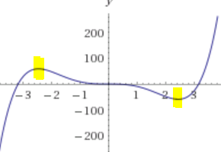
To determine the signs of the derivative, I again used ‘test numbers’ in the various intervals.

Now $x=-\sqrt{6}$ is a relative max, while $x= \sqrt{6}$ is a relative min. The critical point $x=0$ turns out to be neither max nor min (see graph on the right).

Finding Inflection Points and Concavity
Recall that $x=c$ is an inflection point if the concavity changes at that point. Since the second derivative $f’’$ tells us whether the function is concave up (smile face, $f’’>0$) or concave down (frowny face, $f’’<0$), we follow the following recipe to discuss concavity:
- Compute the second derivative$f''(x)$
- Solve $f''(x) = 0$ as well as where $f''(x)$ does not exist. These points are called possible inflection points.
- Create a table with $f''$ and $f$ in the rows and the possible inflection points defining the columns. Determine the sign of $f''$ in each column and write down what that means for $f$. Note: if $f''$ is positive, $f$ is concave up, if $f''$ is negative, $f$ is concave down.
Example: Discuss the concavity of $f\left(x\right)={2x}^{3}-3x^{2}$
- $f^{'}\left(x\right)=6x^{2}-6x$
$f''\left(x\right)=12x-6$
- $12x-6=0$ so that $x=\frac{1}{2}$ are possible inflection points
- Setting up the table:

 | -1 ½ |  | 1
$$f''$$ | - | +
$$f$$ | $$∩$$ | $$∪$$

To determine the signs of the 2nd derivative, I used ‘test numbers’ in the various intervals, substituted them into the 2nd derivative and figured out the sign only.
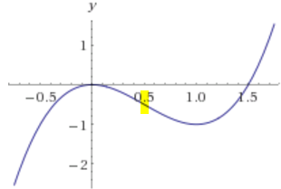
Now $x=\frac{1}{2}$ is indeed an inflection point, since the concavity to its left is different from the one to its right.

Example: Discuss concavity for $f\left(x\right)=x^{5}-10x^{3}$
- $f^{'}\left(x\right)=5x^{4}-30x^{2}f^{''}\left(x\right)=20x^{3}-60x$
- $20x^{3}-60x=20x(x^{2}-3)$ so that $x=0$, $x=-\sqrt{3}$, and $x=\sqrt{3}$ are possible inflection points
- Setting up the table:
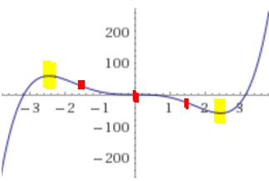
 | -6 -$\sqrt{3}$ |  | -1 0 |  | 1 $\sqrt{3}$ |  | 6
$$f''$$ | - | + |  | - |  | +
$$f$$ | $$∩$$ | $$∪$$ |  | $$∩$$ |  | $$∪$$

To determine the signs of the 2nd derivative, I again used ‘test numbers’ in the various intervals.

Now $x=-\sqrt{3}, x=0,$and $x= \sqrt{3}$ are all inflection points.

