Sample Quiz
- Consider the function $f\left(x\right)=x^{4}-2x^{2}+1$. Determine and classify the local extrema and intervals where f is increasing or decreasing.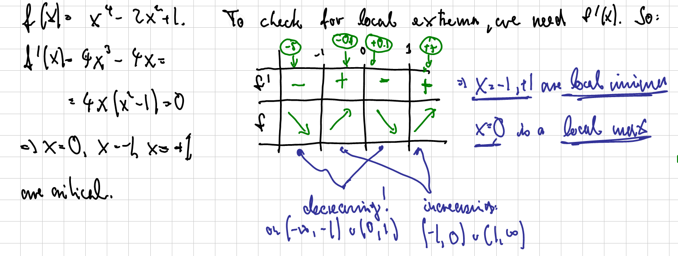
- Consider the function $f\left(x\right)=x^{4}-6x^{2}$. Find the intervals of concavity and identify all inflection points, if any.
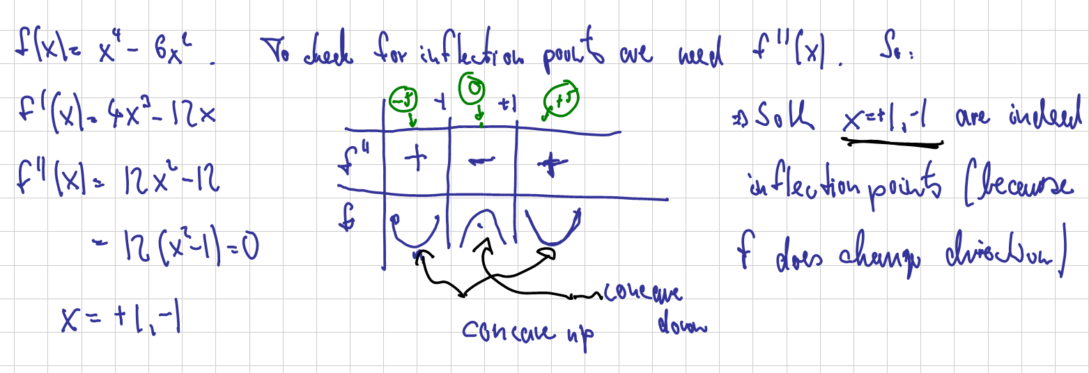
- Sketch the function $f\left(x\right)=\frac{x^{2}}{x^{2}-4}$, including all asymptotes, extrema, inflection points, intervals of increase, decrease, concave up, and concave down