Math 1401 - Practice Final Exam

State the definition as well as the geometric interpretation of:

- f(x) is continuous at the point x = a

- the derivative of a function f(x), i.e. 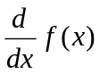

- the definite integral of a function f(x) over an interval [a, b], i.e. 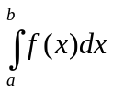

- f(x) = ln(x) (show the graph as geometric interpretation)

- f(x) = e^{x} (show the graph as geometric interpretation)

State the following theorems:

- First Fundamental Theorem of Calculus

- Second Fundamental Theorem of Calculus

- Intermediate Value Theorem

- Rolle’s Theorem

- Mean Value Theorem

- Mean Value Theorem for Integrals

3. Consider the function displayed below, and state whether the indicated quantities are positive, negative, or zero.

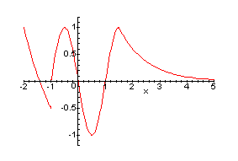
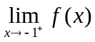 | 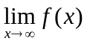 | f(0)
f’(0) | f’(0.5) | f’’(0.5)
f’’(3) | 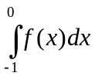 | 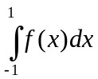

Evaluate the following limits.
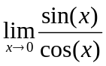

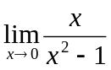

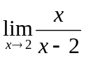

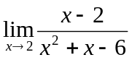

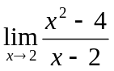

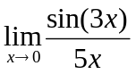

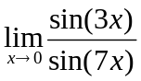

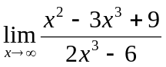

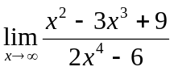

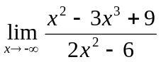

Problems involving the definitions of the basic concepts (continuity, derivative, integral)

- Find the number k, if any, so that the following function is continuous:
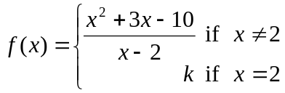

- Use the definition of derivative to find the derivative of 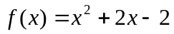

- Use the fourth Riemann sum with left endpoints to find an approximation to the definite Riemann integral 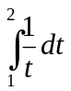 (Note that number is also an approximation to ln(2)).

Find the derivatives of the following functions, using any method you like.
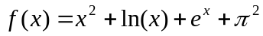
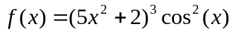
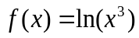
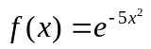
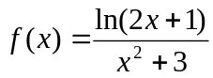
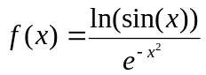
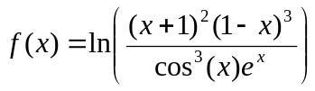
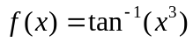
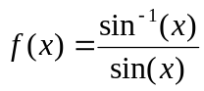
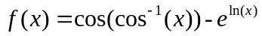

Find the integrals (definite or indefinite) in each of the following problems, using any method you like.
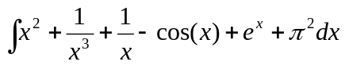
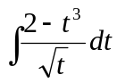
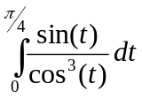
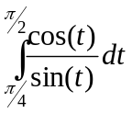
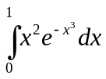
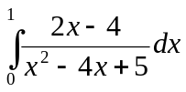
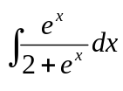
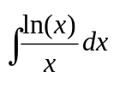
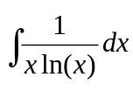
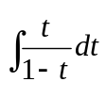
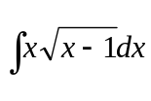
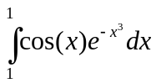
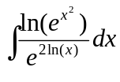
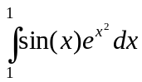
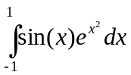 (extra credit)

Evaluate the following definite integrals, using any method you like.
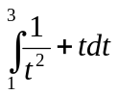

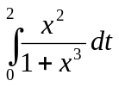

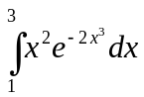

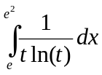

Sketch functions like 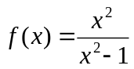 or 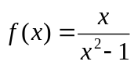, or 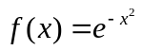 (horizontal asymptote y = 0, no vertical asymptote). Or, sketch the function 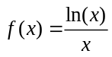 or 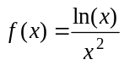 (having asymptotes x = 0 and y = 0).

Find all relative extrema of the function 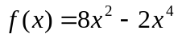 and classify them. Or: find all absolute extrema of the function 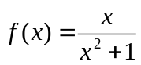 on the interval [0, 2].

Let us define a function 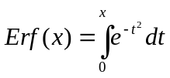. Then find S(0), find S'(0), and find S''(0)

Bacteria follows exponential growth. Initially there are 100 cells but after one hour the population has increased to 420. Find the number of bacteria after 3 hours. Also find when the population reaches 10,000 cells.

Or: A 13 meter ladder is leaning against a wall If the top of the ladder slips down the wall at a rate of 2 m/sec, how fast will the foot be moving away from the wall when the top is 5 m above the ground.

Or: A square is cut out from each corner of a rectangular piece of cardboard. The remaining sides of the cardboard are folded up to form a box without lid. If the original cardboard piece was 10 cm wide and 15 cm high, find the dimensions of the largest box possible.

Or: Rectangular plot of land is fenced in with two kinds of fencing on opposite ends. Type A costs $3 per foot, Type B costs $2 per foot. Maximize the area if you have $6000.00 available. x = one side of rectangle with type A fencing, y = other side of retangle with type B fencing. Setting up the basic equations for area and cost of fencing.

Or: You are standing on a bridge that is 30 m above a river, and you are dropping a ball into the river. The velocity of the ball is given by the equation v(t) = 10 t. We know that the velocity is the derivative of the distance function, hence the distance function is the antiderivative of the velocity function. Use that information to determine the distance function. Then use that distance function to determine when the ball hits the water.

