Checkbook Program – Class Outline

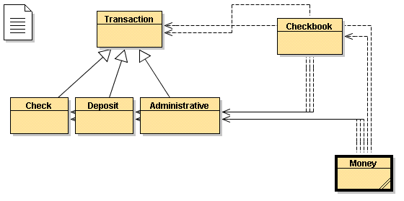  Class structure | 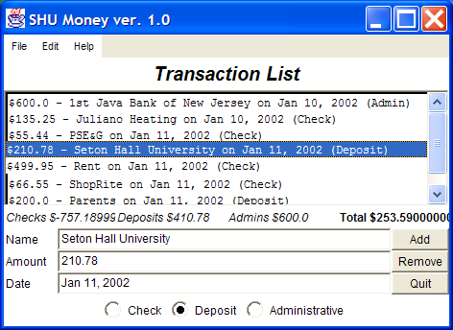  Program layout

class Transaction
// Class to represent a single transaction. All fields are private with appropriate "get" methods. No "set"
// methods are needed because transactions are none-editable.
private String name;
private double amount;
private String date;
private String type;

public Transaction(String name, double amount, String date, String type)
public double getAmount() // returns 'amount'
public String getName() // retuns 'name'
public String getDate() // returns 'date'
public String toString() // returns string representation of a transaction

class Check extends Transaction
// A 'check' is a subclass of transaction representing a check and returning the amount as a negative number
public Check(String name, double amount, String date)
public double getAmount() // overrides inherited method and returns -amount

class Deposit extends Transaction
// A 'deposit' is a subclass of transaction to represent a deposit
public Deposit(String name, double amount, String date)

class Administrative extends Transaction
// An 'administrative transaction' is a subclass of transaction to represent admin. adjustments to an account
public Administrative(String name, double amount, String date)

class Checkbook
// Represents a 'checkbook', i.e. a class storing 'transaction' objects in a 'list'. Also contains various totals
// that are always kept current when a transaction is added to or removed from the list.
private String bankName;
private double checkAmount;
private double depositAmount;
private double adminAmount;
private Vector transactions;

public Checkbook(String bankName)
public double getCheckAmount() // returns totals for all checks
public double getDepositAmount() // returns totals for all deposits
public double getAdminAmount() // returns totals for all admin. transactions
public double getAmount() // returns total total (checks + deposits + admins)
public void addTransaction(Check check) // add check, adjust checkAmount (overloaded)
public void addTransaction(Deposit deposit) // add deposit, adjust depositAmount (overloaded)
public void addTransaction(Administrative admin) // add admin, adjust adminAmount (overloaded)
public Transaction getTransaction(int i) // returns i-th transaction
public void deleteTransaction(int i) // deletes i-th transaction, adjusts approp. amount
public int getSize() // returns number of transactions stored
public String getBankName() // returns the name of the bank
public String toString() // returns string representation of checkbook

class Money extends Frame implements ActionListener, ItemListener
// The actual 'program'. Contains all GUI elements and handles user requests via the standard event
// listening procedures.
private CheckboxGroup radioGroup = new CheckboxGroup();
private Checkbox checkOption = new Checkbox("Check", radioGroup, true);
private Checkbox depositOption = new Checkbox("Deposit", radioGroup, false);
private Checkbox adminOption = new Checkbox("Administrative", radioGroup, false);

private Button add = new Button("Add");
private Button del = new Button("Remove");
private Button quit = new Button("Quit");

private TextField name = new TextField(40);
private TextField amount = new TextField(10);
private TextField date = new TextField(25);

private Label checkAmount = new Label("Checks: $0.0");
private Label depositAmount = new Label("Deposits: $0.0");
private Label adminAmount = new Label("Admins: $0.0");
private Label totalAmount = new Label("Total: $0.0");

private List transactionList = new List(20);

private Checkbook checkbook = new Checkbook("1st Java Bank of New Jersey");

public Money()
private Panel getListPanel() // returns formatted panel with list and title
private Panel getOptionsPanel() // returns formatted panel with checkbox options
private Panel getStatusPanel() // returns formatted panel with amount labels
private Panel getButtonPanel() // returns formatted panel with buttons
private Panel getInputPanel() // returns formatted panel with input fields
private void updateStatus() // updates amount labels, called after adding/deleting
private void addTransaction() // adds transaction, calls 'updateStatus'
private void delTransaction() // removes selected transaction ,calls 'updateStatus'
private void selectNewItem() // puts selected transaction values into text fields
private void selectAdminOption() // turns name field editable on or off
private void exitProgram() // quits program
public void actionPerformed(ActionEvent ae) // reacts to action events
public void itemStateChanged(ItemEvent ie) // reacts to item change events

public static void main(String args[]) // standard main method

