The Internet

With the Internet's rapid growth during the mid to late 90's the ability of programs to utilize the Internet became increasingly important. In fact, the latest versions of most major application packages such as Microsoft Office now contain build-in "Internet support". In some cases that support consists of accessing online information from within a program. In other cases programs can automatically downloading updates or patches, or even create collaborative work environments where people in different locations can work together on a particular project via the Internet. One of the uses of this technology is to create client/server application where one "server" program can provide and synchronize resources with many "client" programs.

We need to understand what the Internet is and how it works. It is particularly important to understand from the outset that the Internet is much more than the "World Wide Web" even though today the web is by far the most utilized component of the Internet.

Definition: The Internet
The Internet is a (huge) collection of wires and computers that collectively transfer digital information wrapped in individual data packets. In effect, it ties a large collection of computer networks together through a mutually agreed upon standard called TCP/IP (Transmission Control Protocol/ Internet Protocol). The computers attached to the Internet fall into four general categories: routers, gateways, servers, and clients.
- Routers are large computers that are directly connected to other routers via high-speed data connections or satellite links. Routers pass data packets along to other routers to bring them closer to their delivery address. Routers form the backbone of the Internet and are "aware" of the topology of parts of the net.
- Gateways are special computers that mediate traffic between local area networks (local collections of servers and clients) and Internet routers.
- Servers are medium-sized computers such as Unix workstations connected to one (or more) router or gateway. Servers provide services to client computers via mutually agreed upon methods of communication called protocols.
- Clients are smaller computers such as individual PC's that are (usually) connected to a router or gateway. Clients send data packets through gateways and routers to servers, requesting certain services via specific protocols.

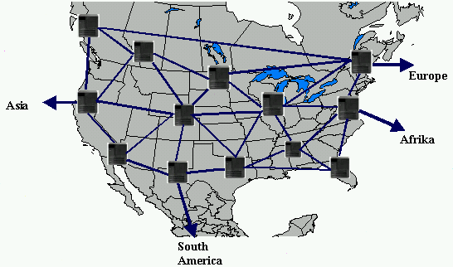
Figure: Interconnected Routers form the backbone of the Internet and span the world

Frequently client computers are connected to other networks in addition to the Internet. Many university campuses and businesses, for example, have their own network that allows users to access common disk space and share printers. The same wires that serve to connect these computers to their own private network also connect the computers to the Internet. That works because data traveling through a network can be encoded in multiple ways. Data that is encoded according to the TCP/IP protocol is "Internet data" and is allowed outside the private network, data that is encoded in other ways remains inside the private network. Such private networks have so-called "gateway computers" that make sure that only data that is specifically for the Internet is forwarded to an Internet router, while other data packets are restricted to the private network. Other computers are connected to the Internet via dialup connections to servers or gateways that in turn forwarding data packets to the nearest Internet router. Since the Internet can utilize existing networks and connect them with each other it is sometimes referred to as the "network of networks".

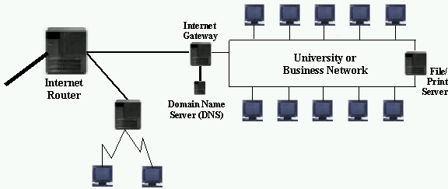
Figure: PC's connected to Internet via Gateway Computer or Modem

The Internet actually derived from another network called ARPANet, created by the Defense Department with taxpayer's money. That network was created in the late 60's to allow military command-and-control facilities to continue to communicate even if some of the nodes of the network were destroyed (by acts of nuclear war, as the plans went). The main feature of this network was that routers could independently redirect data traffic to other nodes if there was a problem with a few nodes between two points of communications. As the thread of war decreased in 70's and 80's, ARPANet was opened up to allow universities to participate in the data traffic. In the 80's businesses joined the network, but it was mainly used by technically and scientifically minded participants who had to be rather skilled to use the net. In the 90's the World Wide Web was created as part of the Internet, and its ease of use and visual impact sparked a huge increase in Internet participants. Today the Internet is mainly run by private companies that continuously add new routing capacities to allow for the huge increases in world-wide data traffic the Internet has experienced in the last years.

What's in a Name: IP Names and Numbers

The first fundamental problem of the Internet is how to uniquely identify all connected systems. Just as every person who wants to participate in the worldwide telephone system needs a unique phone number, all computers connected to the Internet need a unique classification tag. Every computer that is part of the Internet gets a unique identification number and name. That applies also to computers that only connect temporarily to the Internet via a modem connection.

Definition: IP Number and Name
Every computer attached to the Internet is assigned a unique address called IP number. An IP number consists of 4 groups of integers between 0 and 255, separated by dots. Each number also has a unique name associated with it, consisting of multiple strings separated by dots. The last two parts of the name, called domain name, identify a computer as part of the same local network and are associated with the first two groups of numbers. The last part of the name provides some information about the nature of the machine. Every data packet sent over the Internet contains the IP number of the sender as well as the IP number of the intended recipient in addition to any data transmitted.

If a computer can not obtain a valid IP number it resorts to the standard default value of 127.0.0.1 with the associated name of localhost. This name can be used by a machine to connect to itself even when it is not connected to the Internet.

For example, all computers connected to Seton Hall University's campus network are identified by numbers starting with 149.150 and associated names ending in .shu.edu. Thus, Seton Hall has the domain name shu.edu and individual computers have names such as www.shu.edu, pirate.shu.edu, and dhcp-143.shu.edu. The IP numbers associated to these names would look like 149.150.2.1, 149.150.2.6, and 149.150.87.143. A few names and numbers are permanent, i.e. they always refer to the same physical computer. The majority of the names and numbers are associated dynamically and refer to different computers at different times.

Knowing the name of a computer usually reveals something about its origin and purpose, as illustrated in the table below. For example, names ending in .edu are usually associated with computers at US educational institutions, those ending in .de are reserved for computers physically located in Germany, etc.

IP Name Ending | Usual Meaning
.edu | educational institution in the US
.com | commercial site or network
.net | site associated with the functioning of the Internet
.org | non-profit organization
.mil | military institution in the US
.de, .ca, .fr, .it | sites in Germany (.de), Canada (.ca), France (.fr), and Italy (.it)
Table: Meanings associated with Internet names

Although the IP numbers are required to transmit data packets over the Internet, the IP names are much easier for users to remember. Therefore, there are special computers available on the Internet that will look up the number associated with a name. These directory assistance computers are called Domain Name Service (DNS) servers and each computer on the Internet must know the IP number of at least one DNS system to resolve Internet names to numbers. This is somewhat analogous to the telephone system: it is much easier for people to remember names rather than phone numbers. As long as you know the phone number of at least one directory assistance service you can usually find out the number of anyone whose name you know.

Definition3: Domain Name Service, or DNS
Special computers called Domain Name Service (DNS) servers act as "directory assistance" utilities to find the associated IP number for computers referred to by name. That number is required before a computer can send any packets over the net.

Internet names and numbers are maintained, at least at this time, by an organization called INTERNIC (www.internic.net). The directory information that the DNS servers maintain is constantly and automatically updated.

At this point we can piece together a simplified but reasonably accurate scheme of how the Internet works.

Example:
Try to describe what happens when a user establishes a dialup connection to "the Internet", starts his or her favorite web browser, and enters a URL to view a particular web page.

Step 1: A user turns on a PC: The operating system of that PC starts and loads - among many other things - a program that can handle the TCP/IP (Transmission Control Protocol/ Internet Protocol) protocol. At this time the IP number of the PC is 127.0.0.1 and the associated IP name is localhost (see figure below).

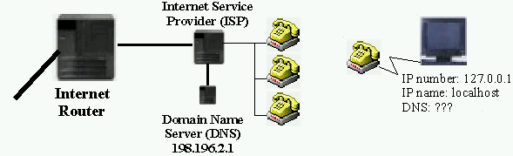
Figure: Individual PC waiting to dialup to the Internet via an ISP

Step 2: The users starts a dialup connection to an Internet Service Provider (ISP) to connect to the Internet: The dialup software calls a particular phone number and waits until some computer answers. When a computer answers, the host computer and the local PC exchange authentication information (such as username and password). If successful, the host machine determines a free IP number within its allocated range and sends that to the client PC. The client PC is then known on the Internet via this IP number and the associated IP name, and traffic to and from the Internet is routed through the dialup host machine to the PC. The host computer also sends the client PC a particular IP number that is to be used as the client's DNS server (see figure below).

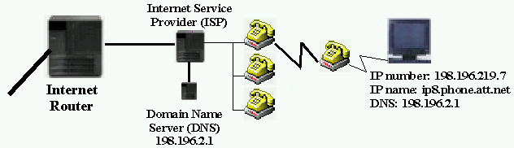
Figure: Individual PC after successful connection to the Internet via an ISP

Step 3: A user starts a web browser and enters a particular URL to view, such as http://www.cat.shu.edu/. The web browser sends a request to its DNS server (defined during the initial phases of dialing up), asking for the IP number corresponding to the name "www.cat.shu.edu". The DNS server searches its database, inquires at other DNS servers if necessary, and returns the appropriate IP number to the client PC. The client PC then sends a request through its host and attached gateways/routers to load a particular web page. The data packet contains the IP number of the client PC (established during dialup), the IP number of the web server (determined by the DNS server) and some information that spells "please give me web page X". The data packets are passed around various gateways and routers until it reaches the destination IP number where it is received by a web server. That web server locates the requested web page on its disk, wraps it into one or more Internet data packets, adds in particular its own IP number as sender and the IP number of the original requestor as recipient, and sends the packet on its way. The packet is again transmitted via gateways and routers along to the original requestor. There it is decoded and the web page is displayed for the user to look at (see figure below).

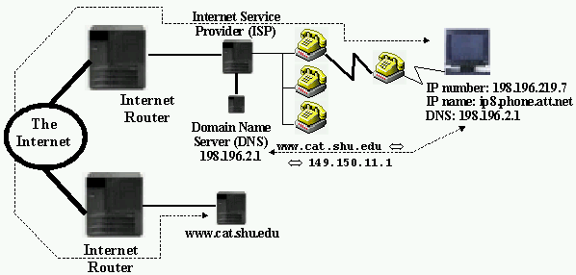
Figure: PC requesting a web page from web server
■

The only part of this picture that we did not explain in detail is how the web server system (www.cat.shu.edu in this example) can understand the request "please give me web page X", and how in turn the PC can decode the answer received. After all, as we saw in chapter 9, if data is isolated from structured types inside a program we need to know something about the data before we can make sense of it.

In addition, we need to know how exactly data can flow into and out of a system connected to the Internet.

Sockets, Ports, and Protocols

There are two final pieces to the puzzle to finish our basic introduction to the way the Internet works: ports and sockets, which are the physical locations where data is transmitted, and protocols, which are the specifications of how the data is structured:

Definition: Ports and Sockets
A port is generally a place where information goes into or out of a computer. Many personal computers, for example, have serial ports, i.e. physical locations to attach input/output devices. Computers attached to a communications network such as the Internet also have ports that are non-physical logical channels identified by a unique port number through which information can flow in and out of the system. Computers on the Internet have over 10,000 logical ports each, where ports with numbers less than 1024 are often reserved for special services.

A socket is a network communications endpoint, analogous to a socket to which electrical wires (the network data connection) can be attached. Sockets are associated with a port, and each port can have one passive socket awaiting incoming connections as well as multiple active sockets corresponding to an open connection on that port. An active socket on one machine is connected to a remote active socket on another machine via an open data connection. Closing the connection destroys the active sockets at each endpoint. A passive socket is not connected, but rather awaits an incoming connection, which will spawn a new active socket.

In other words, when a computer is connected to the Internet, information flows in and out of logical ports identified by number. Each port has a socket associated with it that is initially passive. When a connection is requested to a particular port, the passive socket spawns an active socket on this port that will then serve as one endpoint of the data connection. The remote computer initiating the connection also has an active socket on a particular port, serving as the other endpoint of the data link. Data can then be transmitted through these ports via the active sockets.

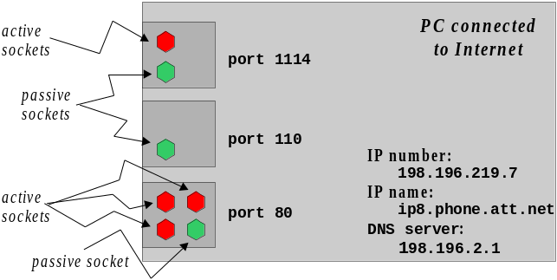
Figure: Schematic computer with ports and sockets

Now that we know how exactly data gets in and out of a computer (more or less at least), we need to specify what type of data exactly is transmitted, how it is interpreted, and how requests are made to initiate any data transfer. That is specified via protocols, i.e. formal descriptions of rules and message formats that machines must follow to exchange data.

Definition: Internet Protocols
A protocol is a mutually agreed upon method of communication between two or more parties that clarifies exactly what type of data exchange will take place and how to initiate it. Many well-known protocols exist for the Internet that govern complex services between two or more computers. Some of the important ones are listed in the table below together with their default port numbers, including:

- http: Hypertext Transfer Protocol - specifies how to request and transmit web pages
- ftp: File Transfer Protocol - specifies how to initiate and conduct file transfers
- smtp: Simple Mail Transfer Protocol - specifies how to send electronic mail
- pop: Post Office Protocol - specifies how to retrieve and manipulate electronic mail

Protocols are specified in so-called Requests for Comments (RFC) and are available in written form on the Internet. Protocols are implemented via programming code to perform the data exchange according to the rules and formats of the particular protocol.

Protocol | Meaning | Standard Port
echo | echoes everything back | 7
discard | discards everything | 9
daytime | sends date and time | 13
ftp | file transfer protocol | 21
telnet | terminal protocol | 23
smtp | simple mail transfer protocol | 25
finger | displays user information | 79
http | hypertext transfer protocol | 80
pop3 | post office protocol (version 3) | 110
nntp | network news, or Usenet | 119
imap | manages email on server | 143
talk | talks to another user | 517
kerberos | security services | 750
Table: Standard Internet protocol names and associated ports

These protocols are very strict and are discussed and refined for quite some time. Once implemented they are strictly adhered to until a refined version of the protocol is discussed, established, and implemented. The tables below show some sample exchanges in various protocols.

Protocol | Default Port | Sample Exchange
http | 80 | ⇒ GET / HTTP/1.0      HTTP/1.0 200 OK   Date: Wed, 18 Mar 1999 20:18:59 GMT   Server: Apache/1.0.0   Content-type: text/html   Content-length: 1579   Last-modified: Mon, 22 Jan 1999 22:23:34 GMT     HTML document …
Table: Sample client/server exchange using http protocol to request a web page

Protocol | Default Port | Sample Exchange
smtp | 25 | ➲ 220 kitten Simple Mail Transfer Service Ready   HELO mycomputer.mydomain   250 kitten.shu.edu   MAIL FROM:<Smith@shu.edu>   250 OK   RCPT TO:<Jones@shu.edu>   250 OK   DATA   354 Start mail input; end with <CRLF>.<CRLF>   Blah blah blah...   .   250 OK
Table: Sample client/server exchange using smtp protocol to send an email message

Protocol | Default Port | Sample Exchange
pop | 110 | ➲ +OK POP3 server ready   <1896.697170952@dbc.mtview.ca.us>   APOP mrose c4c9334bac560ecc979e58001b3e22fb   +OK mrose's maildrop has 2 messages (320 octets)   LIST   +OK 2 messages (320 octets)   1 120   2 200   .   RETR 1   +OK 120 octets   <the POP3 server sends message 1>   .   QUIT   +OK dewey POP3 server signing off (maildrop empty)
Table: Sample client/server exchange using pop protocol to request an email message

Protocol | Default Port | Sample Exchange
Echo | 7 | ⇒ hello   hello   Anybody there?   Anybody there?   This protocol is pretty easy.   This protocol is pretty easy.
Table: Sample client/server exchange using the echo protocol

Client/Server Programs

In the above tables data is exchanged according to the specified protocol, assuming a connection could be established on the default port. Two systems are participating: the system initiating the connection is called client, the system answering the request is called server. Data prefaced by the right-arrow symbol  is sent from the client to the server, data prefaced by the left-arrow symbol  is sent from the server to the client. Such a client/server model, in fact, is the underlying software model that governs the Internet.

Definition: Server Program
A server program is a stand-alone computer program that often has access to a large set of data or other resources and runs in the background on computers permanently connected to the Internet. It has a minimal user interface and operates, for the most part, without user intervention. Servers most often "listen" on specified ports for a network connection, and once a connection is established they communicate with the requestor using a mutually agreed upon protocol. One server program can usually handle requests by multiple clients simultaneously.

All major protocols that are in use on the Internet are implemented in particular server programs.

- A web server program, usually called httpd, listens by default on port 80 for incoming connections and delivers web pages when requested. It implements the http protocol.
- A pop server program, usually called popd, listens on port 110 and is ready to deliver email to a user when asked. It implements the pop protocol
- The program most frequently used to deliver email between computers is called sendmail. It listens on port 25 and implements the smtp protocol
- Other frequently used server programs are ftpd, listening on port 21, and telnetd, listening on port 23.
- A server that may not appear very useful but can be handy for testing purposes is the echod server, implementing the echo protocol. That server listens on port 7 by default.
- Another server program that can be quite useful is called msqld and listens on port 1114 by default. It understands requests in Structured Query Language (SQL) but the actual protocol is more involved than SQL.

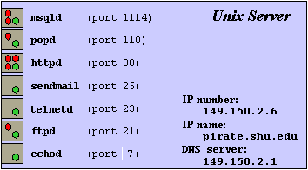
Figure: Typical server programs running on a typical Unix system

The counter-part to server programs are client programs. Those are the programs that the user interacts with and that in turn interact with an appropriate server program who speaks the same protocol as the client.

Definition: Client Program
A client program is a program with an extensive user interface or other visual capabilities, but with little access to resources. A client program communicates with a server program via an Internet connection on a specific port to request information or cause action. It presents the data delivered by the server in an appropriate way or displays appropriate messages regarding the actions caused on the server. In many cases multiple client programs can be serviced by one server program. The client must use the same protocol as the server in order to communicate effectively.

There are many examples of client programs and most modern programs these days include at least a client component:

- Netscape Communicator and Internet Explorer are both web client programs. They both understand the http protocol and interface usually with a web server program such as httpd.
- Chat client programs are commonly used to communicate with several people at the same time, much like a telephone party line. Client programs interface with appropriate chat servers who negotiate the communication between the participating chat clients.
- Email programs such as Netscape Messenger, Microsoft Outlook, or Eudora are client programs that understand the pop protocol or, more and more frequently, another email standard protocol called imap. They interface with appropriate pop or imap servers to retrieve email messages for the user. Most also interface with an smtp client program to deliver outgoing email.
- Anti-Virus protection programs are not client programs but they can often download updated anti-virus definitions from the Internet. They do that by invoking a client component that interfaces with an appropriate server program to obtain the new information. The protocol used is usually proprietary.

Now we have spent a lot of time explaining some of the inner workings of the Internet. It is high time for some examples.

Using Telnet to Connect to Servers

Telnet is a terminal emulation and communications program that allows you to use a remote computer for text-based applications as if you were sitting in front of it. It is most frequently used to interface with a telnetd server program using a specific protocol. However, telnet is very versatile and can be used to interface with many, in fact most, other text-based server programs. Since it is automatically installed on Windows 95/98/NT computers as well as all Unix systems, it is an ideal starting point to explore various servers.

Example:
The daytime protocol (see table) is a particularly simple protocol. It specifies that the server should send the date and time of the server machine to any client connecting to it. Use telnet to connect to the standard daytime port 13 of a machine such as www.cat.shu.edu and describe what happens.

Telnet, by default, tries to connect to a telnetd server on port 23, but it can also connect to any other port and attempt to communicate with a server listening on that port. To start a telnet connection to port 13 on the machine www.cat.shu.edu using a Unix system you type:

telnet www.cat.shu.edu 13

On Windows systems, click on “Start | Run” and type:

telnet www.cat.shu.edu 13

One Macintosh systems, the procedure is similar. Of course the system you are using should be connected to the Internet prior to initiating a connection. If everything works, you will see a response from the daytime server such as the one shown in figure below.

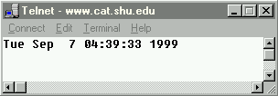
Figure: Typical response from a daytime server

The daytime server will deliver the current date and time of its system, which may be different from the current time of the client system. After sending the information, the server immediately closes the connection.
■

Telnet can also be used to connect to servers that speak a more complex protocol such as http. It will not make any attempt to interpret the response sent by a server in any way, it simply displays it "as is".

Example:
Review the sample session using the http protocol and an httpd server shown in on of the tables above, then use Telnet (not Netscape or Internet Explorer) to try to obtain a web page from the web server running on the machine called www.shu.edu or from another system such as www.yahoo.com. Explain in detail what is happening when you are successful.

First of all, we are trying to connect to another computer on the Internet, so we must be connected to the Internet either via a dialup connection or another network connection. Once your connection to the Internet is established, you can start the telnet program to connect to the desired host as in a previous example. Note, however, that based on our previous discussion we now need to connect to port 80 on the specific host, because httpd web servers are listening on port 80. To start the telnet connection on Unix systems, you type:

telnet www.shu.edu 80

to connect to the machine called www.shu.edu on port 80. On Windows systems, select Start | Run... and enter the desired host name and port in the dialog box that pops up:

telnet www.shu.edu 80

One Macintosh systems, the procedure is similar If you are indeed properly connected to the Internet, you will soon see a prompt informing you that you are connected. However, nothing else will happen. The web server program is now waiting for you - or rather the client program - to issue an appropriate request for a web page as outlined in the http protocol. In a prior table we saw a sample session with an httpd server so we know that the appropriate commands to request a web page are:

GET / HTTP/1.0


In other words, type "GET / HTTP/1.0" as indicated, hit ENTER - nothing happens - and then hit ENTER again. Now you have issued the simplest command from the http protocol that the server understands and you will see a "web page" similar to the one shown below:

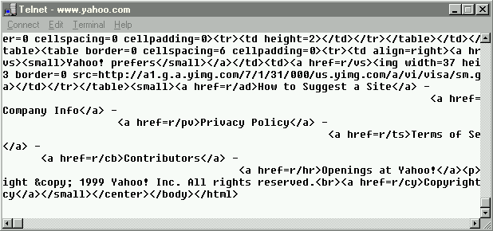
Figure: Resulting data transmitted when requesting a web page via telnet

Of course this data does not look the way it would when requesting the same page with a web browser. A web browser, in addition to being able to speak http with a web server, also understands the Hypertext Markup Language HTML, which consists of formatting commands enclosed in angular brackets. A web client applies appropriate formatting mechanisms instead of simply displaying the HTML tags as our telnet program does. However, we have achieved our goal: we did get the desired web page from the web server even if it did not look very pretty.

Here is what happens in detail:

- You establish a dialup connection if necessary: your Internet service provider assigns an IP name and number to your computer and tells your computer with DNS server to use.
- You establish a telnet connection to www.shu.edu on port 80: First, a request is transmitted to the DNS server to find the IP number of the host named www.shu.edu. Once the DNS server supplies that number, a data packet including this number, your own IP number, and some additional information that says "establish connection with port 80" is sent to your dialup server. That server passes the packet along to routers, who in turn deliver it, eventually, to the machine with the IP number associated with www.shu.edu. That machine looks at the packet and opens a connection to port 80. A passive socket on that port spawns an active socket that serves as the termination point of your connection. A connection is now established from a socket on some local port of your system to the socket on port 80 on www.shu.edu.
- You type GET / HTTP/1.0: An appropriate data packet is sent through the Internet to the receiving active socket on www.shu.edu. There the web server listening to port 80 picks up the packet and reads your command. It sees "GET", which instructs it to look for a web page. It sees "/" (a single slash), which means to get the top-level web page, which has the actual URL http://www.shu.edu/index.html. It sees "HTTP/1.0", meaning that it is to use version 1.0 of the http protocol. Nothing happens yet, because the web server is waiting for other options that you may want to specify in accordance with the http 1.0 protocol.
- You press ENTER, which sends an empty line to the web server: That tells the web server that your command is finished. The web server now retrieves the appropriate web page from its hard disk, adds some header information to the page, wraps the data into one or more packets including the IP number of the recipient, and sends the packet back to your computer. There the telnet program receives the information and displays it on the screen.
- The web server now closes the connection and is ready to service another client request or your telnet client again, should you so choose.
■

It should be noted that the above scenario is the same regardless of which particular system you are using and independent of the system where the web server program is running. The point of adhering to a specific protocol is that you can implement programs that speak that protocol on pretty much any system you choose (as long as it can establish a TCP/IP Internet connection). This, of course, makes client/server programming in the programming language Java particularly attractive: not only is the protocol system independent, but also the actual Java classes are platform independent so that one client or server program can run on pretty much any platform without having to recompile anything. This is one of the reasons why Java is frequently called the "programming language of the Internet".

Thus the Internet can support a maximum of 255⁴ = 4,228,250,625 computers. But the first two integers often identify a domain and the domain owner is free to administer their last two integers as they please. Therefore per domain 255² = 65,025 IP numbers are unavailable even if only 10 of those numbers are used.
Seton Hall, for example, could support 65,025 computers but in reality connects at most 2-4% of that figure. If that ratio were representative for other domains, a more realistic limit on the number of possible Internet computers is closer to 3% of 255⁴ or approximately 130 million machines worldwide.
It usually takes a day or more for a new Internet name to trickle through all DNS systems around the world. A new Internet name is universally available only after all DNS systems are updated.
On Windows-based PCs, this program is, essentially and simplified, called "winsock".
There really is no need to say "please" to a web server …
The specific path the return packets take may very well be different from the original path.
Compare example 9.2.14 where we saved two int values to disk but retrieved the data as a double, which was for all intent and purposes a valid but random double.
The http protocol, for example, was recently upgraded from version 1.0 to version 1.1, which means that all web servers and web browsers had to be rewritten to adhere the new http 1.1 protocol.
Server programs can be started on any computer, even on a localhost not connected to the Internet. However, in order to connect to a server the client program needs to know the IP name of the server. Therefore that name should not change and the server system should be connected at all times.
Of course multiple requests are not handled truly simultaneously unless the system that runs the server has more than one processor.
It should be secure enough to prevent a virus program from infecting the downloaded information.
Telnet programs are readily available for free for Macintosh systems (see appendix).
If there is no daytime server listening on port 13 of the server system you will get a message saying "request denied" or something similar. You can try any other machine name you know such as www.sun.com, www.ibm.com, www.mit.edu, etc. until you find a daytime server that will answer.
The web server does not know that a non-web browser has connected as a client.
Depending on how telnet is configured you may or may not see what you are typing. Even if you do not see anything, type the commands as indicated; they will be sent to the server whether you see them or not.
A true web client such as Netscape would interpret the response and show you the information formatted according to the HTML formatting tags included in the response.

